

Daniel Wild

BCIS309 – Work Integrated Learning PROJECT, software development pathway

Semester 1, 2023

automated ui testing suite for ara ict division

Final Report

Version 2.5

Contents

Executive Summary 1

Halfway Report 1

Final Report 1

Introduction 3

Project Details 4

Project Name 4

Overview of Industry Client 4

Project Background 4

Project Scope 6

Project Goal(s) 6

Benefits of Project 6

Project Requirements 7

Expected Deliverables 7

Halfway Report 8

Updates 8

Reflection 15

Final Report 16

Final Summary 16

Reflection 21

Project Goal(s) 21

Benefits of Project 21

Project Requirements 22

Expected Deliverables 22

Stakeholder Management 25

Project Hierarchy 25

Reporting and Meetings 25

Halfway Report 27

Updates 27

Reflection 28

Final Report 29

Final Summary 29

Reflection 30

Student Skills 31

General Skills Required 31

ICT-Specific Skills Required 31

Skills from Relevant L6 and L7 Courses 31

Approach to Learning New Skills 32

Halfway Report 33

Updates 33

Reflection 36

Final Report 37

Course Evaluation 37

Final Summary 39

Reflection 42

Project Plan – High Level 43

Phases 43

Timetable 46

Burndown Charts 50

Resources/Access Required 52

Detailed Project Plan 53

Halfway Report 59

Updates 59

Reflection 74

Final Report 75

Final Summary 75

Reflection 83

Risk Management 84

Approach 84

Risk Table 85

Halfway Report 89

Updates 89

Reflection 94

Final Report 95

Final Summary 95

Reflection 99

Quality Assurance 100

Approach 100

Quality Assurance Table 101

Test Plan/Scenarios/Cases 105

Halfway Report 106

Updates 106

Reflection 115

Final Report 119

Final Summary 119

Reflection 126

Methodology 127

Overview 127

Literature Review 128

Critique (Pros and Cons) 129

Halfway Report 130

Methodology Essay Summary 130

Updates 130

Reflection 133

Final Report 135

Final Summary 135

Professionalism 136

Professional Standards 136

Relevance of ITP Code of Ethics 138

Relevant Legislation 140

Halfway Report 141

Reflection 141

Final Report 142

Final Summary 142

Reflection 143

Sustainability, Inclusive Practice, and Te Tiriti o Waitangi 144

Relevance of Principles to Student and Industry 144

Halfway Report 146

Reflection 146

Final Report 147

Final Summary 147

Reflection 147

Self-Assessments 148

Halfway Self-Assessment 148

Self-Assessment 150

Final Self-Assessment 152

Reflections 156

Approach 156

Halfway Report 158

Update 158

Reflection 160

Final Report 161

Final Summary 161

Appendices 166

Appendix A: Timetables 167

Appendix B: Industry Burndown Charts 169

Appendix C: Academic Burndown Charts 170

Appendix D: Academic Task breakdown 171

Appendix E: Industry Task breakdown 172

Appendix F: Risk Management 173

Appendix G: Past Weekly Reports 175

Document Control

|  |  |  |  |
| --- | --- | --- | --- |
| Date | Author | Version | Status of Document/Updates Made |
| 6/03/2023 | Daniel Wild | v0.1 | Document Creation |
| 21/03/2023 | Daniel Wild | v0.1 | Submitted for Academic and Industry feedback |
| 22/03/2023 | Daniel Wild | v0.2 | Product Owner’s feedback implemented |
| 27/03/2023 | Daniel Wild | v0.3 | Industry Supervisor’s feedback implemented |
| 27/03/2023 | Daniel Wild | v0.4 | Academic Supervisor’s feedback implemented |
| 27/03/2023 | Daniel Wild | v0.4 | Submitted for Academic and Industry feedback |
| 28/03/2023 | Daniel Wild | v0.5 | Industry Supervisor’s feedback implemented |
| 28/03/2023 | Daniel Wild | v0.6 | Academic Supervisor’s feedback implemented |
| 29/03/2023 | Daniel Wild | v0.6 | Submitted for Academic and Industry feedback |
| 29/03/2023 | Daniel Wild | V1.0 | Signed off by Product Owner and Industry Supervisor |
| 29/03/2023 | Daniel Wild | V1.0 | Signed off by Academic Supervisor |
| 29/03/2023 | Daniel Wild | V1.0 | Sent to Course Convenor for signoff |
| 30/03/2023 | Daniel Wild | V1.0 | Signed off by Course Convenor |
| 25/04/2023 | Daniel Wild | V1.1 | Course Convenor feedback implemented |
| 25/04/2023 | Daniel Wild | V1.2 | Halfway report version created |
| 7/05/2023 | Daniel Wild | V1.2 | Submitted for Academic and Industry feedback |
| 8/05/2023 | Daniel Wild | V1.3 | Product Owner’s feedback implemented |
| 8/05/2023 | Daniel Wild | V1.3 | Industry Halfway Assessment added |
| 15/05/2023 | Daniel Wild | V1.4 | Industry Supervisor’s feedback implemented |
| 16/05/2023 | Daniel Wild | V1.5 | Academic Supervisor’s feedback implemented |
| 17/05/2023 | Daniel Wild | V1.5 | Submitted for Academic feedback |
| 18/05/2023 | Daniel Wild | V1.6 | Academic Supervisor’s feedback implemented |
| 19/05/2023 | Daniel Wild | V2.0 | Halfway Report submitted for marking |
| 4/06/2023 | Daniel Wild | V2.1 | Final Report created |
| 8/06/2023 | Daniel Wild | V2.1 | Submitted for Academic and Industry feedback |
| 9/06/2023 | Daniel Wild | V2.2 | Product Owner’s feedback implemented |
| 10/06/2023 | Daniel Wild | V2.3 | Industry Supervisor’s feedback implemented |
| 11/06/2023 | Daniel Wild | V2.4 | Academic Supervisor’s feedback implemented |
| 12/06/2023 | Daniel Wild | V2.5 | Final Report submitted for marking |

# Executive Summary

## Halfway Report

Over the last few months, I have been working with my industry partner, the Ara ICT Division, on my Capstone Project. We set out with the goal of creating a range of testing suites for several of the apps managed by the ICT Division that would help to improve their deployment process by implementing sets of user interface tests that can be automated to run with minimal interference required that will ensure that the overall standard of the tested apps does not degrade over time.

As of this Halfway point in the project’s duration, I am halfway through my third sprint with three apps testing suites created, one of which has been sent for deployment and two that are awaiting code review, with a fourth ready to be started when the third sprint ends in the coming week.

Throughout this process, the skills I already had have been significantly increased. I have gained experience in management areas like project scoping, development methodology, stakeholder management, risk management, and quality assurance. To manage each of these aspects of the project, I have maintained a range of academic documentation, which is used to track my progress towards completing the project deliverables.

The first three academic deliverables have been accepted, with three more completed as part of this report.

The project has been progressing well and is on track to finish on time as planned, with all industry deliverables accepted and the final academic deliverables in progress. With this in mind, testing suite development will continue for five to six weeks. At that time, the deliverables and project timeline will be reviewed against the quality assurance acceptance criteria before the focus shifts to the completion of the final documentation ready for the project’s outcome to be presented to the stakeholders.

## Final Report

As part of my capstone project, I worked with my industry partner, the Ara ICT Division, to create UI automated testing suites for six React-based web apps. Each testing suite automatically logins into each website and completes a series of tests to ensure all workflow and functionality works correctly on each site. This ensures that no release from the production deployment pipeline regresses the overall standard of the tested apps, with releases becoming more reliable and efficient with fewer errors. This goal was successfully achieved as each testing suite detailed in this report was integrated into the pipeline. During this process, I gained many skills, such as advanced testing procedures and production pipeline deployment, along with a fascination with the power of automation tools like Puppeteer, which I would like to explore further.

This process was documented in a series of deliverables such as reports, an essay, a poster, and a presentation explaining how I managed the project from the proposal stage to completion. During this process, I gained a range of skills and experience in project management, implementation of development methodology, risk assessment, quality assurance and self-assessment. This helped me iterate my processes and deliverables until they met a high industry standard. As part of this process, I have reflected on the mistakes I made and the lessons I learnt. I am ready to jump into my next project with those in mind.

This work proved beneficial for both parties, as it provided my industry partner with an automated rapid testing pipeline requiring minimal human intervention, which offers rapid testing directly from development to production deployment that increases the speed of testing with fewer errors. At the same time, providing me with very valuable knowledge and experience that will aid me during my career. For more detailed information, please continue reading this report.

# Introduction

The purpose of this report is to present a document that details information about the project I will work on during my Capstone. It will do this by describing the proposed project’s details, scope, plan, risk management, quality assurance plan, ethical and legal considerations, and project management framework that will be utilised throughout the project’s development. The information was gathered during research and interviews with the client, which will be used to create a solution that meets the client’s needs. It will also continue as a live document throughout the development process, using the specification and appendix sections to show the continuous updates to the documents used during this report to show the process of the overall project up until completion.

# Project Details

In this section, I will explore the specific project details discovered by interviewing clients about their needs.

## Project Name

Automated UI Testing suite for Ara ICT Division

## Overview of Industry Client

Ara Institute of Canterbury is a subsidiary of Te Pūkenga New Zealand Institute of Skills and Technology in Canterbury, New Zealand. Ara Institute of Canterbury Ltd (n.d.-c) explains that Ara is the Māori word for path or journey. It represents the learning process, the many pathways to success, and the routes and rivers that crisscross the Canterbury Plains from the mountains to the sea. Formed in 2016 when CPIT and Aoraki Polytechnic merged. Te Pūkenga (2022) stated that as of the 1st of January 2023, Ara merged into Te Pūkenga, becoming part of one national polytechnic along with all other Institutes of Technology and Polytechnics in New Zealand. Ara provides a personalised learning experience. One that is flexible and respectful of students’ educational needs and career goals. The focus is always on balancing theory with practical learning to ensure students are work-ready when they graduate. A study with New Zealand (2017) suggested that over 17,000 students, including 1,800 international students, study each year. Ara Institute of Canterbury is one of New Zealand's largest tertiary institutions, with facilities in Christchurch, Timaru, Ashburton, and Oamaru.

## Project Background

### Overview

The Ara ICT Division is looking to improve its code release process using Continuous Integration (CI), Continuous Deployment (CD), and Continuous Testing (CT). Dobra (2021) stated that these are practices built around DevOps methods to create rapid testing that works directly from development to production deployment. Developing a set of quick, automated deployment tests that require minimal interference. With the goal of creating a testing suite that will ensure that no release degrades the overall standard of the tested apps. To help create a solution, Puppeteer has been selected. Kazuaki Matsuo (2022) explained that Puppeteer is a Node.js library that provides a high-level API to control Chrome development tools protocols allowing for a unit test to be created with built-in keyboard input or form submission.

### Current Situation

The work has been started on the automated testing by an Ara Bachelor of Information and Communication Technologies (BICT) graduate over the summer break, who completed the testing on one of the applications. This has left six more applications needing test scripts developed, all with a range of features from simple to complex. The framework of automated API testing has been set up, and materials have been established and centralised, ready for management, so it is prepared for the new testing suites to be integrated. Currently, vulnerability testing is done weekly.

### Future Situation

A development pipeline has been established to run the automated testing suite on all the app functionalities with minimal human intervention. The testing suite will only need stakeholders’ interaction when tests fail, and they have been alerted. Once the stakeholder has been warned, they will be able to ensure the features that failed the tests are not deployed, allowing any issues to be resolved. Talin (2023) explains that this is a form of regression testing used to ensure the software is still behaving as it should and that new bugs or functional issues have not been introduced after a specific change or update is made.

# Project Scope

In this section, I will go more in-depth on the project’s overall scope, created with the client, while conducting interviews to define the project details.

## Project Goal(s)

### Industry

Have a complete automated testing suite using Puppeteer for the five react web applications as part of a development pipeline that allows for minimal manual interference unless tests fail during redeployment and need human intervention to problem solve. Time permitting complete research and discovery on possible testing solutions for the sixth app, which is desktop based instead of web-based, will need different testing and automation platforms other than puppeteer.

### Student

I want to create a complete automated testing suite for all the applications the stakeholder wants to be tested. After the project, as an outcome of my work, I want to look at the completed code and think of all things I have learned and that I have skills that have been expanded by real-world experience. It is also an excellent opportunity to have a satisfied client in my work history who can be my referee during future work applications.

## Benefits of Project

### Industry

* Direct development to production deployment for rapid testing.
* Increase the speed of testing over manual testing.
* Releases become more reliable with fewer errors.
* Increased deployment efficiency.
* Automated pipeline requiring minimal human intervention.

### Student

A chance to challenge myself to take the programming, unit testing, and development methodology skills I have learned over the past three years of studying the BICT and push them to the next level to be applied in real-world situations. The chance to participate fully in a real-world industry environment to get as much experience as possible. It is also a chance to gain experience with puppeteer, a new technology I can add to my work portfolio.

## Project Requirements

* Create a list of functionalities that must be tested for each web app.
* Develop automated UI testing suites that cover each app’s functionality.
* Integrate the development pipeline to allow human intervention to stop redeployment when tests fail.
* Complete research and discovery on possible testing solutions for the desktop app.
* Create architectural-level documentation.

## Expected Deliverables

### Industry

* Daily stand-up updates.
* Weekly meeting updates.
* Burndown charts.
* Daily status reports.
* Risk register updates.
* Issues raised updates.
* Testing code for each of the five react web applications.
* Create architectural-level documentation.

### Academic

1. Work Integrated Learning Agreement
2. Project Proposal
3. Proposal approval document
4. Weekly Reports
5. Risk assessment
6. QA report
7. Halfway Academic Report
8. Halfway Assessments (from IS, AS, and self)
9. Final Academic Report
10. Methodologies Essay
11. Poster
12. Short Paper
13. Panel PowerPoint slides
14. Panel Presentation

## Halfway Report

## Updates

### Current Situation

As of this Halfway point in the project’s duration, I am halfway through my third sprint with three apps testing suites created, one of which has been sent for deployment and two that are awaiting code review, with a fourth ready to be started when the third sprint ends in the coming week. This process is shown below when Figure 1, *My Kanban Board at the Start of Sprint 1* and Figure 2, *My Kanban Board at the End of Sprint 3* are compared. Figure 1 shows my Kanban board at the start of sprint 1 before any work had been done, while Figure 2 shows my Kanban board and the end of sprint 3 with app 1 in deployment, the subtasks of apps 2 and 3 in testing, meaning they are working and apps 2 and 3 are in progress as they wait for code review so that they can be moved to deployment.

Each app, when run in either my local environment or during the build environment, can login with a test username and password, find a sequence of textboxes, radio buttons, dropdown boxes and buttons to click or enter text into to simulate a real users input and then move to the next page until all functionality of the website is tested. The results of each of these tests are then output to the user in the terminal, meaning if any fail, the user can then intervene to solve the problem before the app is finished deploying. The below Figure 3, Figure 4 and Figure 5 shows the terminal output of my first three testing suites being run with all the tests passing. The number of tests and their level of complexity vary depending on the complexity of the application.

From there, I will have two more react web applications to create testing suites which should line up with sprints five and six leaving me about a week and a half of industry hours left if I continue at my current rate of hours per week. This will leave me with time to look at the final task which is shown below in Figure 1 as DU-26 UI tests for document upload. This is the desktop-based app discussed above in the scope which will not be able to be tested using the Puppeteer tools and methods that I have implemented on the react apps. This is why this task has been left to last and we have been evaluating the viability of me getting enough time to both research and develop tests for it each after each sprint. We are currently in the process of negotiating whether this task could be done during an extended 320 industry hours or is something that the industry would like to hire me on a short-term basis to complete.

### Project Goal(s)

The list of react web applications to be tested was expanded to a total of seven during the first week of industry work as it turned out there was another app that needed testing which had been left off the original list of six which was Metro Services the app, I ended up starting with during sprint 1. As per the below screenshot, Figure 1 shows my swim lanes of the dev team Kanban Board as of the 29th of March 2023 with my first task in the in-progress lane and the other six in the to-do lane.

Figure 1   
*My Kanban Board at the Start of Sprint 1*

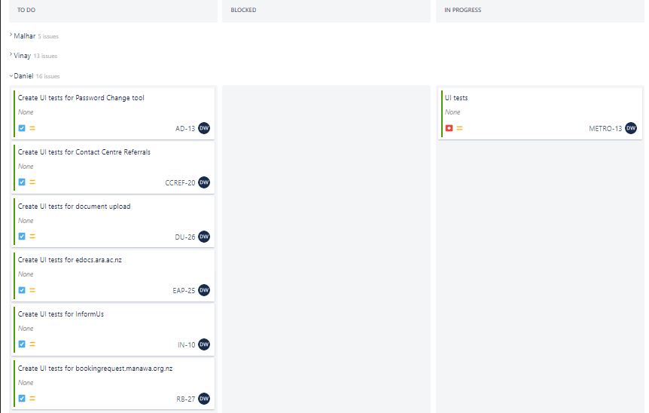

Figure 2   
*My Kanban Board at the End of Sprint 3*

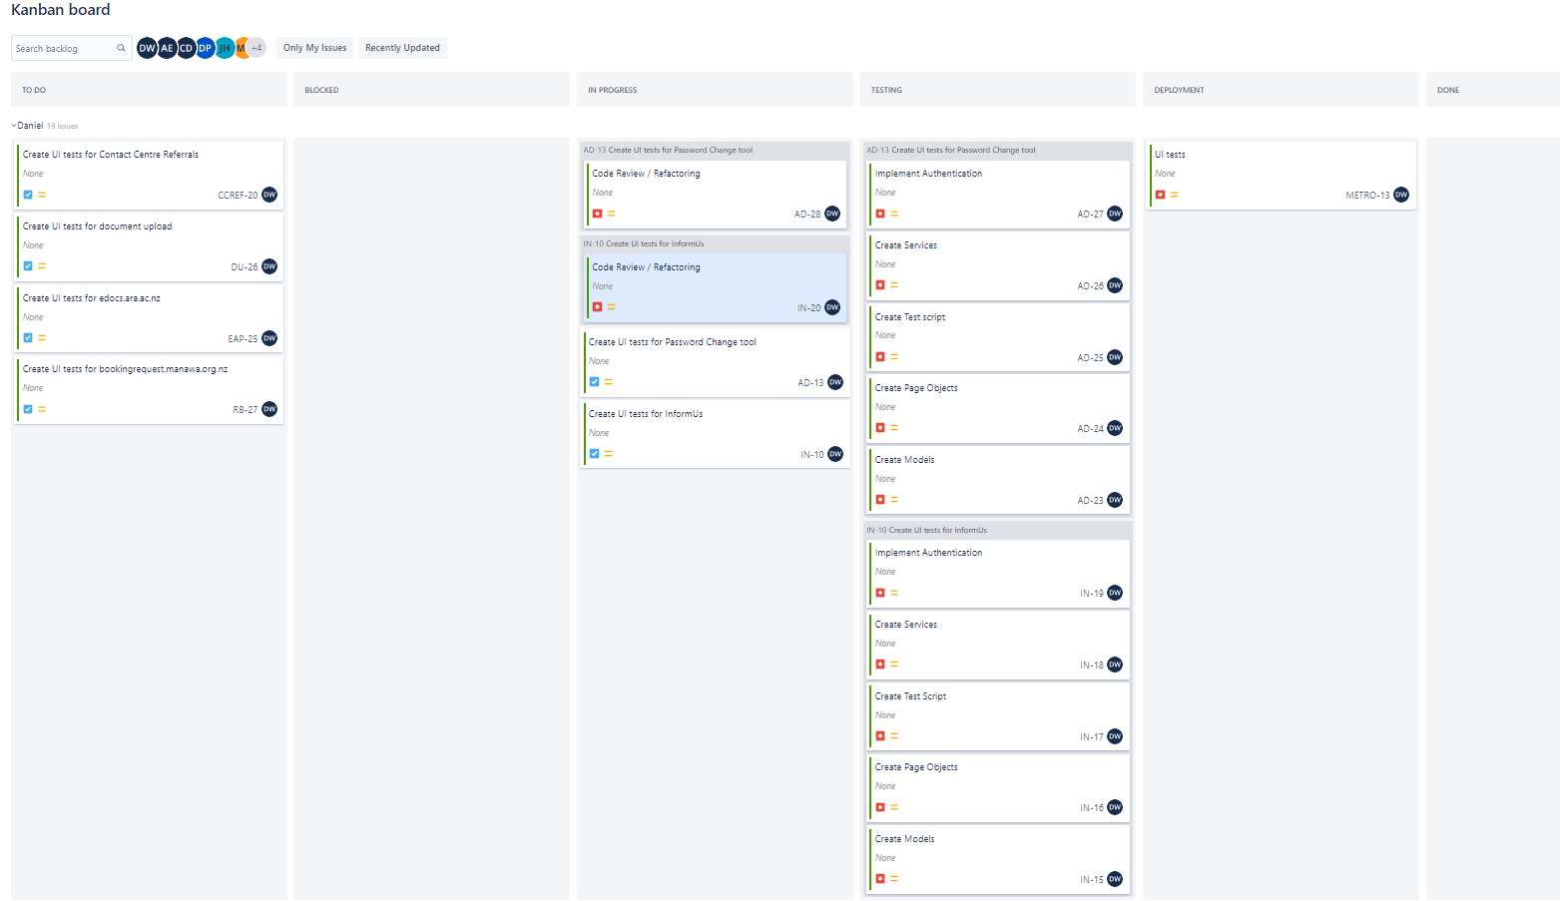

Figure 3   
*Testing Suite 1 Output*

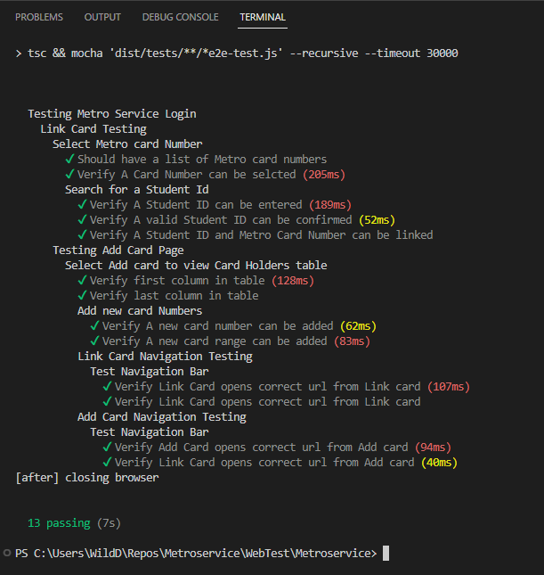

Figure 4   
*Testing Suite 2 Output*

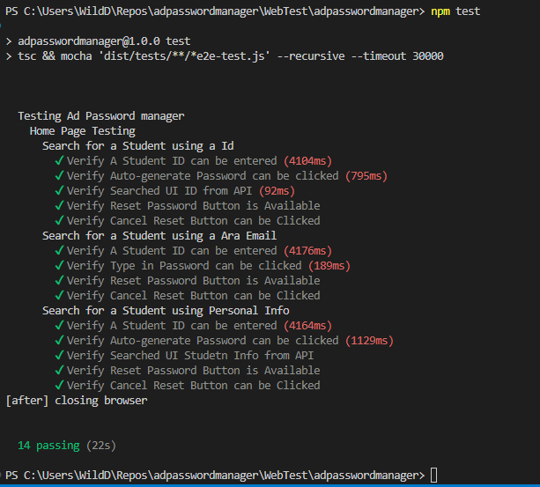

Figure 5   
*Testing Suite 3 Output*

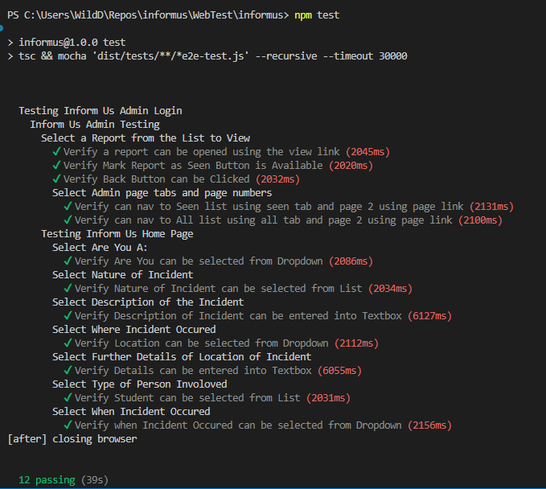

### Expected Deliverables

After getting feedback from the Course Convenor, he pointed out a few academic deliverables I missed above when writing my proposal which is the Proposal approval document meaning the non-disclosure agreement and proposal signoff form which I completed and handed in. As well as the Halfway Assessments (from IS, AS, and myself) which I had on this list, but thought was more for the supervisor to do so removed them. However, the Course Convenor advised they are done between us and the supervisors meaning it is a process that we will go through together and then they will be given to me to hand in and action any feedback for future improvement. These have been added back to the list above and will be tracked using the quality assurance process.

## Reflection

### What Went Well

Academically I was very happy with my marks for my proposal, there was a lot of going back and forth for feedback but in the end, it paid off as there was only one major section that needed to be fixed up for the reports going forward. I also think I have done well to keep up with the weekly academic deliverables up to date like the weekly reports, risk assessment, and QA which I have updated every Monday since the start of the project.

Industry-wise I have very much seen the benefits of doing a real project in the industry as stated above. For example, I have had the challenge I was expecting with the scale of things I needed to learn in the first few weeks, but I feel that the skills I already had like unit testing have already been expanded. I also feel like I have learned a lot in general about how IT companies using agile work in the real world. Coming from my background working general office jobs there was a lot of messy micro management and looking over everybody’s shoulders to make sure work was getting done. Whereas the dev team has been very organised but self-organised which I like, and think has helped me keep on track with my deliverables. As shown above in Figure 1, Figure 2, Figure 3, Figure 4 and Figure 5 I had a list of testing suites to complete, and I am slowly making my way through them with a working testing suite being ready for code review and deployment at the end of each work week on average.

### What Didn’t Go Well

The project proposal took far longer to write than I predicted, and the feedback given by both supervisors took a while to implement, which meant that I was not able to meet the original deadline for the proposal signoff and had to ask for an extension. This ended up being a benefit in the end as I think we got to the best possible version of my proposal. However, I have tried to learn from that experience and made sure to get this version of the report going as soon as I had enough info to complete the sections so that I give myself and my supervisor enough time to get and implement a few rounds of feedback and iteration before the signoff due date.

The output of my working testing suites for each react web applications is a few days behind the original industry sprint plan due to the time taken during the onboarding during the first few weeks, plus both the Easter and Anzac Day holidays but I am in the process of catching that up and so hope to have my second web application fully tested by the end of the 28th of April which is halfway in sprint 3. Meaning that by the start of sprint 4, I will have three apps tested and be on track.

## Final Report

## Final Summary

At the end of my fifth and final sprint, I delivered the six testing suites for the react apps within my three hundred hours, as shown below in Figure 6 *My Kanban Board at the End of Sprint 5*, showing my last Kanban Board. This means I was able to complete the project within the five 60-hour sprints I had planned in the proposal. This left the stretch goal desktop-based app DU-26 UI tests for document upload, as shown in Figure 1, unnecessary as this would have been an optional sprint 6 if time was permitted, and I needed more hours to meet my three-hundred-hour target.

Overall, the last two sprints following the Halfway report were very successful because the apps were more complex than the ones tested during the previous sprints. App 5 needed code to find unique codes for the URL to find the correct files, as shown in Figure 8 *Testing Suite 5 Output*. While apps 4 and 6 had complex workflows that needed thirty to forty tests, as shown in Figure 7 *Testing Suite 4 Output* and Figure 9 *Testing Suite 6 Output* below. This complexity must be considered when making the new testing suites and ensuring the older apps were implemented correctly into the pipeline. This involved changing each app to remove old files that did the Microsoft login, setting up the base info for each page, and replacing them with a global version of these pages that would be downloaded to each testing suite as a dependency. This helped to reduce code duplication across all the apps and made it easier for the code to be run on either a local or production environment, solving an issue I had that I had to change small bits of code when the apps were ready for production to make sure it would run in the pipeline. These changes took some time as they caused some bugs in some apps, but they gave me a chance to learn how to debug under pressure and that just because code work for me locally does not mean it will work in all environments, which is something I need to keep in mind. This made for a challenge with industry hours quickly running out, but I’m proud I was able to get it all delivered.

Figure 6   
*My Kanban Board at the End of Sprint 5*

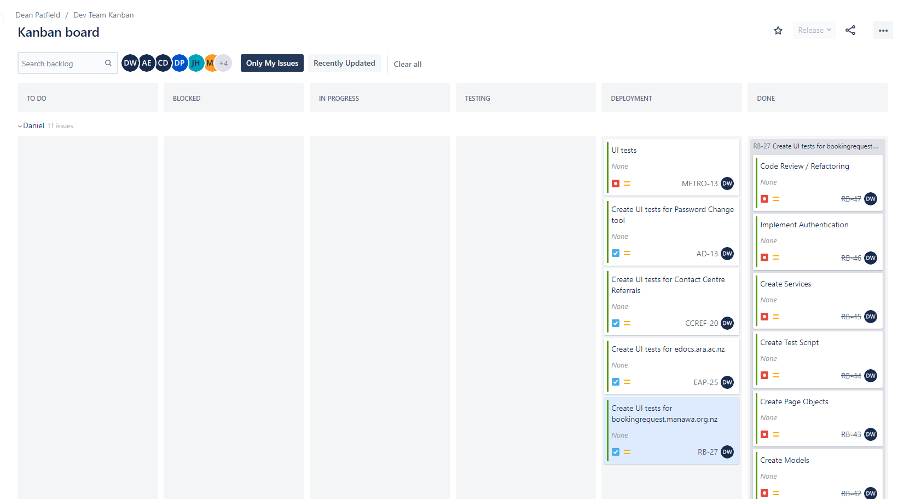

Figure 7 *Testing Suite 4 Output*

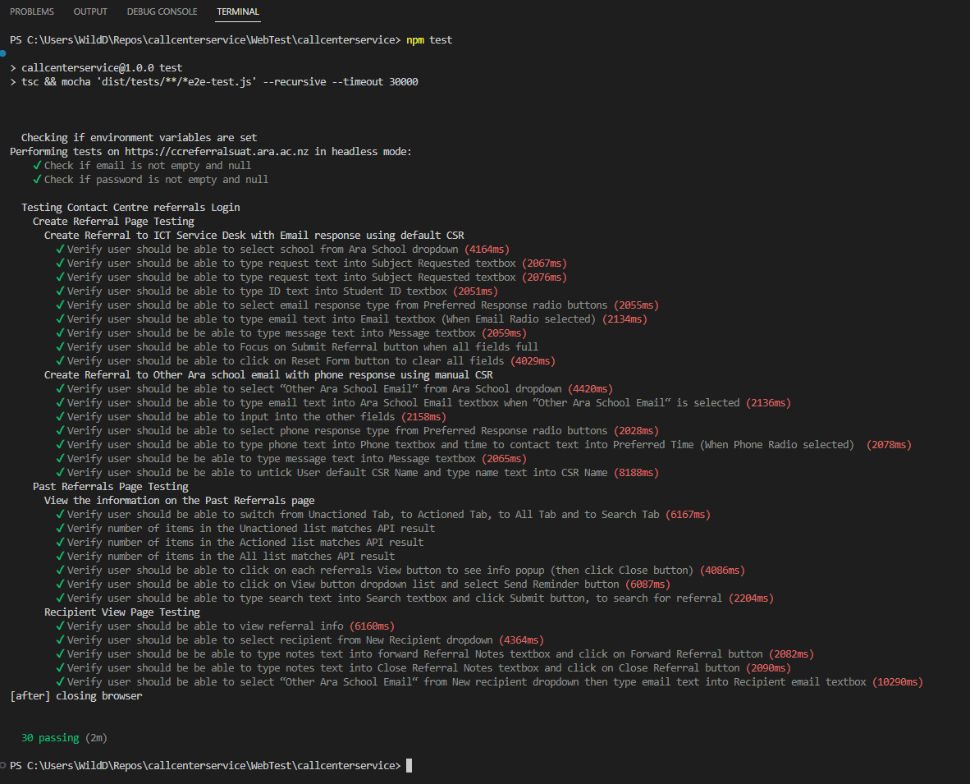

Figure 8 *Testing Suite 5 Output*

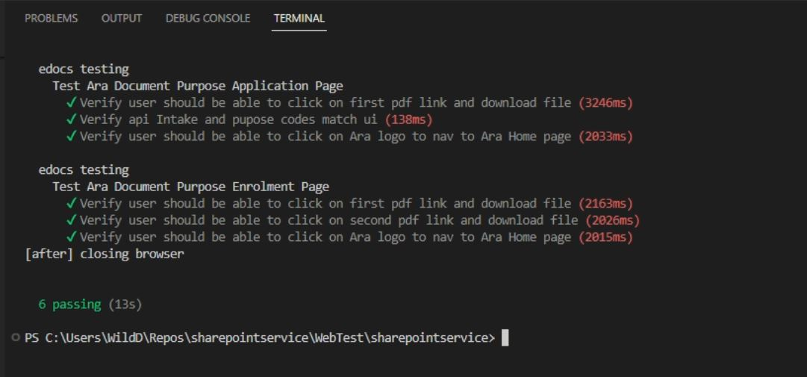

Figure 9 *Testing Suite 6 Output*

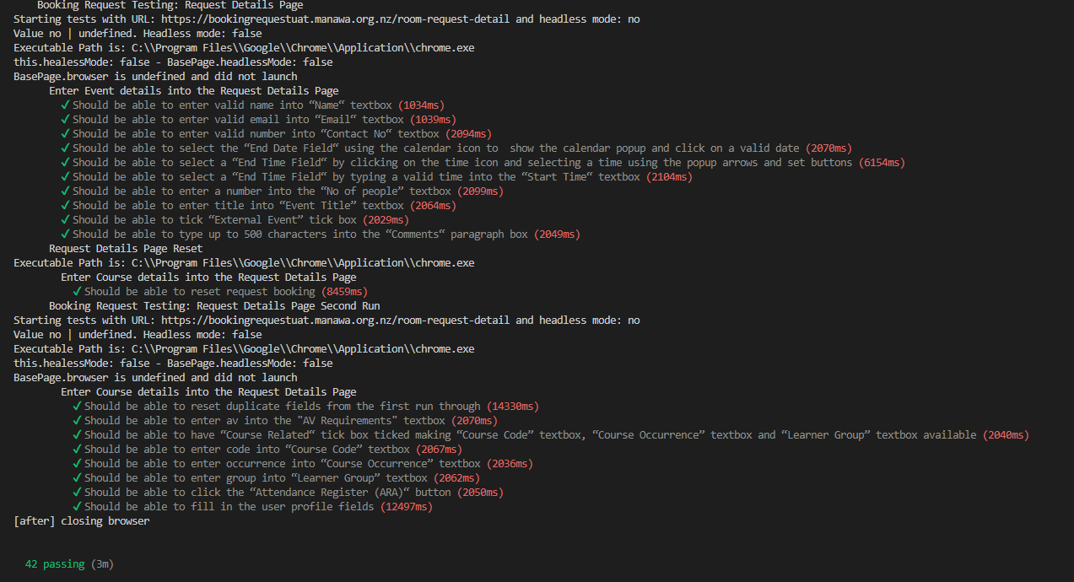

## Reflection

## Project Goal(s)

### Industry

Together with the work of both my industry supervisor and team members we were able to implement my testing suites into the deployment pipeline. This means we were able to achieve the goal of creating a deployment pipeline that needs minimal manual interference for the six react based web apps.

### Student

I am proud that I was able to complete all six apps in the timeframe, it looked like a lot of work going in, but I was able to get through it. I think my testing skills have improved a lot as I have learnt more about not only how to do effective testing but also reasons why it is important. I gained a lot of real word experience working in the industry that helped me get my head around things that have been talked about when studying. For example, we have been shown Agile and Kanban methodology in a few different classes, but it was not until I could see them in action and experience them for myself, did they start to make sense to me. I now understand why these methodologies are so important within industry. I would like to think my work and attitude have impressed both my industry supervisor and product owner, enough to achieve my goal of having them as satisfied clients that will be happy to act as referees in the future.

## Benefits of Project

### Industry

I believe the industry received what it was seeking, in terms of releases becoming more reliable and increased deployment efficiency as the tests are very closely linked to each apps workflow to make sure all functionalities are covered. This means that the automated pipeline should pick up any problems when tests fail and alert the team with an email. While I was working on the project, one of the other apps the team worked on broke during deployment after an unrelated feature had been updated. This took much time to troubleshoot. The team said a UI test would have picked it up during deployment and would have made the fix easier to find. This shows why the project was necessary and a benefit to the client.

### Student

I got the challenge I was originally looking for. My testing skills were pushed to much higher levels with the experience I gained. I am far more confident about the best ways to write mocha tests to make sure they are testing in the way they should be. I learned a lot about new tools like Puppeteer and Jenkins as explained in detail in the below Skills Section.

## Project Requirements

For each application tested a list of functionalities that need to be tested was created to form the basis of the testing suite, as shown below in Figure 10 *Testing Suite 6 List of functionalities*. These provided a guide that would be used to make a list of what web elements were needed for each function. This made creating the XPATH and puppeteer code for each test much easier. Allowing me to achieve the first two requirements List of functionalities and Automated testing suites as listed above in the proposal.

As each testing suite was complete it was code reviewed and then approved for merge into the development branch. Once this was done, I worked with the industry supervisor to integrate each into the deployment pipeline. This involved him setting up environmental variables so that the pipeline could get the right username, password, and URL for each app when it ran the tests. He also created the backend to send emails when tests failed. This along with a later change to how each page used a library of abstract interfaces instead of local versions caused some problems and confusion for me but we were able to get each to work in the end and achieve this requirement.

Research and discovery tasks of finding ways to test the seventh desktop-based app were optional stretch goals put in by the industry in case I completed all the other testing suites before my 300 hours were up and needed more work. As this was not the case, as I completed the six-testing suite just as my 300 hours were finished, the research and discovery tasks were removed from the requirements and put back into the team's work backlog.

## Expected Deliverables

### Industry

* Stand-up updates were successfully delivered each day.
* IS updates were successfully delivered each Friday meeting.
* Burndown, Weekly Reports and Risk updates were successfully delivered each Friday meeting.
* Testing code updates were shown during fortnightly Dev meeting and successfully delivered following each code review.

### Academic

* Work Integrated Learning Agreement, Project Proposal and Approval Document were successfully delivered after being reviewed by all stakeholders.
* Weekly Reports, Risk Assessment and QA were successfully delivered each week after being reviewed during AS and IS meetings.
* Halfway Report and Halfway Assessments were successfully delivered after being reviewed by all stakeholders.
* Final Report, Methodologies Essay, Poster, and Short Paper were successfully delivered after being reviewed by all stakeholders.
* Panel presentation was successfully delivered after being presented to the stakeholders.

Figure 10 *Testing Suite 6 List of functionalities*

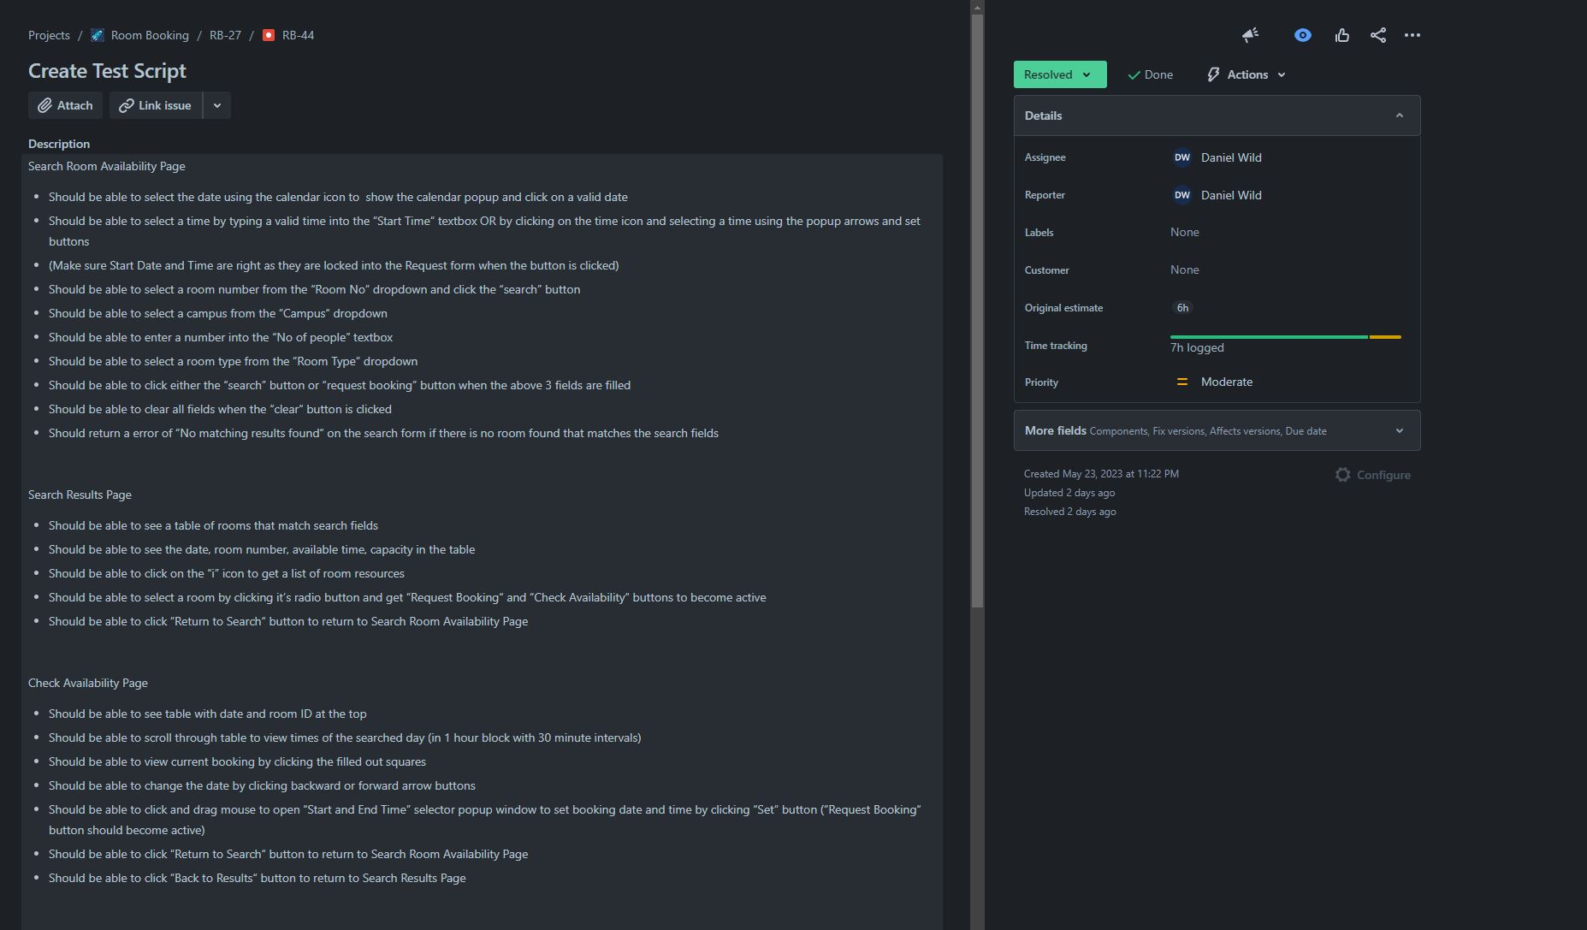

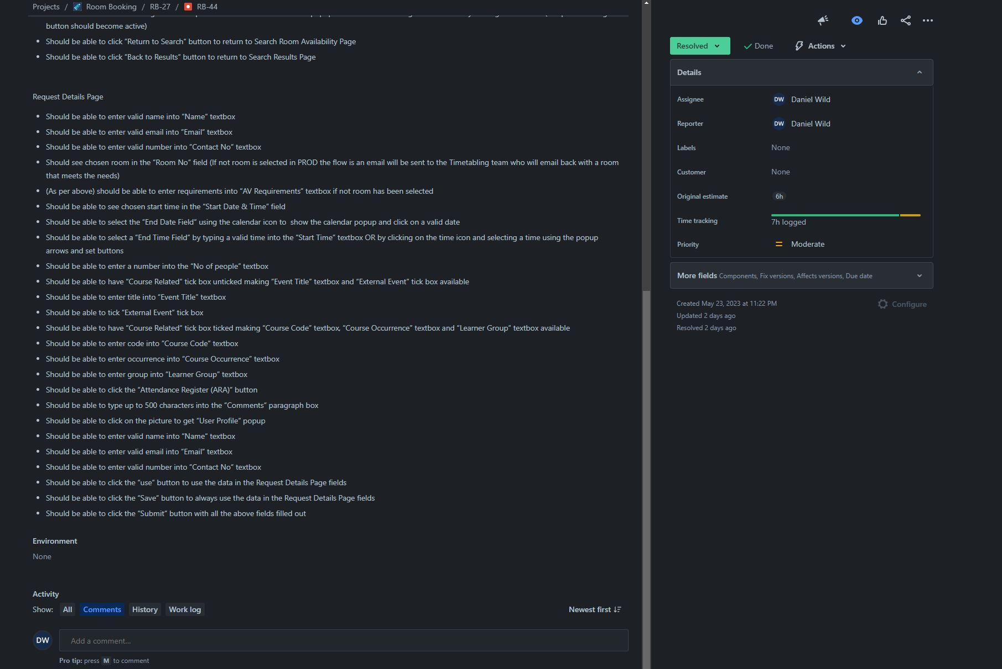

### What Went Well

Academically I am proud of the way I was able to keep up with the weekly updates and get the other deliverables into states where I am happy to hand them in while working thirty hours work weeks. I was very well organised and disciplined, making sure to update the weekly report, risk assessment, quality assurance and burndown charts every Monday afternoon. These would then be sent to my AS to review before our Tuesday meeting. I was also very good at scheduling writing time when the bigger deliverables needed to be done like the Halfway or Final report. I worked out that a maximum of an extra four-hour writing time after work was the perfect balance to get the work done but not burn myself out. This planning helped me to deliver the academic deliverables to a high standard.

Industry-wise I was able to get the more complex apps tested within less time than I thought I had originally. When I was writing my Halfway report, I thought I would have six sprints meaning I would have had an extra week worth of industry hours. However, that was not the case, so I ended up with one three-week sprint 5 with both apps 5 and 6 in it. This was a challenge as not only was app 6 very large but at the same time I was trying to gather as much evidence of my work as I could and at the same time update the other apps to work with the new pipeline integration. It was a challenge, but I was able to get both the complex app 6 tests done and get all the other apps ready to be integrated. Overall, a bit more time would have been nice, but I am happy with what I was able to achieve in my three hundred hours.

### What Didn’t Go Well

Academically I have continuously put myself in situations where I am writing my reports against the clock. With the Halfway report an extension was needed so that the supervisors could have time to give feedback and on the Final report I had just over a week to get it in three business days before the panel. This helps with motivation but does not help my stress levels. What I have learnt is there will always be a time crunch so the smart thing to do is to always be working on the reports in the background so that the crunch is reduced. This is something I would do if I had the chance to start this project over or something I would advise future capstone project students to do.

A lesson I have taken for the future from my industry work is about prioritising work. While working on app 6 I was given app 4 back to debug as an issue had been found during its deployment involving new code that had been added by my industry supervisor. He had given it to me as a chance to debug someone else’s code which I was also familiar with. Unfortunately, I struggled to debug the problem and after talking about it we said we would look at it again in the afternoon. I took that as a chance to go back and make some progress on app 6 but what he meant was to keep working on it and we will see where you are at this afternoon as this is the priority. I should have been more aware that since his work was waiting on me to solve the problem that it was a high priority or asked about the priority, but I did not think to. So, in future when presented with different tasks like that I will make sure to know what the priority is.

# Stakeholder Management

In this section, I will go more in-depth on the stakeholders for the project. Explaining who each of them is, how they fit into the hierarchy of the project, and how we will communicate throughout the project’s duration.

## Project Hierarchy

The below Tables identify the main stakeholders for the project. Table 1 *Industry Stakeholders* consists of the industry stakeholders from the Ara ICT Divisions team who work in T block of Ara’s Madras Street, City campus. They consist of Information Systems Manager Dean Patfield who will serve as the Product Owner and DevOps Administrator Vinay Varma who will serve as the Industry Supervisor. Table 2 *Academic Stakeholders* consists of the academic stakeholders who work mainly in S block of Ara’s Madras Street, City campus. Course Coordinator David Weir and Luofeng Xu who will serve as the Academic Supervisor. Table 3 *Student* consists of my information as student / Intern developer.

Table 1   
*Industry Stakeholders*

|  |  |  |
| --- | --- | --- |
| **Name** | **Role** | **Contact details** |
| Dean Patfield | Product Owner | Dean.Patfield@ara.ac.nz |
| Vinay Varma | Industry Supervisor | Vinay.Varma@ara.ac.nz |

Table 2   
*Academic Stakeholders*

|  |  |  |
| --- | --- | --- |
| **Name** | **Role** | **Contact details** |
| Dr. David Weir | Course Convenor | david.weir@ara.ac.nz |
| Dr. Luofeng Xu | Academic Supervisor | Luofeng.Xu@ara.ac.nz |

Table 3   
*Student*

|  |  |  |
| --- | --- | --- |
| **Name** | **Role** | **Contact details** |
| Daniel Wild | Student / Intern developer | djw0393@arastudent.ac.nz |

## Reporting and Meetings

### Industry

* Weekly Industry supervisor meeting with my industry supervisor Friday afternoons in the office to discuss the progress since our last meeting, any barriers to progress, areas of satisfaction or concern, and general reflections using the weekly report which will then be signed off.
* Daily morning stand-up meeting in the office or online with the ICT Division team to discuss progress and goals for the day.
* Developer and DevOps meeting Wednesdays 1-3 weekly in the office and online with the product owner to discuss overall team performance.
* Jira task updates and Bitbucket commits done by me in the office hourly to show what I am doing and what I have done.
* Daily status reports sent to my industry supervisor showing progress, risks registered, and issues raised.
* Microsoft Teams messaging is used to directly communicate with my industry supervisor or other dev team members to ask questions or get help solving issues.

### Academic

* Weekly Academic supervisor meeting with my academic supervisor Tuesday afternoons in his office to discuss the progress since our last meeting, any barriers to progress, areas of satisfaction or concern, and general reflections using the weekly report which will then be signed off.
* Stand-up update in class each Monday 3-5 and Thursday 1-3 with the Course Convenor to discuss changes in the project since the last meeting.
* Weekly emails on Monday to send through weekly reports before our meeting and to advise of any things I would like to discuss.

### Reports

* Daily stand-up with the product owner and my industry supervisor.
* Class stand-up with the Course Convenor.
* Weekly academic reports with my academic supervisor.
* Weekly industry reports with my industry supervisor.
* Weekly academic burndown charts for my academic supervisor.
* Weekly industry burndown charts for my industry supervisor.
* Weekly Risk management with my industry supervisor and my academic supervisor.
* QA with my industry supervisor and my academic supervisor.

## Halfway Report

## Updates

### Reporting and Meetings

Correction of the above list of industry meetings, the Developer meeting on Wednesdays is every 2 weeks 1 till 2. This meeting also is being used for me as my sprint review at the end of each sprint, which I use to show the team what I have been working on to get feedback, advice, and answer questions. While my Friday Industry meetings on those weeks are also used as sprint retrospectives in which we look back at what went well and did not go well in the last sprint well planning the next.

The way the weekly reports are used has been different than I expected. I thought that I would be filling out two each week during the weekly meetings one with my AS and one with my IS. In reality, it is one report I fill out on a Monday which I then send to my academic supervisor who goes through it with me in our Tuesday meetings. I go and make any needed changes and then show it to my industry supervisor in our Friday meeting in which we go through it again to confirm everything, and I make any changes needed later that day to create the final version for each week. I think this is good as it keeps us all on the same page and does not segment any problems into academic or industry as they could affect both sides. It also gives me the chance to keep all the other reporting documents like risk assessment, burndowns, and QA as up-to-date as possible since I am updating them three times each week.

## Reflection

### What Went Well

I think I have done a good up to this point keeping my stakeholders informed of my progress using the different documents I am keeping updated every week like the weekly reports, burndown charts, and the risk assessment. It has been a very agile and collaborative effort with both my academic supervisor and my industry supervisor contributing to the documents, with either updates to the sections of the documents that help to clarify the process or input into the reports with ideas or risks that I had not thought of. This has led to good discussions in both weekly meetings that have helped me to clarify things I did not understand or helped me think about the things I was struggling with differently.

### What Didn’t Go Well

I don’t think I did as well as I could of during the presentations at the Wednesday dev meetings. The first week I did not have anything functional to show as I had not done the tests end to end at that point so could only really show untested code well saying what I hope it would do. During that meeting the feedback was that you need to be able to test each bit of code works as intended which is where working on the tests end 2 end comes in. Meaning you get to work on software faster that can be presented to stakeholders. My industry supervisor also gave me the advice that you should avoid showing code as much as possible in presentations especially to groups of non-technical stakeholders as they do not understand the code, they just want to see working software. Which why we are implementing Agile, as one of the 12 principles is “Working software is the primary measure of progress”. I was able to implement this advice and was able to show many functioning tests at my second meeting which then allowed the team to give me more practical feedback which will help me during the next sprints.

## Final Report

## Final Summary

Overall, the stakeholders were managed using three main methods depending on who the stakeholder was.

The supervisors were kept informed using the weekly report in the weekly meetings. This was effective as it allowed them to view my thinking and progress using the reporting documents like the weekly reports or risk assessment, before discussing any questions or improvement they had with me during our meeting. This proved to be a very effective form of communication between myself, and the supervisor as updates each supervisor would make would be filtered through to the other, for evidence of this please see Table 45 *Weekly Progress Report at Week 11 (1/05/2023)* or see appendix G. This helped to keep the meetings as short as possible but also very beneficial to both of us. This was also helped by that fact that I was proactive and used my initiative with any problems either I or the supervisors encountered, as they were brought up by using either email or Microsoft Teams messages and later discussed during meeting if needed.

The Course Convenor and Product Owner were informed most effectively using their respective stand-up meetings. This allowed for a quick verbal summary of either what had been done and how many hours had been worked or what the goal was for the day, depending on the meeting. This helped keep meetings short but informative for all involved.

The Developer and DevOps Wednesday meetings were an effective way of showing the team what I had done and was planning to do with each testing suite. It also gave me valuable feedback and advice as team members would ask questions about both how the tests were while making suggestions about how they could function or how I could improve my presenting.

In summary each form of stakeholder management planned out in the Project Proposal along with the changes made during the Halfway report proved to be very beneficial in keeping everyone involved informed on my progress, while also helping me to improve my processes as I worked.

## Reflection

### What Went Well

As discussed in the above Halfway Stakeholder Reflection and below Halfway Professionalism sections one of my biggest challenges during the project has been confidence to speak both in stand-up meeting and when presenting. I think the experience I have gained during this project has helped me a lot with this and made me more confident in my communication skills. This has helped me to improve my stakeholder management skills as I have gone through this process, with me now feeling like my stakeholder management was a very effective aspect of my project.

### What Didn’t Go Well

As discussed in the Halfway report Methodology Reflection section my methods of time tracking became very spread out and disjointed between hours written in my notebook, added into each Jira sub task, and added to my task breakdown spreadsheet. This was somewhat cleaned up after that report with the use of the notebook being introduced in favour of Jira tracking, but it still left data duplication and inconsistencies. With the knowledge I have now, I believe that the Jira tracking is something only I would look at, and I would show anyone else who asked, my breakdown spreadsheet. For future projects or if I had the chance to do the project again, I would make sure to only have one hour tracking system that both fits into my project management methodology and can be used to inform stakeholders.

# Student Skills

In this section, I will go more in-depth on the skills required for the project. Explaining what each of them is, which class they were covered in, and how I will learn new skills during the project.

## General Skills Required

* Communication
* Teamwork
* Individual work
* Time management
* Report writing
* Risk assessment
* Planning
* Project management
* Quality Assurance
* Professionalism
* Ethics
* Willingness to learn.
* Handle criticism
* Self-refection
* Problem-solving

## ICT-Specific Skills Required

* JavaScript
* Typescript
* Unit Testing
* Puppeteer
* Test Automation
* Git version control (bitbucket)
* Development Methodology (Agile scrum, Kanban)

## Skills from Relevant L6 and L7 Courses

* BCDE211 Best Programming Practices (Web and Mobile Development) – JavaScript, Typescript, Unit Testing.
* BCDE321 Advanced Programming - Git version control, Unit Testing, Teamwork, Individual work, Time management.
* BCDE311 Software Development Project - Report writing, Risk assessment, Planning, Quality Assurance, Professionalism, Ethics, Teamwork, and Time management.

## Approach to Learning New Skills

During the industry work learning new skills will be based on my communication skills. At first, there will be a lot of techniques and skills to either learn like Puppeteer, the automation process, and bitbucket, or refamiliarize myself with JavaScript and Typescript so that will mean lots of asking questions and note-taking with my industry supervisor or other team members. From there I will read my notes or other material and practice those things in my own time. On top of that small roadblocks will be brought up during the daily stand-up meetings while I am also keeping live documents of updated questions to ask either my academic or Industry supervisors.

Academically concepts that are part of the project proposal and future versions of the report are either introduced or reintroduced from old classes in class each week. I take notes and save the documents to study later to be applied as I work on each part of the report while also updating the live document of questions to ask during the weekly academic supervisor meetings.

## Halfway Report

## Updates

### General Skills Required

Over the last four weeks doing the industry work has reinforced for me the most important general skills are communication and time management. You need to be able to keep track of what you have done each hour so that you can report it in the stand-up meetings the next day and plan out what you will be doing that day. You also need to be able to keep track of how long you stay stuck on a problem if you cannot solve it within an hour you probably will not be able to solve it quickly in the next hour so you need to either communicate that you need help or be able to change the task you are time managing to go onto something else so you can come back and try and solve your problem later.

### ICT-Specific Skills Required

Some ICT skills that I have used that I did not expect when I did the project proposal are:

* XPATH
* Jenkins Development Pipelines
* API’s
* Mocha chai
* Node.js
* HTML
* Java
* Selenium

Some of the above were things that I had never used or heard of before but have learned to use during my sprints to this point. For example, XPATH which is a Selenium technique used to navigate through HTMl structure to dynamically search for an element within a web page. For our purpose we use it to create an HTML path in the Typescript testing code to the tested websites features like buttons or text boxes so that I can tell the automation to put specific text in the right textbox and click the enter button.

Another example of this is Jenkins which is an automation server which acts as a pipeline for each apps CI and CD process. Each app contains a file that serves as a set of instructions used to build each app during deployment. Meaning that with my code added my tests become part of the continuous deployment each web app goes through when they are deployed. This can either mean the changes are deployed to the User Acceptance Testing (UAT) or the production version of the app (PROD) which I have learned about as I went through the process. UAT means User Acceptance Testing which is the version of the site that is not accessible to the public but is used to test in real-world situations as explained by Stanford University (n.d.). This is where I have done most of my work to build my tests but once they are all given the quality assurance acceptance they are built and deployed to PROD.

The rest of the things on the list were things I have used in the past but did not think would be required skills when I created my Project proposal. For example, Java and HTML both are required to be read instead of written to find things that I need for my testing, HTML is used to find the XPATH website features as stated in the above paragraph while Java is used to find API code which I need to pull data from the site backends so that they can be compared to what is on the site frontend during my tests.

### Skills from Relevant L6 and L7 Courses

After getting feedback on my Project Proposal from the Course Convenor in which he advised that the above section was not done very well and that there are much more relevant skills from many more courses I have done I decided to go through all my files of all the level six and seven courses I have done and find revenant skills that were either taught to me or expanded during the direction of each course. With this info, I created the below Table 4 *Skills From Courses* which links skills that I have found revenant to my project to this point to the courses I completed at Ara while doing levels six and seven courses.

Table 4  
*Skills From Courses*

|  |  |  |
| --- | --- | --- |
| Course Level and Name | Skills Learnt | Relevance to Project |
| Level 6 - BCDE211 Best Programming Practices (Web and Mobile Development) | JavaScript, Typescript, Unit Testing, Problem-solving, HTML, Node.js, Selenium | Used in helping teach me the skills needed to develop the tests and solve problems. |
| Level 6 - BCDE223 Best Programming Practices (Java) | Java, Unit Testing, Development Methodology, Problem-solving, Node.js, Selenium | Used to read the app code to get an idea of functionality that needs to be tested. |
| Level 6 - BCIS208 IT Service Management | Communication, Teamwork, Planning, Risk assessment | Used in helping teach me the skills needed to work and communicate with the supervisors around hours planning, risk management and QA |
| Level 6 - BCIS207 Enterprise Solutions Deployment | Report writing, Risk assessment, Project management | Used in helping teach me the skills used to both track the project and write reports about my progress. |
| Level 6 - BCDE214 Database Administration | Problem-solving, version control, Development Methodology, Time management | Used in helping teach me the skills I have used to implement version control on my work and work through deployments. |
| Level 6 - BCDE215 Web Development | HTML, Unit Testing, Problem-solving | Used in helping to expand my knowledge of HTML which I need to look through to find element XPATH. |
| Level 6 - BCDE213 Interactive Media Development | Individual work, Communication, Time management, Report writing, Planning, Project management, Quality Assurance, Problem-solving, Development Methodology | Used in helping give me experience in time and project management which have been crucial doing the project. |
| Level 6 - BCDE222 Best Programming Practices (C# .NET) | Problem-solving, Unit Testing, Development Methodology, Planning, Time management | Used in helping give me experience in the testing a development method I have used during the project. |
| Level 6 - BCDE224 Best Programming Practices (Server-Side Programming - PHP) | Problem-solving, Unit Testing, Development Methodology, Planning, Time management, APIs | Used in helping give me experience in working with APIs which I use to compare to my tested UI in the project. |
| Level 7 - BCDE321 Advanced Programming | Git version control, Unit Testing, Teamwork, Individual work, Time management, Problem-solving | Used in giving me experience working with others in Git version control environments and doing code reviews on our work. |
| Level 7 - BCIS303 Information Technology Governance | Problem-solving, Willingness to learn, Self-refection, Professionalism, Project management, Planning, Time management, Teamwork | Used skills learnt in report writing to talk about my Willingness to learn, Self-refection, and Professionalism. |
| Level 7 - BCDE311 Software Development Project | Individual work, Communication, Time management, Report writing, Planning, Project management, Quality Assurance, Problem-solving, Development Methodology | Used in helping give me experience in the most important parts of project management which have been crucial doing the project. |
| Level 7 - BCIS302 Managing Information and Cybersecurity | Problem-solving, Willingness to learn, Self-refection, Professionalism, Project management, Planning, Time management, Teamwork | Used skills learnt in problem-solving how users use each app. |

### Approach to Learning New Skills

During the completion of my first testing suite during sprints 1 and 2 I have done a lot of my learning via links to websites or YouTube videos sent to me by Development team members when I have specific questions about things like how XPATH works. This worked well for the first weeks as I did not feel comfortable doing these things without asking questions as I did not know much about them, but now with some experience my industry supervisor and I have agreed that more of that kind of learning should be able to be moved to research in my own time that can be implemented during work time so that I am be more efficient doing must onsite industry hours to give me the best possible chance of both learning as much as I can and completing all the project scoped work within my 300 hours.

## Reflection

### What Went Well

Every day I am gaining more experience and skills in talking about and presenting my work. Each day during stand-up I can convey what work I completed the day before and what I plan to do during the current day. I have also to this point twice presented my work to the Dev team during our fortnightly meeting which I have treated as a sprint retrospective. During each, I have shown the team my code and working tests while explaining future features, and next steps and taking questions or feedback. Giving me practice and making me more confident for the final panel presentation.

I learned a lot of new things like XPATH and Jenkins, what they are how they are written, and the best practice of how to implement them. Got industry experience creating automation of testing and first-hand experience seeing CI/CD pipelines. I learned new angles to skills that I already had like HTML, Java, Node.js, and Mocha Chai by seeing different ways that they can be used. I was also able to do a reflection on all the different courses I have done during my studies and link them to skills that I am now using during my project and will continue to use in my future industry work.

### What Didn’t Go Well

There were skills that I thought I had from the above lists that I either had forgotten or they did not make sense until I worked with them within an industry framework.

For example, Agile focuses on delivering working software as the primary measure of progress. During my first sprint, the sub-tasks for creating the testing suite were broken down for me and added to my Kanban Board. I then worked on those tasks in a more Waterfall mindset with the idea that creating the page models would lead to creating the page objects and so on till I had working tests. Meaning by the end of the first sprint I had lots of lines of code that I did not know if they were functional or not. The process is far more agile in that each test should go through each sub-task end to end until it is a working test. At which time I can move on to the next. This is the process I have implemented during sprint 2 and will continue into future sprints.

Another example was my use of Git, something I have mostly used individually or in team scenarios where we would share the initial base code but then go off and expand on it as individuals never needing to merge the code back together. Meaning when it came to important things like branching, pushing, and pulling I made mistakes. When I finished my first testing suite and we needed to merge it with the main development branch we ran into a lot of problems. Somehow, I had not branched my original local version from the right place meaning when it came to merging Bitbucket refused as the two branches did not share a common ancestor this meant the merge had to be done manually by comparing the two versions of each file. I was also only committing my changes to the local version of the branch, not the pushed online version, and was not pulling meaning other team members’ work was committed putting my version out of sync. This also meant that I put my work at risk as if my machine had broken all my work would have been gone. However, these issues have been fixed and addressed and I have made steps to make sure I implement best-practice version control going forward.

## Final Report

## Course Evaluation

BCDE211, BCDE223, BCDE215, BCDE222, and BCDE321 are programming courses designed to teach students how to code to industry standards to produce commercially viable software while learning how to resolve pragmatic issues.

As per the above Table 4 they helped to develop my skills in various programming languages while helping me learn testing and problem-solving skills that proved crucial during the duration of my project. For example, while creating one test I would read through HTML code to find a XPATH element, read through the sites JavaScript to find their data API, write Typescript code to run Puppeteer actions in the browser, create Mocha tests to make sure the action could be completed using a Boolean and finally problem solve to find the reason that tested failed. All of these are part of skills I learnt well in these courses which I applied regularly during my project.

A recommendation I would make that would have helped me in my project is if the courses had focus more on both testing and debugging. Going into the project I was not very confident when it came to testing, as in the courses testing had either been the focus of an assessment where the tests had already been created and we needed to make them pass or was a thing we created to get extra marks after already getting most marks from creating a solution. I think an assessment that focuses on creating tests using industry best practices and talking about how they work or why they are important would be very beneficial to future students. I also think an assessment based on debugging would be very beneficial. BCDE211 showed us how to page break our code to show if code was working correctly and how this could be used to find problems in our code. However, we were never tasked with debugging other people’s complex code. This is something I was tasked with during my project and struggled with. I think an assessment focus on the best practices of debugging complex code would be very useful to be added to many of the programming courses and would have helped me during my project.

BCIS208, BCIS207, BCIS303 and BCIS302 are information system courses designed to teach students knowledge of, and ways to apply various methods of, deploying information technology solutions including methodologies for integrating IT solutions, while learning to strategically analyse and evaluate IT solutions.

As per the above Table 4 they helped to develop my skills in Report writing, Communication, Planning, Project management and Time management. Going into the project I was confident about my writing, planning, and management skills because I had gained a lot of experience doing each to complete different assignments across the above IS courses. Throughout the level six and seven courses I learnt all the skills I needed for my capstone project, I just needed to be able to apply them within a real-world environment.

A recommendation I would make that would have helped me in my project is if the course had found ways to have students experience Agile Methodologies in more realistic environments. For me I remember writing lots of notes and talking a lot about Agile, but it did not make sense to me until I was experiencing it in a real workplace. For example, when I broke my first testing suite down into sub tasks, I thought they were steps that needed to be completed to create working tests. In doing this I created a series of pages of code that did nothing. The reality was each sub task was an Agile task that would be completed in a loop until a working test was created, then the process started again for the next test. Once I realised this, the functioning tests were created quickly, and I was working in an Agile way instead of a Waterfall way. I think more assessment based around these real-world scenarios would allow students to put the theory they are given into practice which will help them learn Agile quicker.

BCDE213, BCDE224, and BCDE311 are courses designed to help students get ready for the capstone project by simulating what the development process will be like and introducing students to the reporting tools that will used and the levels of reporting required in the final project.

As per the above Table 4 they helped to develop my skills like Time management, Report writing, Planning, Project management, Quality Assurance, and Development Methodology. For me the academic side of my project was shaped by these courses, and I chose the Project Plan, Risk Assessment, Quality Assurance, and other crucial reporting documents I used to keep my stakeholders up to date on my progress, based on the experience I gained with them during these courses. Though many of them were evaluated and changed throughout the capstone the experience with them before this project was highly valuable.

A recommendation I would make that would have helped me in my project is adding an organised team project to the BCDE311 course that makes the students have Agile roles and use version control. The reason for this is that during my project I made mistakes around version control. Prior to doing the project I had only used version control in an environment where either only me or one other person was working on the same project. This means it does not make much difference if you forget to commit your changes for a while or go off and work on a new feature, because there will be little chance of causing clashes in the code. However, when in a real-world team environment, you can have many people in a team working on the same piece of software on different branches. If you are not careful to make sure you are regularly pulling and pushing your branch, you will run into a lot of code clashes that need to be resolved when you try to merge your branch back into main. I think an assessment that puts students into real-world development team environments, getting them used to good version control branching practices, would have been very beneficial to me before I did my project.

I believe all these recommendations could be effectively adopted with a small update to either BCDE213’s or BCDE311’s assessment 3. They both already simulate the Capstone project structure so changing it to be more of a realistic structure where teams of students in set role use an Agile Methodology and version control tool of their choosing would not be a large change. While a project based around all students either creating or testing different parts of an application would make debugging skills essential. If it functioned like how Tech Colab does now with the tutors as the supervisors of a real project that is too small to be a Capstone, I believe it would be a very beneficial addition to the degree.

## Final Summary

In summary, during my project many of the skills I already had were tested and enhanced as I also gained new skills which were needed to complete the scope of the project. In this section I will list all the skills I needed to complete my project, then will go in depth with two examples of the most important skills I needed from each type of skills. During which I will be explaining if I had the skills before or gained it during the project and how my experience either helped me learn the new skills or expand on the skills I already had.

### General Skills

The general skills that I needed for my project were:

* Communication
* Teamwork
* Individual work
* Time management
* Report writing
* Risk assessment
* Planning
* Project management
* Quality Assurance
* Professionalism
* Ethics
* Willingness to learn.
* Handle criticism
* Self-refection
* Problem-solving
* Stakeholder management

During the duration of my project the communication skills I already had have been greatly increased by my experience. Prior to my project I was always nervous and lacking confidence when communicating what work I had done. However, through daily experience of stand-up meetings, I have gained more confidence in communication of my progress. I achieved this by using detailed note taking in a book while I worked. This allowed me to both track what I had done each day for my reporting documents and allowed me to create short summaries that I could uses as bullet point guides to communicate in stand-up what I had done and what I planned to do. This process was very beneficial and is something I will use during future projects.

Prior to the project I had no experience of Stakeholder Management. Over the duration of the project, I learnt ways of managing stakeholders both as a collective and as individuals. This involved learning the ways I would interact with each stakeholder and finding the right reporting tool to use to communicate to them the information they wanted. I learnt this by talking with each of them during our meetings. For example, as explained in the Halfway Report Update Stakeholder Section I originally believed that the weekly report would be filled out as two separate reports with each supervisor as I thought they would want to split it between information about my academic and industry work. However, the process quickly changed to one report that would be discussed and updated at each meeting as they believed information like barriers to process would be relevant to both sides of the project. This process covered many of the skills listed above like time management, risk assessment, and quality assurance which make up overall project management of which I have learnt a lot about and gained experience which will be useful going forward in my career.

### ICT-Specific Skills

The ICT-specific skills that I needed for my project were:

* Typescript
* JavaScript
* UI Testing
* Puppeteer
* Test Automation
* Git version control (bitbucket)
* Development Methodology (Kanban)
* XPATH
* Jenkins Development Pipelines
* API’s
* Mocha chai
* Node.js
* HTML
* Java
* Selenium
* Linting
* Terminal commands
* Debugging

I experienced each of these as part of my project, some I had learnt in the courses above in Table 4, but my project work experience helped to teach me much more about them or I experienced them for the first time while working on the project.

I had some experience with Mocha tests before the project started. However, prior to the project, my output of Mocha tests was very basic. I could do very simple things like write code to give a variable a value then test whether is not null to make sure it got a value, then test that value against a hard coded value to make sure it got the right value. For example, expect(name).to.be.not.null; then expect(name).to.be.equal.to(‘Daniel’); this is alright if the value is always going to be Daniel but in a dynamic website used by different people it won’t be. What I learnt to do was create a test that can do many actions with an input then compare the results to the backend API. For example, the test will find the name textbox and input a valid name then, find the search button and click it. If this action can be done a Boolean will return a true, then the UI value that is found in the search will be compared to the site’s backend API, which if they are the same will pass the test. This makes for a set of tests that are much more effective at simulating user behaviour and having test coverage overall site functionalities. This improvement in testing skills was gained by a mix of trial and error as I worked on the tests and help from teammates both through asking them questions or them showing me examples from other tested apps. This process helped me to improve many of the skills I already had thanks to learning from the experience of my teammates.

Prior to the project I had no experience of Development Pipelines other than hearing the term in passing. As I worked through the project, I learnt about Jenkins as detailed in the above Halfway ICT-Specific Skills Section. However, as I went, I learnt a lot about deployment in ICT. I experienced the fact that just because code works on your local machine it does not mean it will work in the deployment environment. Often all the tests would work for me but fail in the pipeline, with the issue being that the code in the interface of my machine was pointing to the local storge of Chrome whereas the pipeline had it stored in a different place, meaning the pipeline could not open Chrome, so the tests failed. This led to all my testing suites being changed to use global variables so that all variables like login details and paths to Chrome are set at the start of a session either by the pipeline or locally. It also led to the interfaces being taken out of each individual testing suite and turned into a dependency library that is download to each, meaning if the code changes for one app it changes for all of them which cut out code duplication. What this process gave me was skills in overall software deployment teaching me that you cannot guarantee things will work on all machines just because it works locally and to be wary of hard coding values and code duplication. I learnt this from trial and error as I deployed a finished testing suite and from sitting with my industry supervisor as we watched a deployment and he explained to me what was happening. This process was a big challenge during the closing stages of my project and what I learnt I will carry on with me into future projects.

## Reflection

### What Went Well

As detailed above during my project I have had many experiences that have taught me many lessons to take into the future and improved many of my skills. I have improved my ICT-specific and general skills like testing and communication greatly and learnt new skills like stakeholder management and deployment pipelines. I also think my academic skills have been greatly improved as I worked through the creation and feedback process with my stakeholder on each of the variations of the reports and other deliverables created during the project. Overall, the project has been a very beneficial process that has not only given me experience to put on my CV but also helped get my skills ready for my future employment.

### What Didn’t Go Well

As explained above my skills in both version control and debugging were weaknesses I discovered while working on my project. They are both very important parts of development teams which I struggled with during my project causing me to lose time that could have been focussed on either getting the project done sooner or being able to work on the desktop app stretch goal. I have made detailed notes about what I did wrong and learnt when encountering these problems and this something I will continue to investigate to try and improve on in the future. If I could do the project over again, I would make sure I was more prepared for these barriers to my progress so that I could resolve the issues faster.

# Project Plan – High Level

In this section, I will go more in-depth on the project plan. Explaining what each phase of the project will be using diagrams, showing the timetable with forecasted hours and the project plan breaking down each phase shown into tasks per deliverable.

## Phases

Kanbanize (2023) explained that agile project management is an iterative process of managing requirements within a project. It focuses on flexibility, frequent value delivery, and fast feedback. The goal of using agile to manage your projects is an ability to adapt quickly and make changes when requirements change rapidly. Agile project management allows teams to collaborate more effectively and produce better-quality work. The Agile cycle of continuous adaption is made up of five phases as seen in Figure 11 *Agile Project Management Phases* below. These will be used to manage both the academic and industry deliverables over the duration of the project.

Figure 11   
*Agile Project Management Phases*

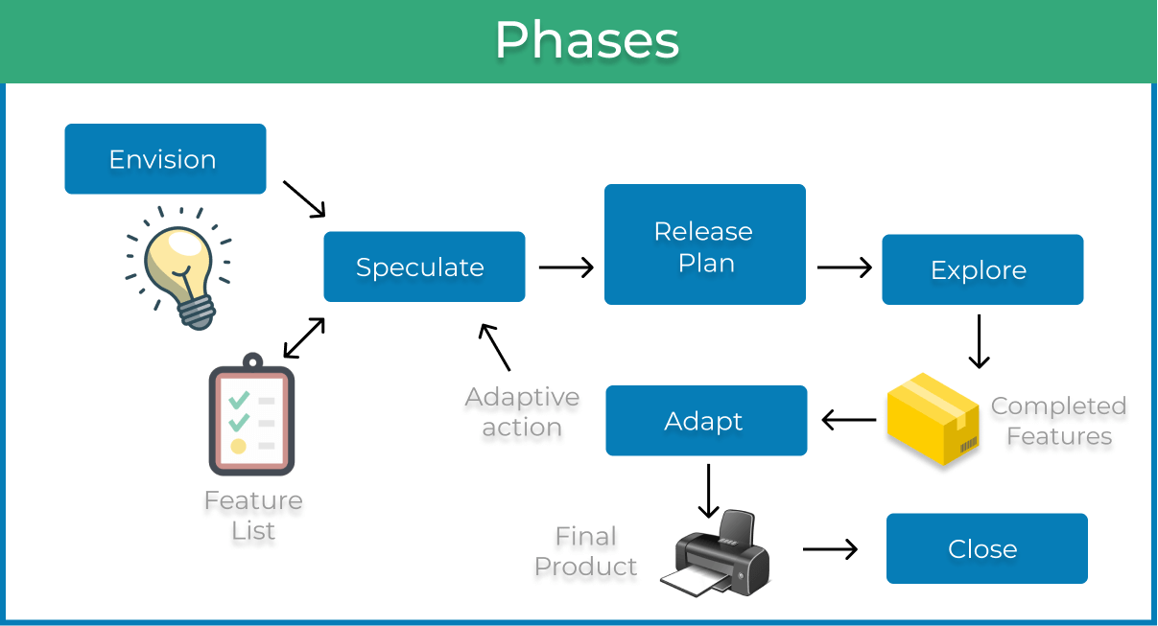

*Note.* Diagram showing the phases of the Agile Project Management Phases created by (Kanbanize, 2023).

### Envision Phase

Chandana (2023) explained the envision phase starts with the creation of a high-level vision for the project. The client identifies the key capabilities they want the project to achieve by detailing their objectives or the business problem they wish to solve. From this, the project participants and stakeholders are identified.

### Speculate Phase

Chandana (2023) explained the speculation phase starts with the high-level project vision being translated into requirements the team can use to create a plan. From this, requirements are determined and a backlog of tasks is created. The speculation phase should produce a high-level release plan for the stakeholders, user stories for the team to understand requirements, and high-level milestones to speculate how long each feature will take to create.

### Explore Phase

Chandana (2023) explained the explore phase starts with agile team members exploring ways to fulfil the requirements of a project. The high-level release plan is turned into an iteration plan and the release plan. User stories are turned into tasks that make up deliverables that can be tested, then iterated on, or released.

### Adapt Phase

Chandana (2023) explained the adapt phase starts with the deliverables being adapted using customer feedback. The team reviews the results of the last execution, the current situation, and the performance of the team during the last iteration against the plan. The requirements, project approach, process, and objectives are adapted based on stakeholder feedback.

### Close Phase

Chandana (2023) explained the close phase starts with all the deliverables being completed and released. The team reviews the overall process so that lessons learned can be used to improve the next project going forward into the future.

### Continuous Improvement

Kanbanize (2023) explained work should be broken down into small deliverables that are continuously handed over to the customer for their examination and feedback. This engages agile team members in cycles of frequent learning as the project is developed ensuring improvements occur while the project is still in motion, see the below Figure 12 *Continuous Improvement Diagram*. This will be done by my supervisors and me each week, as I hand over to them my code, risk assessment, quality assurance, and reports for feedback and recommendations on improvements for the next iterations.

Figure 12   
*Continuous Improvement Diagram*

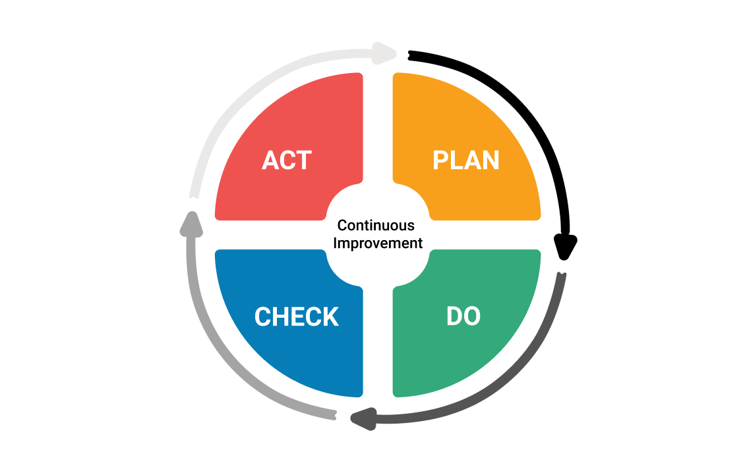

*Note.* Diagram showing the continuous improvement diagram created by (Kanbanize, 2023).

These phases will make up the bases of my overall course management. As per below Table 7 each of my academic tasks have been linked to one of the above phases. The duration of these phase will be tracked using my project planning spreadsheet which is made up of tab containing Table 5, Table 6, Figure 14 and Figure 15. These will be used to track my progress by hours and make sure I am on track to meet my 150 academic and 300 industry hours. This process will be repeated three times in a loop for each of the overall academic deliverables. This Proposal will start at the Speculate Phase and Explore Phase as I form my ideas around it and create the solution. It will then be sent to the stakeholders for feedback which puts it into the Adapt Phase once the feedback has been returned to me and can be implemented. This phase will repeat using the Continuous Improvement framework on each small section of the report until all stakeholders are happy to sign off on the proposal, at which point it will be handed in and be put into the Close Phase. This process will then start again for both the halfway and final reports starting with the Speculate Phase where the improvements and feedback given to the last report will be the base of the next interaction. The industry deliverables will follow the same structure apart from being tracked using sprints. The deliverables during each sprint will be determined, planned out and created while in the Envision Speculate and Explore phase respectively then will go through the Continuous Improvement framework during the Adapt phase until they meet industry standards at which point they will pass the quality assurance tests set for them as per the below QA section.

## Timetable

Below are figures showing the different parts of the project plan I have created to get an initial estimate of what my forecasted hours per week in both industry and academic will be from the project start date of the 27th of March 2023. There is a total work budget of a minimum of 450 hours across both academic and industry work. With a split of 300 hours of industry work and a minimum of 150 Academic hours though some people will need more as shown below in Tables 4 and 5. This is updated weekly with the actual hours worked in both industry and academia so that they can be compared to the planned hours (see Appendix A).

Averbuch (2022) explained why weekly scheduling is a tricky skill to master and how a template can help teams plan their workload. This information was used to create the template used in Table 5 and Table 6. As seen in Figure 13 *Initial Weekly Schedule Plan*, with an estimated 30 hours a week of industry hours broken down into three hours Monday and Thursday, 7 hours Tuesday, and 8 hours Wednesday and Friday I estimated that my halfway point of 150 industry hours worked will be around the week of the 10th of April.

As per Figure 14 *Industry Burndown Chart at Week 5 Ending 26/03/2023*, my industry work predicted finish date is around the 4th of June 2023 while academic work is predicted to continue till the week ending on the 18th of June 2023 as per Figure 15 *Academic Burndown Chart at Week 5 Ending 26/03/2023*. Each of these burndown charts is updated each week with the actual hours worked as seen in Figure 14 and Figure 15 so that the results can be graphed each week (see Appendix B for Industry and Appendix C for Academic). There is also an alternative plan I will execute if needed when the academic work needs to be focused on like during the halfway stage when the halfway report needs to be done. I will reduce industry hours to 21 and increase academic to 16 by working Friday from home after attending a stand-up over MS Teams.

Figure 13  
*Initial Weekly Schedule Plan*

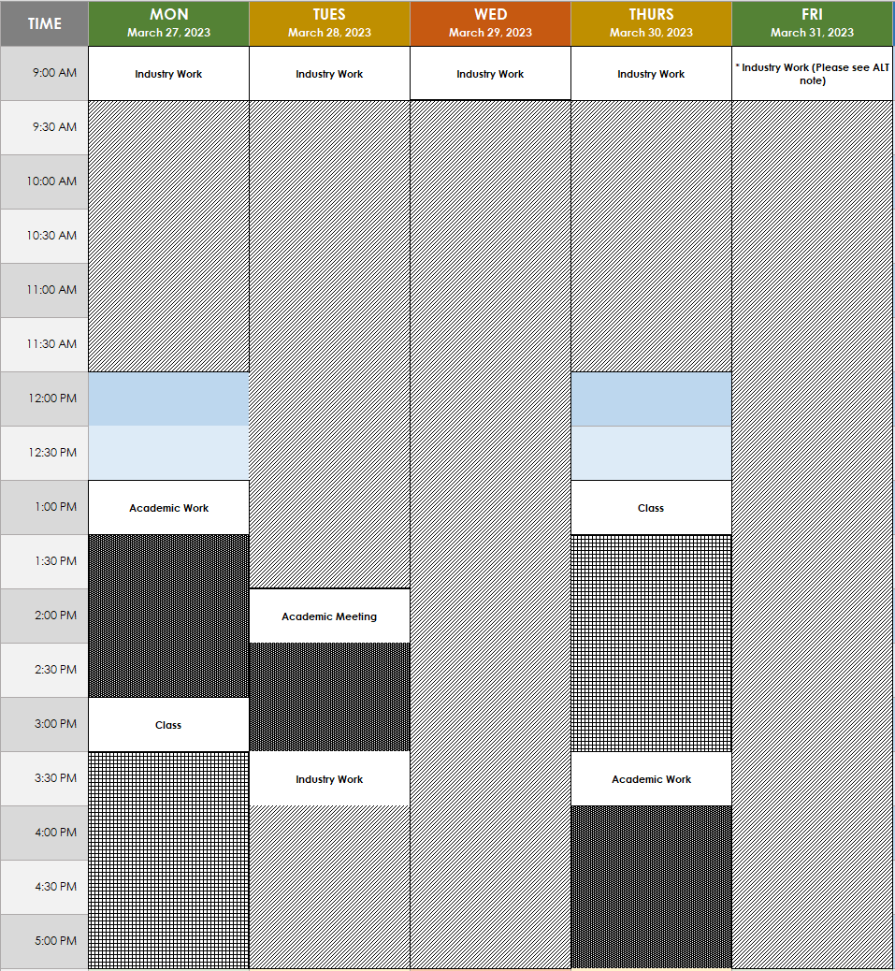

*Note.* Diagram created by me to show the break of the hours I plan to work on the parts of the project with each pattern representing the time spend doing the above work stated in the textbox.

Table 5  
*Industry Project Timetable at Week 5 Ending 26/03/2023*

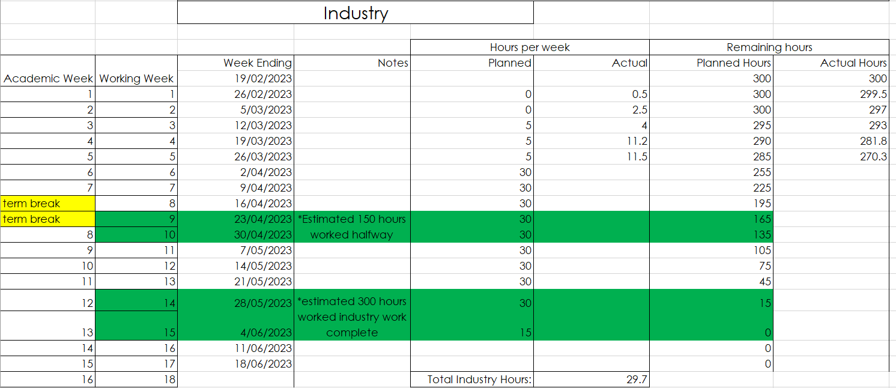

Table 6  
*Academic Project Timetable at Week 5 Ending 26/03/2023*

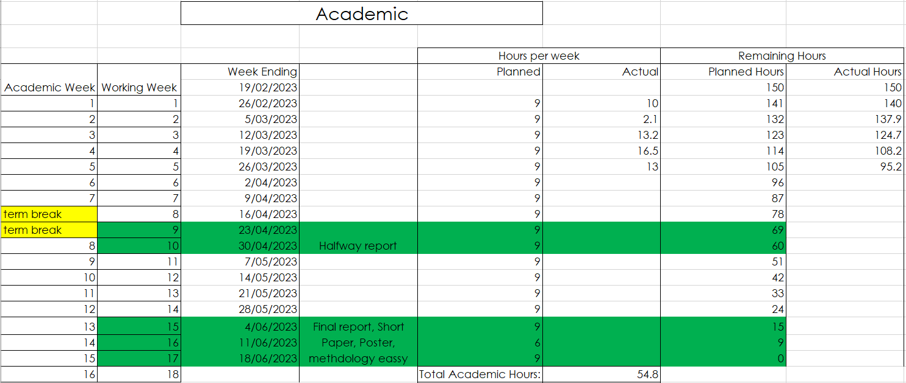

## Burndown Charts

### Industry

Figure 14 *Industry Burndown Chart at Week 5 Ending 26/03/2023*

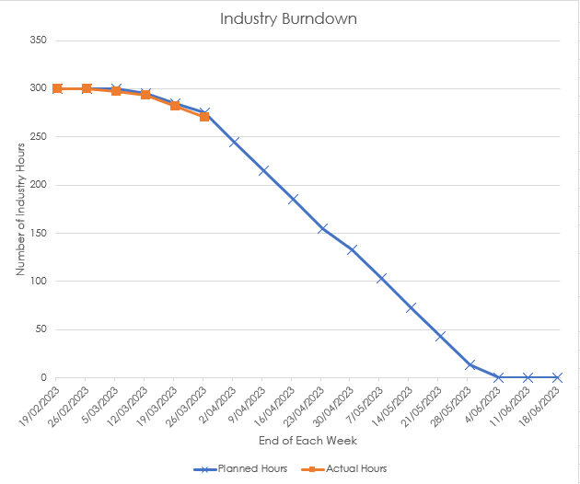

### Academic

Figure 15  
*Academic Burndown Chart at Week 5 Ending 26/03/2023*

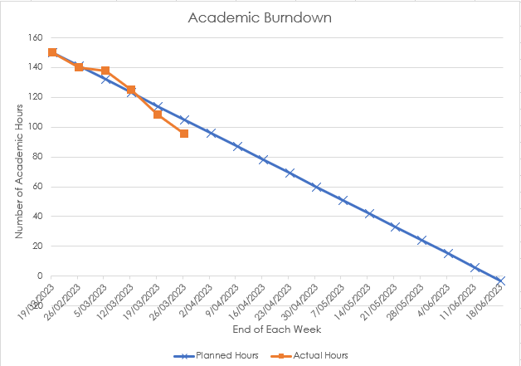

The above Table 5 *Industry Project Timetable at Week 5 Ending 26/03/2023* and Figure 14 shows that my industry hours as of Week 4 are on target as planned if not slightly ahead.

While Table 6 *Academic Project Timetable at Week 5 Ending 26/03/2023* and Figure 15 show academic hours are much more variable with week 2 much less than the planned 9 hours with 2 hours done and the rest of the weeks much higher than the planned 9 with 13 – 16 hours done in weeks 3, 4 and 5. This means the overall hours done are very close to planned but the weekly is very different.

## Resources/Access Required

* Office computer
* Ara staff email/login
* Staff security card for T block
* Microsoft Teams communication
* Access to the team’s project management software Jira
* Internal development software and current code
* Access to the team’s bitbucket version control

## Detailed Project Plan

The detailed project plan breaks down my estimation of the deliverables that are required during each phase and the tasks that make up each deliverable if that is applicable. Each then has an estimated time they will take to complete and a date they will be complete. This will be reviewed each week with an actual time taken and date added so that an hour variance from the current 450 hours estimated can be calculated as shown in Table 7, Table 8 and Table 9 below. Table 7 and Table 8 show the academic deliverables organised into the agile project management phases so that each can be tracked through the continuous improvement process. Table 9 below shows the industry work broken up into sprints for each testing suite and the deliverables that make them up.

To keep track of this for the review at the end of each week I have created two Task breakdown sheets one academic and one industry. Each is updated daily with information about the tasks and subtasks I completed that day, the date they were either completed if they are one-day things like classes, or a start and end date if they are larger tasks. A duration is tracked for each, and the total duration of time spent on work that week is calculated and added to the burndown charts, see Figure 14 and Figure 15 above and the project plan see Table 7, Table 8 and Table 9 below.

This process is in flux and evaluated each week so that each week is more detailed than the last for example as seen in Table 7 and Table 8 the academic timeline I started during week 3 (ending 10/03/2023) calculating my report writing time over the week but decided in week 4 that it would give me more information if I separated how much time I spent on writing each day. This shows how long I average writing per day so that I can see where I have less or more time for future reference when I start writing the Halfway Report. See Appendix D for the past week’s academic task breakdown sheets, Appendix E for the past weeks’ industry task breakdown sheets.

Table 7  
*Academic Project Plan at Week 5 (Ending 24/03/2023) Part 1*

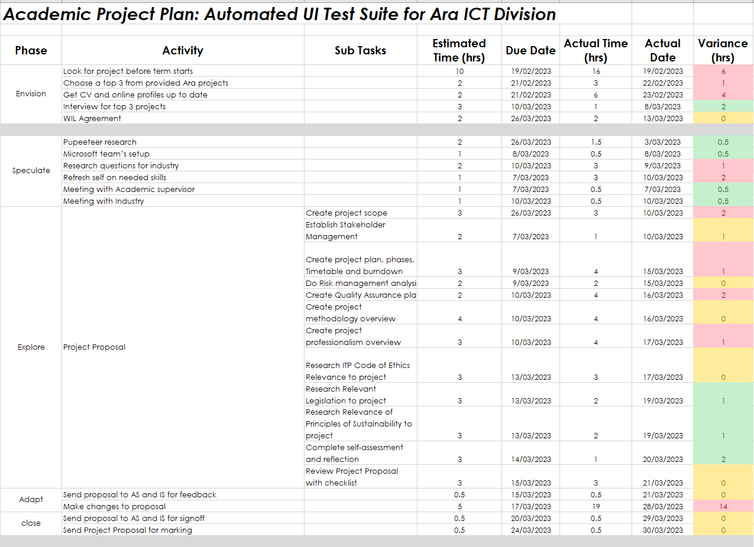

Table 8  
*Academic Project Plan at Week 5 (Ending 24/03/2023) Part 2*

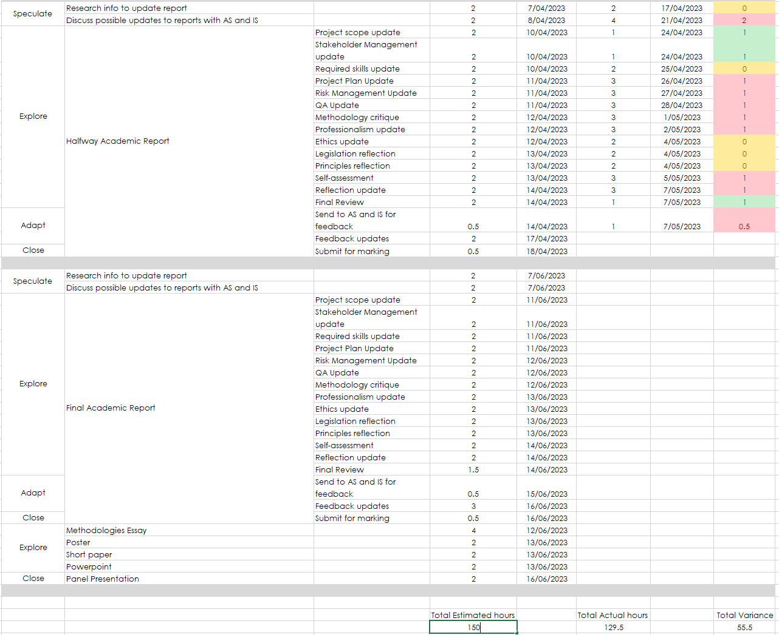

Table 9  
*Industry Project Plan at Week 5 (Ending 24/03/2023)*

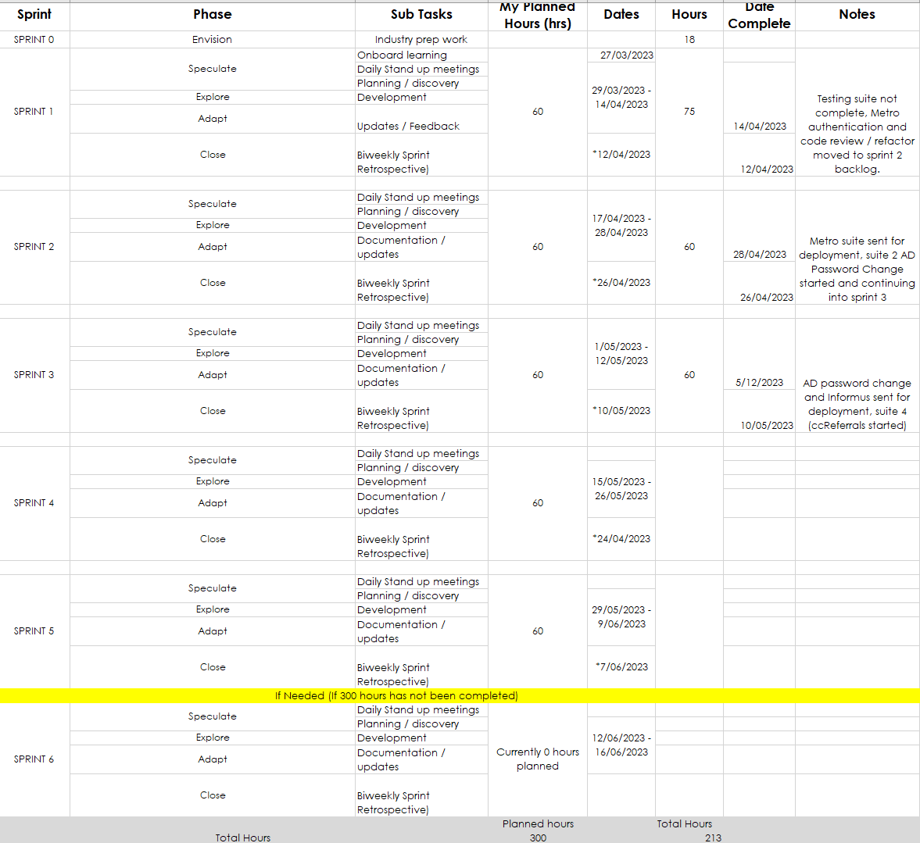

Table 10  
*Academic Project Task Breakdown at Week 5 (Ending 24/03/2023)*

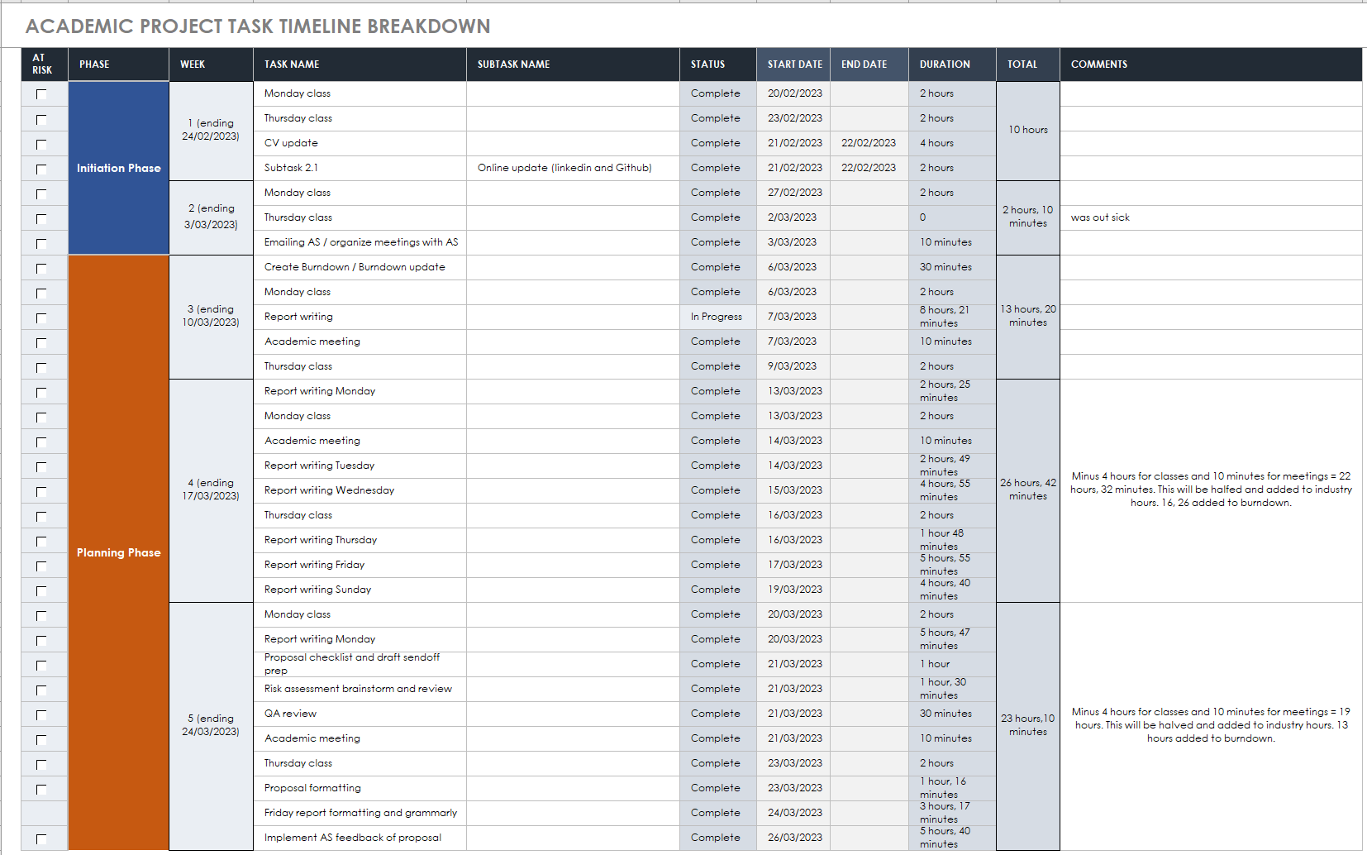

Table 11  
*Industry Project Task Breakdown at Week 5 (Ending 24/03/2023)*

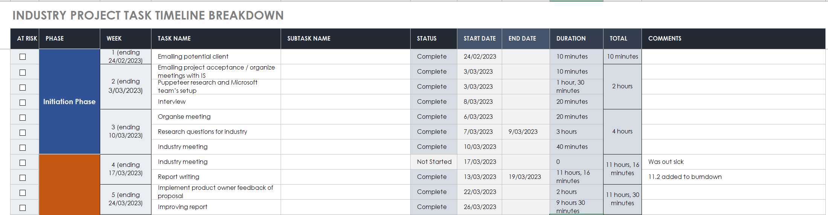

## Halfway Report

## Updates

### Project Plan

The project plan changed a lot during the writing of the project proposal. It was originally before the start of the project one combined academic and industry plan with the phases of Initiation, Planning, Executions, and Project Closure based on the Project Management Life Cycle which was recommended by Martin (2023) to be an essential framework that could map a project of any size. However, as seen in the below Table 12 *Initial Project Plan Part 1* and Table 13 *Initial Project Plan Part 2* and as pointed out by both my supervisors the approach is very much represented as waterfall-like methodology rather than the Agile methodology needed. This approach also added a lot of risks to the project as in theory each testing suite would lead directly into the next, meaning if the project owner decided to change the order of the testing, he wanted me to do the whole project plan would have been thrown out. In the end, this approach was got rid of and replaced with the Agile Project Management Phases approach and the separate academic and industry project plans seen above and updated below.

Table 12  
*Initial Project Plan Part 1*

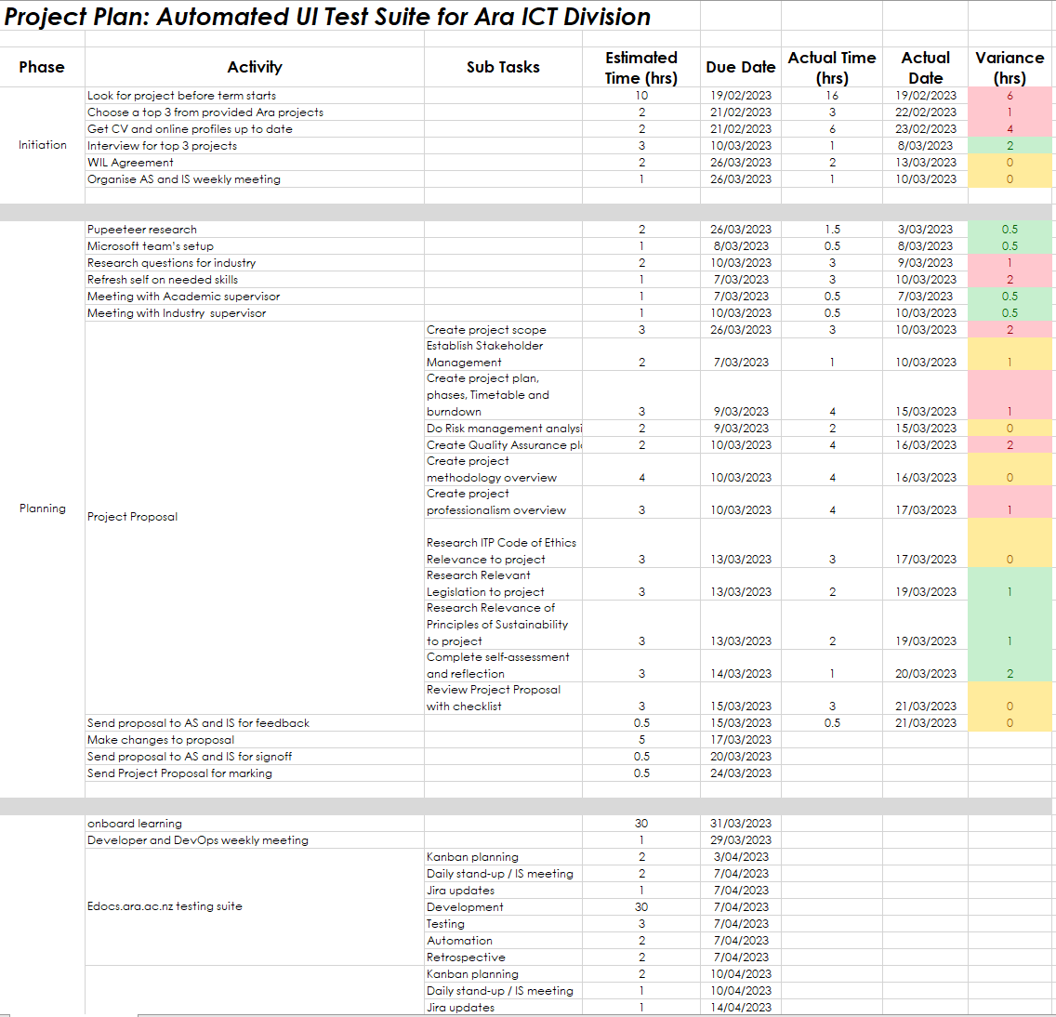

Table 13   
*Initial Project Plan Part 2*

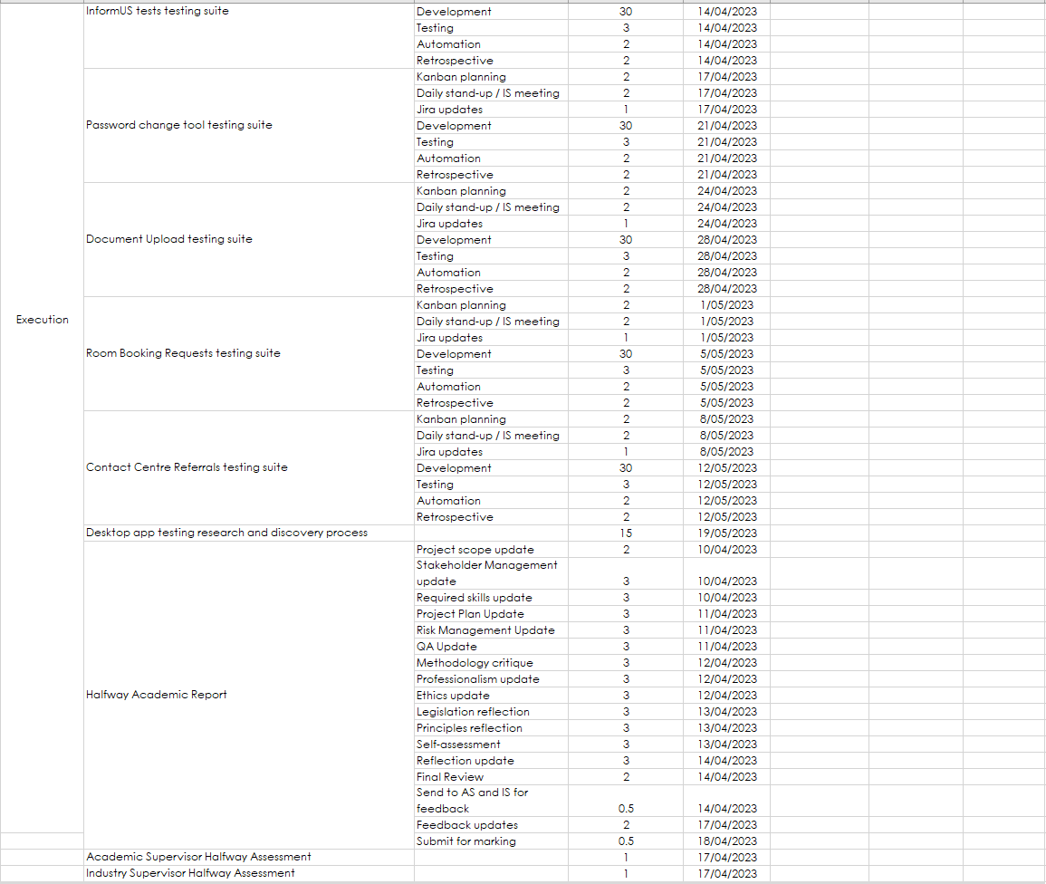

Table 14   
*Academic Project Plan at Week 10 (Ending 30/04/2023) Part 1*

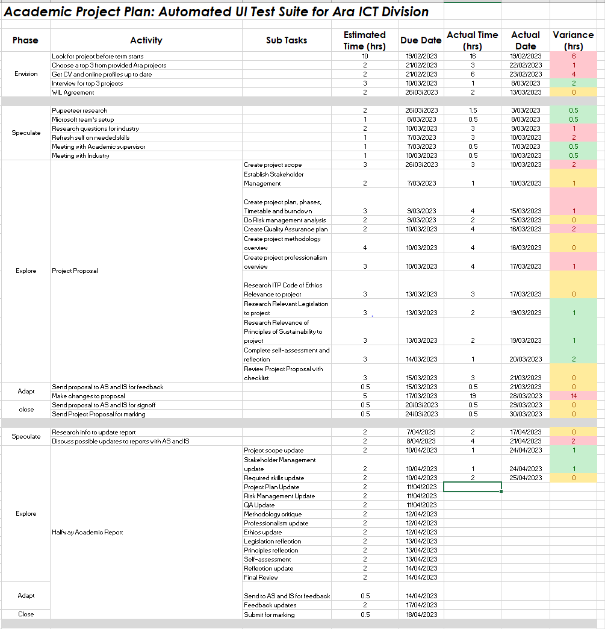

Table 15   
*Academic Project Plan at Week 10 (Ending 30/04/2023) Part 2*

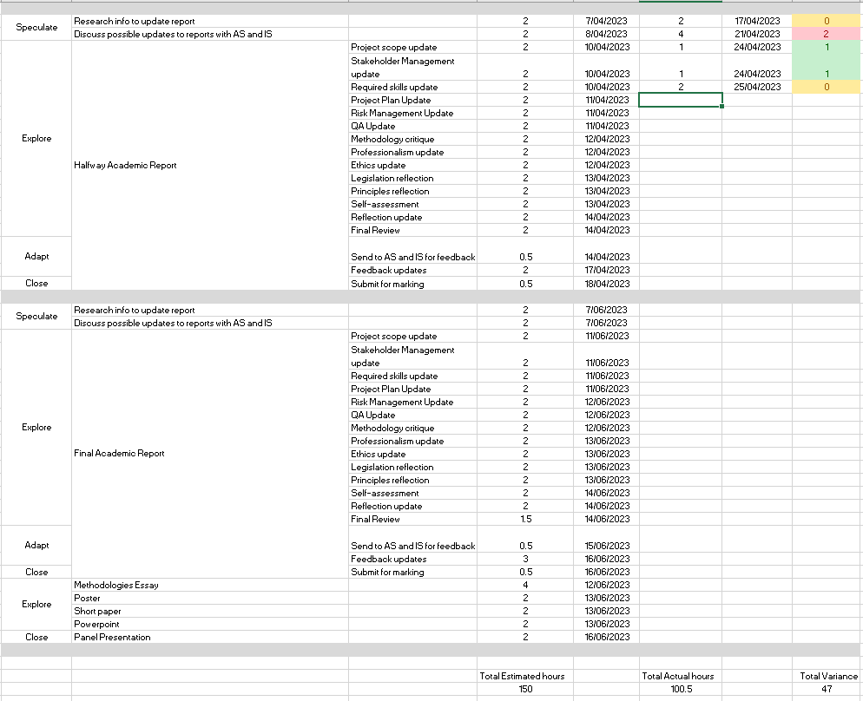

Table 16   
*Industry Project Plan at Week 10 (Ending 30/04/2023)*

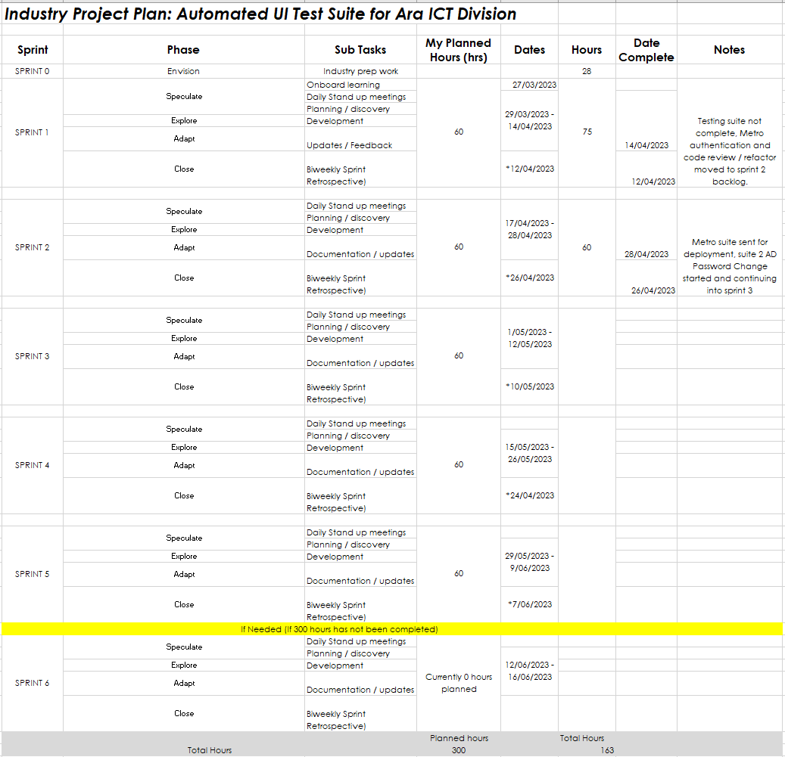

### Timetable and Burndown

The industry timetable changed slightly due to public holidays over Easter and Anzac Day. I forgot to check up on when I did my original planning out of the hours. This meant that I ended up with three weeks where I did 22 hours instead of the planned 30. However, I kept the actual hours within 2 hours of the panned hours as per below Table 17 *Industry Project Timetable at Week 10 (Ending 30/04/2023)* by doing 31 hours the week ending 2/04/2023 and 38 hours the week ending 23/04/2023 which I also plan to do the week ending 7/05/2023 to get the hours as close as possible. My industry supervisor has reviewed the numbers and is happy with the way we are tracking but we have also created a work-from-home contingency plan in case the risk of lost industry hours becomes a reality and the difference between planned and actual gets out of hand. These numbers are also reflected in below Figure 16 *Industry Burndown Chart at Week 10 (Ending 30/04/2023)* which is the graph of the industry hours in the timetable to this point.

The academic timetable is much more variable as I put a lot of hours into writing the project proposal over working weeks 3, 4, and 5 with 13 hours done in two of the weeks and 16 hours done in the other which is much more than my planned 9 hours as per the below Table 18 *Academic Project Timetable at Week 10 (Ending 30/04/2023)*. However, during the weeks the industry work started we did not have any classes, so I only updated my documents and had my academic meeting. Meaning I only did less than 4 hours over working weeks 7, 8, and 9. The actual hours will increase a lot over the next three weeks as I complete the Halfway report and implement any feedback given. These numbers are also reflected in below Figure 17 *Academic Burndown Chart at Week 10 (Ending 30/04/2023)* which is the graph of the academic hours in the timetable to this point.

Table 17   
*Industry Project Timetable at Week 10 (Ending 30/04/2023)*

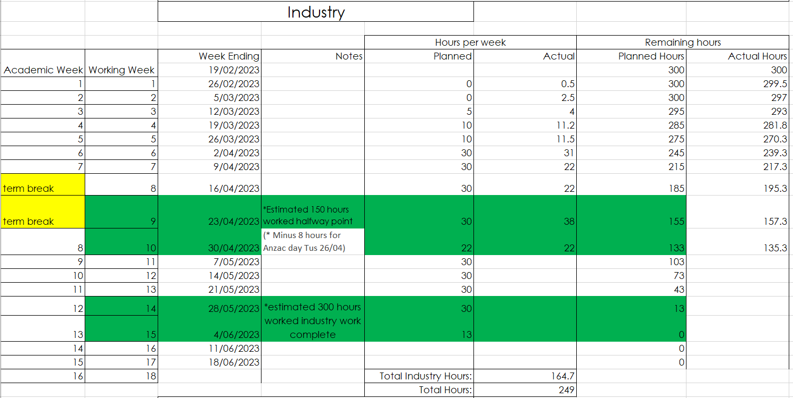

Table 18 *Academic Project Timetable at Week 10 (Ending 30/04/2023)*

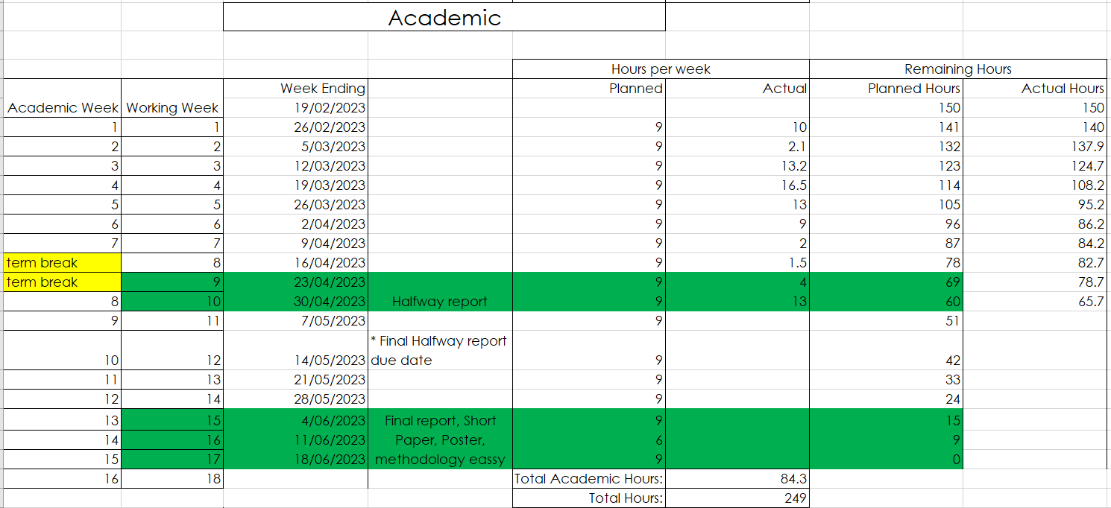

Figure 16 *Industry Burndown Chart at Week 10 (Ending 30/04/2023)*

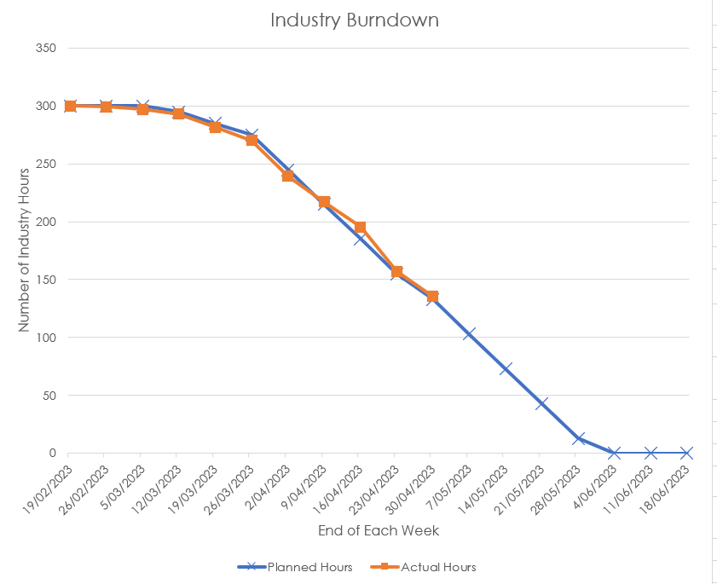

Figure 17   
*Academic Burndown Chart at Week 10 (Ending 30/04/2023)*

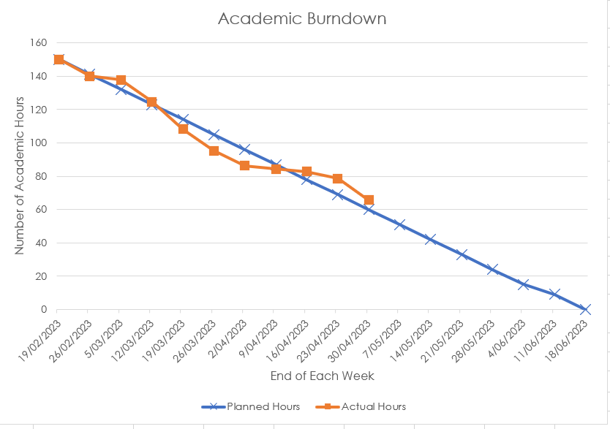

### Task Breakdown

To keep track of both things I need to remember, ask a team member, or the tasks I work on or complete each hour I adopted the strategy of having a book next to me in which I write everything in during the day. Then I transfer them to more readable formats at the end of the day like general notes/questions or my task breakdowns. The task breakdowns shown below as Table 19 and Table 20 have been updated daily with these notes showing me what I did for the hours tracked in the above timetable and burndown section. They have also been updated since the proposal versions above to better reflect the change to Agile methodology. Meaning the Phase column which in the old version had the Project Management Life Cycle reflecting the above Initial Project Plan, has been replaced with my industry sprints and the Agile Project Management Phases respectively as stated in the updates section above.

The task breakdown was also used to track my continues improvement as shown in Figure 12 above on each of the testing suites that were completed. This is because even after each set of tests were completed things could be found by others during code review or deployment that needed to be changed or when I move on to the next app, I learnt a better way of doing something so I went back and changed the past code. For example, my first app was sent back to me about a week after the code review as when it had been built for deployment it had failed due to a difference in how my local machine and the pipeline accessed the browser. Myself, one of the team members and the industry supervisors then went through the continuous improvement process of plan by finding out what the problem was and how er could solve it, do by sending me off to implement the solution, check by pushing the new code to the pipeline to make sure it worked and act by implementing the change into the other testing suites going forward. This process is shown below in Table 21 *Continues Improvement Steps of Work Sent Back for Update*. This process has been very helpful for improving work both industry and academic so will be used a lot going forward as more of my work is being looked at or used by other people. This is very important as it helps to keep the deliverables as high of a standard as possible while also giving me chances to learn more things from different people.

Table 19   
*Industry Project Task Breakdown at Week 10 (Ending 30/04/2023)*

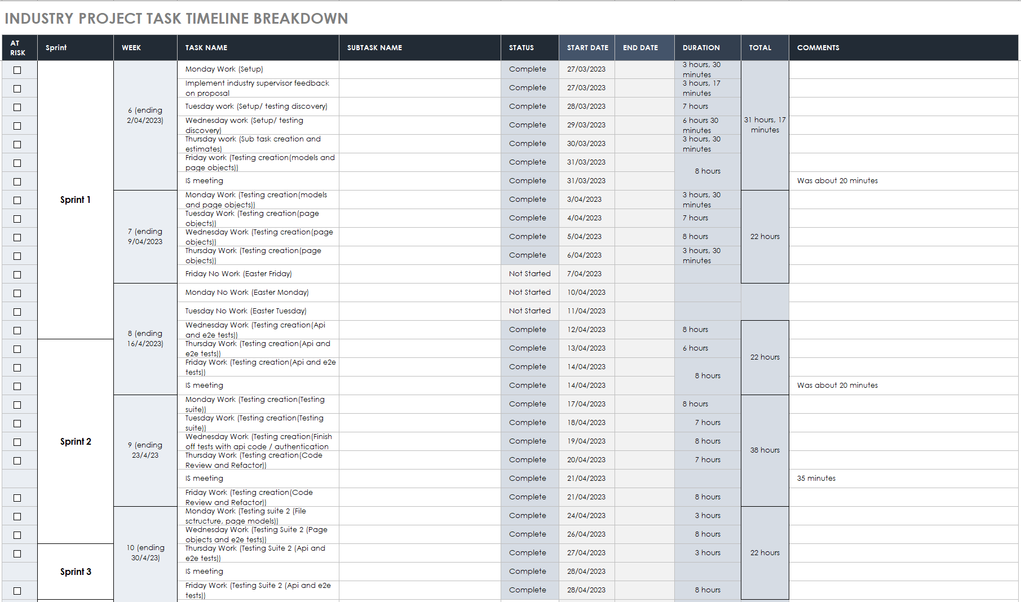

Table 20 *Academic Project Task Breakdown at Week 10 (Ending 30/04/2023)*

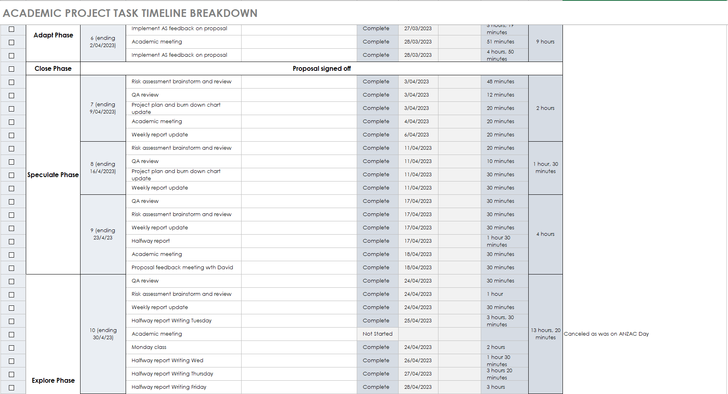

Table 21   
*Continues Improvement Steps of Work Sent Back for Update*

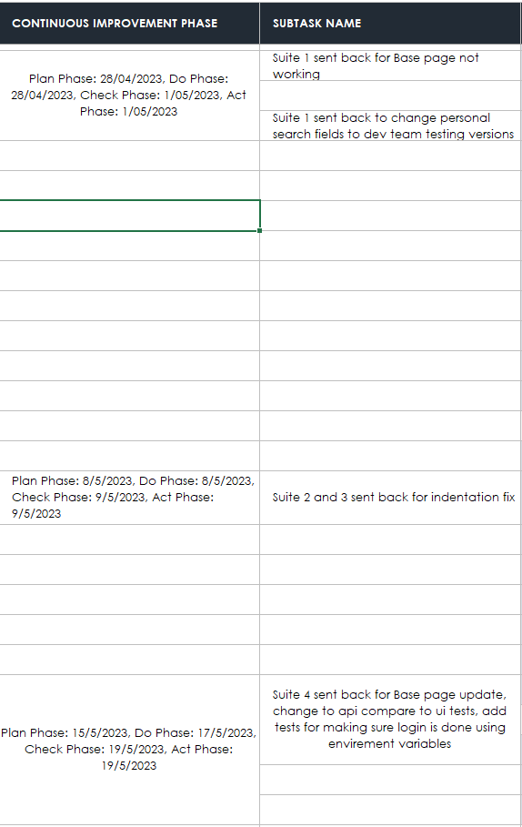

## Reflection

### What Went Well

I have managed to keep the industry hours close to what was planned and very consistent. This means I have been able to keep the industry project plan as shown above in Table 16 *Industry Project Plan at Week 10 (Ending 30/04/2023)* on track within a week or so. This means that in terms of delivering the testing suites I am on track to deliver one working suite per sprint. That will probably change in the coming weeks as we start working on the more complex apps but for now, I am happy that the industry hours and project plan are going close to what I originally planned.

I think my way of tracking everything has greatly improved from how I thought it would be going in. When I started, I thought using just an app to track time worked and the burndown spreadsheet would be enough for everything, but I quickly adapted when lots of info was given to me on day 1 of the industry. My method then became to write everything down in my book which I kept on my desk. From things I learnt, to things to remember or ask, and hours tracked. I then turn those notes into different digital versions like task breakdowns, timetables, and general notes. This process has helped me keep up to date with all my academic deliverable documents and keep track of the tasks I have done or things I am learning each day.

### What Didn’t Go Well

I think I got too focused on industry work over working weeks 7, 8, and 9 as I stated above. With less than 4 hours of academic work done for updates and meetings, I feel behind on my planned 9 hours when I could have put a few more hours in each of those weeks into starting the Halfway Report. This would have reduced the workload in the weeks that followed week 9 and would have meant I could have had my report in for feedback sooner, which would have reduced the chances of delays when the deadline is close and could cause me to have to get another extension. A good lesson for me to learn going into the final report is to start working a week or so before you think you need to.

## Final Report

## Final Summary

### Updates

During the Halfway report feedback and discussion, it was decided that the project plans as shown above in Table 14, Table 15 and Table 16 were confusing to have mixed in with the other tables and I was not updating them as much as the task breakdown and Timetables as shown above in Table 17 and Table 18. The decision was made to merge the Project Plans and Task Breakdowns together to consolidate data and remove duplication. As per the below Table 23 *Final* *Academic Project Plan and Task Breakdown* for the academic table each of the task I planned to do have been added to the Planned Tasks column. These are matched up with the Week and Phase columns using the Planned Date column in which I originally planned to be doing each phase of the project. Finally, I have added Planned Task Duration and Planned Total columns showing the total hour I planned to work on each phase which will be compared with the Total column in the end to show how many hours over or under the planned 150 I was. As per the below Table 22 for the industry table I have added columns Planned Completion Date and Planned Hours these are linked to each sprint and advise when I planned to start, finish, planned hours and when I would have my retrospective for each sprint. These planned hours and times have also been compared to what I did which shows I was ahead of my schedule as I ran out of hours on the 2nd of June while the plan was to finish a week later the 9th of June. Overall, this change was worth doing as it cut down on info duplication and helped to simplify the reporting by only adding what was needed from the old project plans into the new merged version.

After seeing the time, I took to complete the halfway report which was more than 30 hours I decided that with the other deliverables like the essay, poster and short paper also needing to be done at the same time as the final report, that I would need a lot more academic hours than the original planned 150. For this reason, the hours were raised to 200 giving me a predicted overall hour of 500. As per the below Table 25 and Figure 19 this was exceeded to a final total of 510 hours.

### Summary

Overall, the industry hours were almost perfectly on target as I had planned, apart from small deductions in hour for weeks 11 and 13 which were made up for during weeks 12 and 14. As shown in the below Table 24 *Final Industry Project Timetable* and Figure 18 *Final Industry Burndown Chart*, I finished right on week 15 as planned, with a small unplanned extra 5 hours to make sure everything was finished, bringing the total industry hours to 305. The academic hours were much more inconsistent as shown in the blew Table 25 *Final Academic Project Timetable* and Figure 19 *Final Academic Burndown Chart* as I very much reduced my academic hours when there were not classes or reports due so that I could focus on industry hours. This means there has been a large increase the last few weeks both during the halfway stage and during the final stage to get all the academic work done. However, this was always the plan linked to industry work finishing on week 15 so that I could have as many hours as possible to get everything finished. With that in mind the project plan was executed very well with little to no major changes from the planned hours.

The course management approach detailed in my proposal was well executed as each academic and industry deliverable was put through the Agile Project Management Phases and Continuous Improvement framework until they were at a standard where they could be accepted using the quality assurance method. Tracking each stage of this became easier as the project went on as detailed above because the number of files was reduced. This resulted in the project management mythology being tracked using the below Table 22 and Table 23 with the phase showing which stage of the project each task I have worked on was linked to.

Table 22   
*Final* *Industry Project Plan and Task Breakdown*

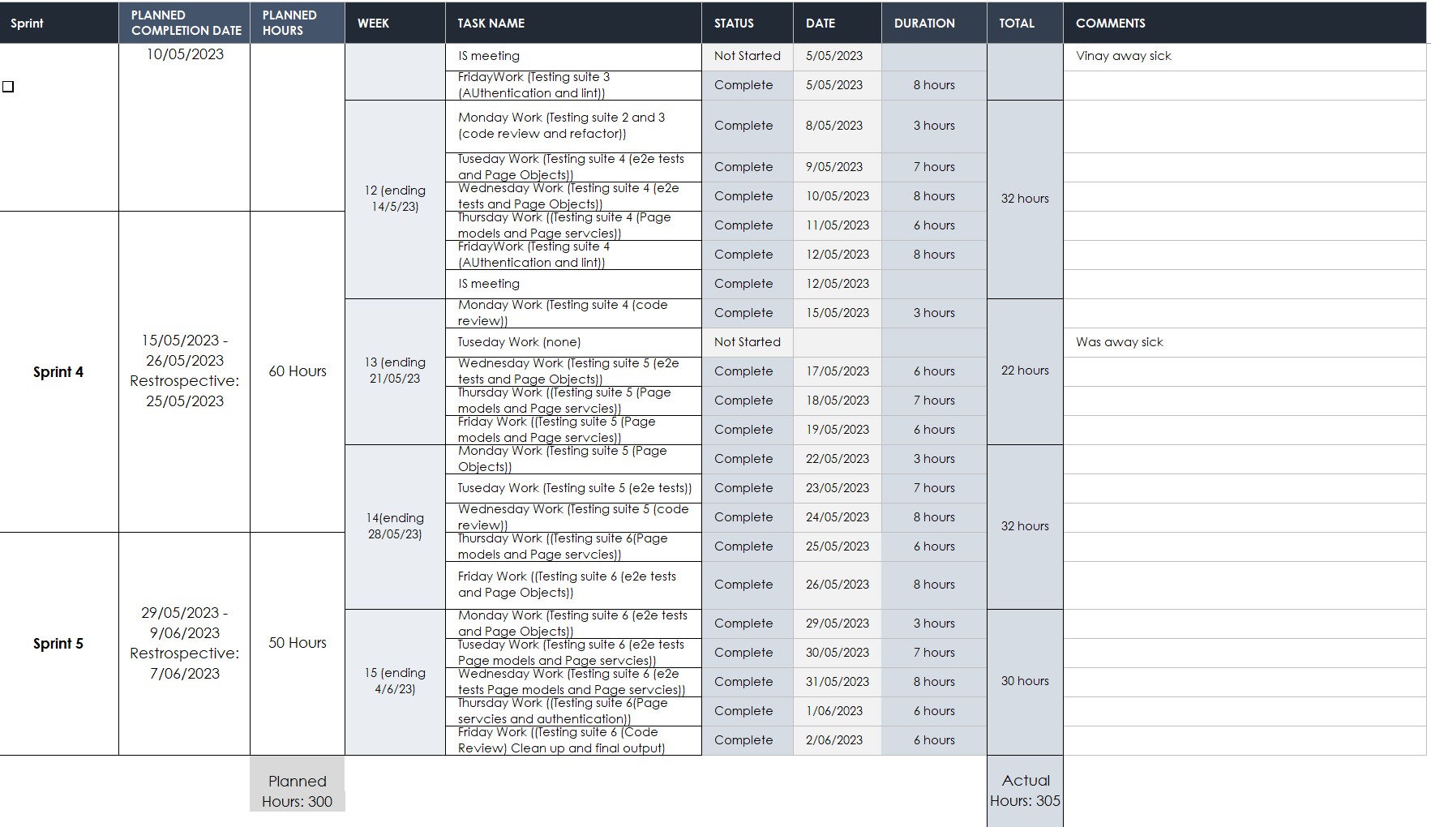

Table 23   
*Final* *Academic Project Plan and Task Breakdown*

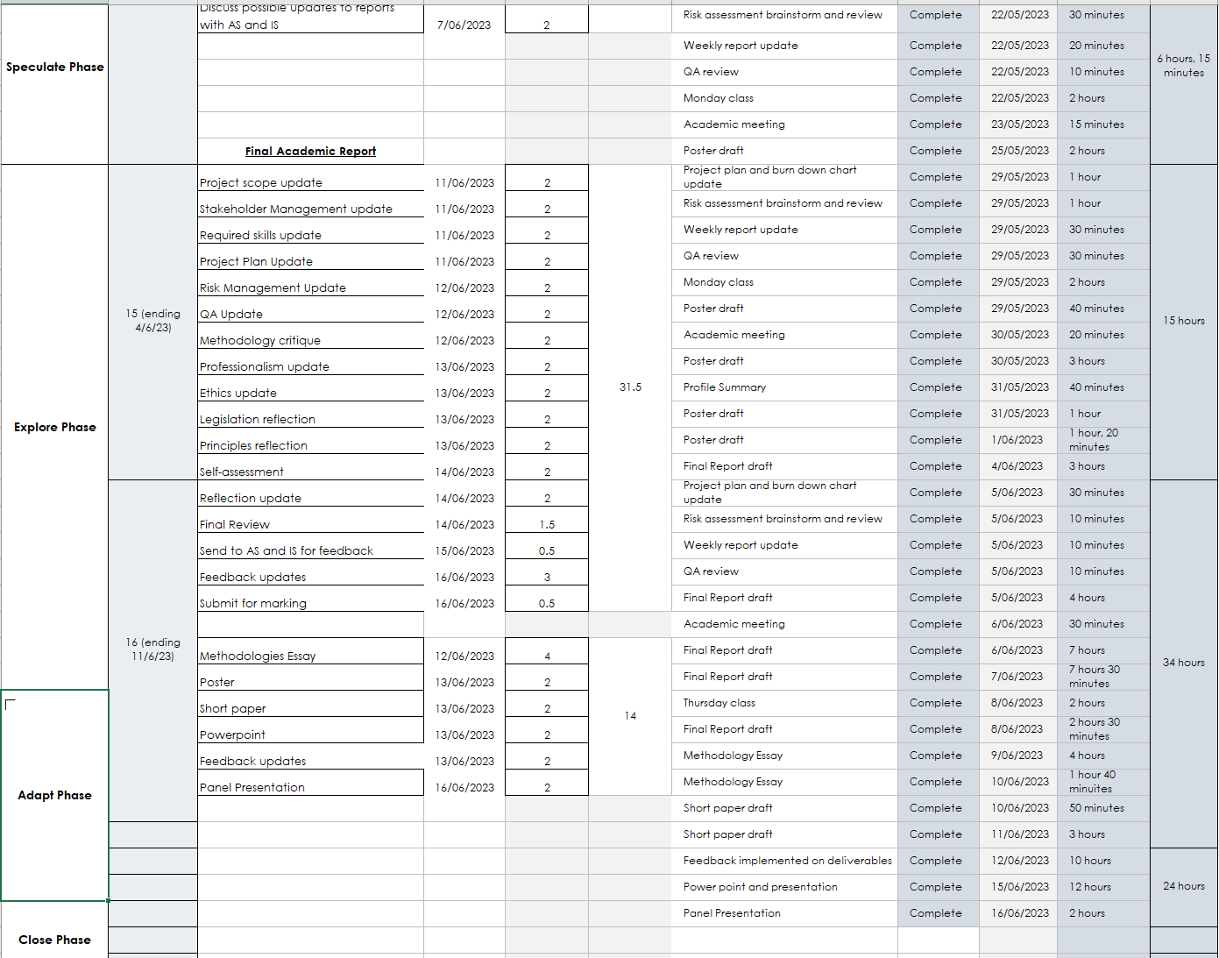

Table 24 *Final Industry Project Timetable*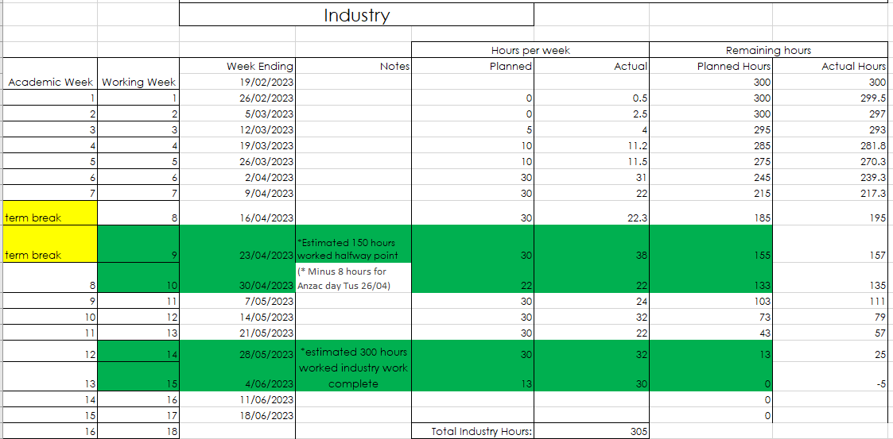

Figure 18 *Final Industry Burndown Chart*

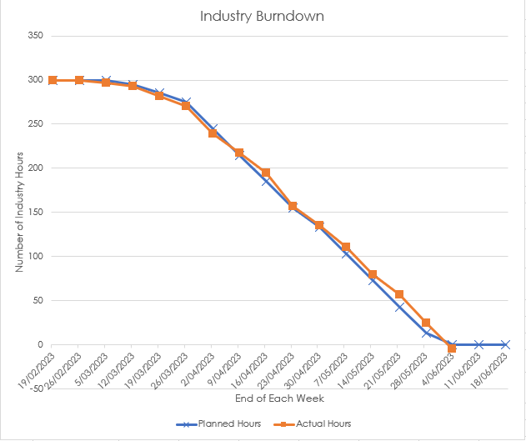

Table 25 *Final Academic Project Timetable*

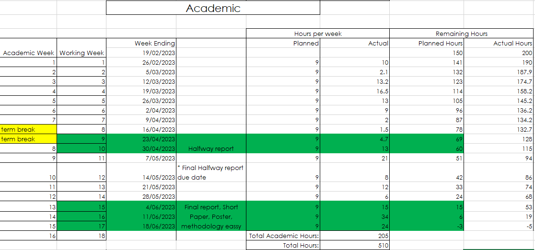

Figure 19 *Final Academic Burndown Chart*

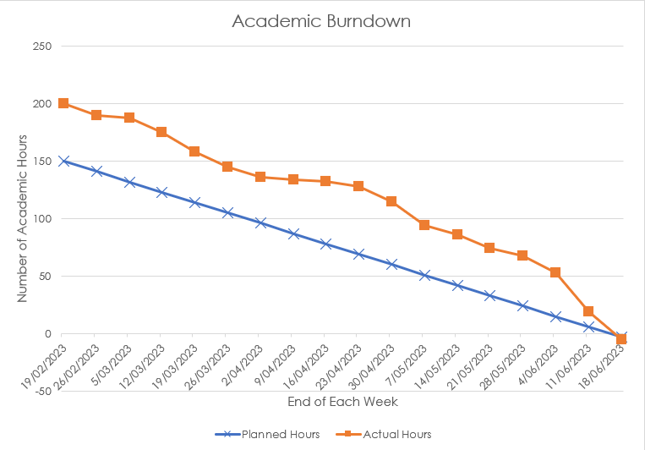

## Reflection

### What Went Well

I am very proud with the way I was able to stick to the original plan of getting my 300 hours done before the 5th of June to allow me time to work on the academic deliverables. During the duration of the project there were small things that took hours away from me like family bereavement or illness, but I was able to work around them using my project plan and risk assessment to mitigate their impact and plan to up lost hours where I could. Overall, my notebook and Jira hour tracking method was effective and as I progressed, I was able to cut down on the spread sheets I was not using like the Weekly Schedule from my Proposal or the Project Plan from my Halfway Report. This helped to streamline my weekly update process and limit data duplication.

### What Didn’t Go Well

With my panel booked for the 16th I have left myself with 10 full days without industry work to get everything done. I worry if it is enough time to get both the writing and stakeholder feedback done before the deadline. This continues what has been the biggest issue for me throughout this project which was time delays on reports because of either not starting early enough or not getting feedback in time. These were managed using my project plan to carefully plan out my hours so I knew how long each task would take and coming up with adding signoff delays to the risk table so that I could plan mitigation and contingency plans with my supervisor. Going forward into the future I need to take the lesson to always start before I think I need to and if I had the chance to do the project over again, I would make sure I am more proactive with my report writing.

# Risk Management

In this section, I will go in-depth into how risks will be managed during the duration of the project. During the development of the project, risks may occur that have an impact on the development. To help mitigate the impact I must go through the process of identifying the risks thinking about the consequences if they occur, how likely they are to happen, and coming up with contingency plans for them.

## Approach

For this Microsoft (2022) suggested using the Microsoft risk template tool which uses a scale of each risk’s probability and impact to rank all risks by the level of exposure they have. The initial risks were identified during the initiation phase of the project after the first class of week 1 when the process of getting a project through Ara began. They were then reviewed at the end of week 2 when I had my interview and accepted the project. From then onwards the process will be a review of the current active risks from the week before and an identification process of new risks for the coming week on a Monday. These will then be shown and discussed with both my academic and industry supervisors during the weekly meetings.

Clarkson (2012) suggested identifying potential risks using a What-if structure. Writing each brainstormed idea as a phase that begins with “what if…” or “how could…”, to examine risks at a system level. This identification process will be done on each potential risk before they are added to the risk tool and rated for probability and impact. This will then allow for a process of identifying what will trigger each risk, how I can mitigate the trigger, and what I can do as a contingency plan when a risk occurs as per the simple Microsoft risk template tool which I downloaded from the Ara Moodle (n.d.) as the original can no longer be found anywhere else, but it is still a very good tool which is why I have selected it. I selected the tool because of my familiarity with it after using it in BCDE213 and BCDE311, I believe the simple layout makes it easy to read and the exposure ranking system allows for a clear precise decimal number to show the most immediate and impactful risks being monitored.

Microsoft (2022) suggested having 9 columns but as per Table 26 *Project Risk Assessment at Week 5 (Ending 24/03/2023)*, I have added 4 more for the review process. The risk table is broken up into thirteen columns:

1. #- risk identifier used to give each risk an identity that can be referred to.
2. Condition - used to capture the description of risk.
3. Consequence – used to describe the result of the risk happening.
4. Probability – used to estimate the probability of a risk happening, measured on a 1 – 99 percent scale.
5. Impact - used to estimate the severity of the damage done to the project’s chance of success if the risk occurred measured on a 1 – 10 scale. (1 meaning minimal impact and 10 meaning catastrophic project-ending impact)
6. Exposure – a calculation of Probability times Impact creating a scale of 0.01 – 9.9, used to sort the list by biggest risk.
7. Mitigation - used to describe the plans in place to either reduce the Probability or Impact the risk has.
8. Contingency - used to describe the plans in place for when the risk becomes a reality.
9. Triggers - used to describe what would prompt you to execute the Contingency.
10. Category – Is the risk personal, project-focused, or business focused.
11. Date Added – The date and work week in which the risk was identified.
12. Date of Review – The date and sprint in which the risk was reviewed.
13. Change – the change in probability since the last review.

## Risk Table

Each week when I complete the identification process outlined above, I brainstorm as many risks as I can think of by writing them on notes and ranking them on a board by severity and possibility. As per above each risk is identified by writing a what-if sentence in the brainstorming area off the side of the board and is added to as a sticky note if they are relevant to the events of the past week or could be relevant to the coming week. I then rate each risk on the board by deciding on how probable the risk is of happening between unlikely, possible, or likely on the board’s Y axes. That is then matched with how I rate the severity of the risk would have if it happened between minor, moderate, significant, and server as seen on Table 27’s X axes. These ratings give the risk a placement square which is numbered 1 to 10 plus a square for risks that are no longer relevant or have happened. The numbering of the square then is transferred to the Risk Table as the tracked risks impact score as per the above list and below Table 26. See Table 27 for my current week’s brainstorming and (Appendix F) for the past week’s Brainstorming Board and Risk Table. These are then cut down to a top five that will be tracked on the risk table, Hoffman (2002) advises that per best practice monitoring more than five active risks is too many and the project could be too risky to undertake.

My Current risks are categorised into three types Personal, Project / Academic, and Business / Industry. This approach is working for now, but I will most likely review these categories are the start of the project work with my academic and industry supervisors to refine them into more specific types.

As per Table 26, my current top risk is “Scoping Issues” with a probability of 70%, impact of 8 out of 10, and Exposure of 5.6 referring to the level of scoping I have done, with a lot of unknown and assumptions which could cause issues during the projects. If the tracked risk becomes a reality, or the project gets to a place where the risk can no longer happen the risk will be moved to the inactive list and updated with a change in probability of either 0% or 100% respectively. However, the same risks may become relevant again during future reviews so can be readded to the active list under a new identifier number.

Table 26  
*Project Risk Assessment at Week 5 (Ending 24/03/2023)*

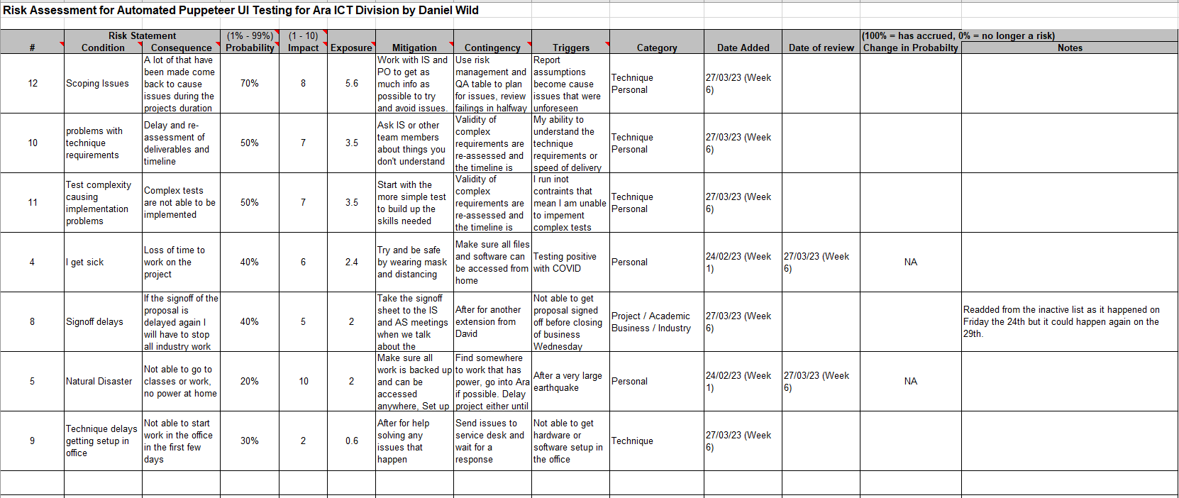

Table 27  
*Risk Brainstorming Board at Week 5 (Ending 24/03/2023)*

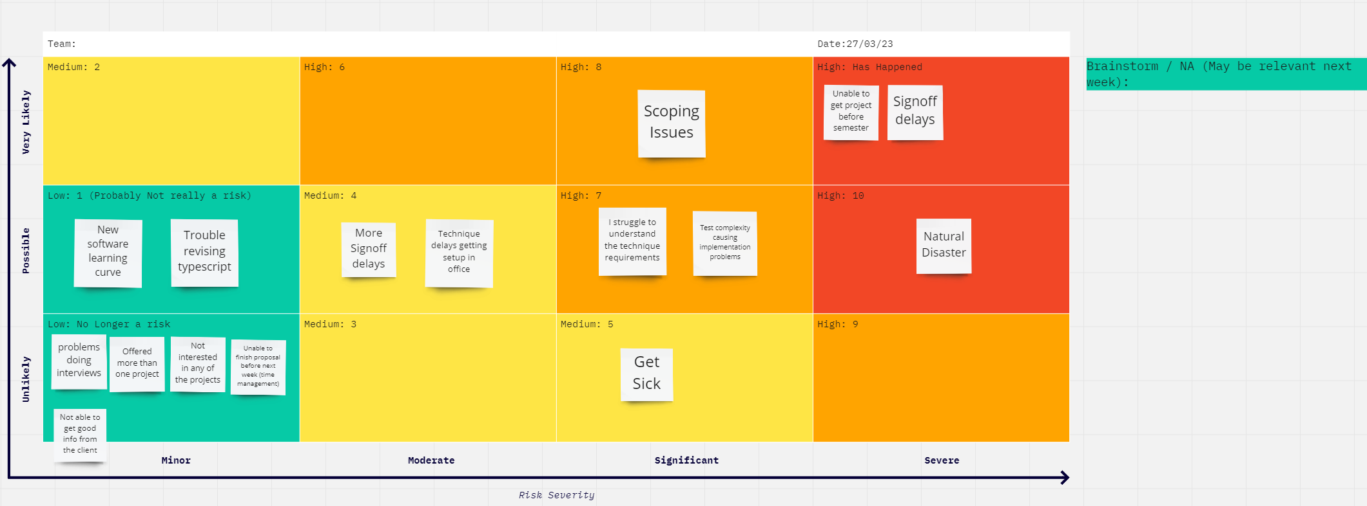

## Halfway Report

## Updates

The risk table has been updated or reviewed three times a week so that new risks can then be added, and old ones can be updated. Once by me on a Monday afternoon, the next either during or after my academic supervisor meeting on a Tuesday, and the final time on a Friday after my industry supervisor meeting. I also created a plan with the supervisor that if a risk has a very high exposure of over 6 for example it will be reviewed daily so that it can be either mitigated to try and get the probability reduced as much as possible.

During this process, the brainstorming board as shown below in Table 30 *Risk Brainstorming Board at Week 10 (Ending 30/04/2023)* has been refined. The brainstorming section on the side is used to write my lists of What-if structure questions as Clarkson (2012) suggested. While I have continued to rate each risk on the board by deciding on how probable the risk is of happening between unlikely, possible, or likely on the board’s Y axes. That is then matched with how I rate the severity of the risk would have if it happened between minor, moderate, significant, and server on the X axis. Giving each risk a placement on the board with a number that is then transferred to the risk table as its impact.

As per the below Table 28 *Project Risk Assessment at Week 10 (Ending 30/04/2023)* and as agreed upon with both supervisors I have the Hoffman (2002) recommendation of only tracking five or fewer risks at a time. This is because I found that it was not practical or realistic as many more things arise as possible risks that need to be put on the table so that they can be mitigated, and contingency plans made. However, it is possible to break the table down into the top five exposure levels if needed so that the most impactful or probable risks can be focused on.

As per my proposal above I have also kept track of the risks that have either happened or are not risks at the current moment. As shown below in Table 29 *Inactive Risk Table* *at Week 10 (Ending 30/04/2023)*. So far there are ten of them which I have kept in a separate table so that I can readded them to the active table if they become relevant again. It also shows how many little things can happen during a project which if not mitigated could cause issues as to whether the project is successful or not. I think this illustrates nicely how effective my risk management process has been to this point as all risks that have occurred have been mitigated or had their contingency plan put into action which has meant their impact on the project has been minimal.

When Table 26 above and Table 28 below are compared most of my original top risk have either been reduced in exposure or moved to the inactive table as they either happened or are no longer risks at this time. For example, scoping issues which was number one with exposure of 5.6 above has been reduced to exposure 2.8 as of week 10. This is because when I did my Proposal my methodology was very risky as explained in the methodology halfway section of this report. Meaning there was a lot of room for unforeseen risks in the scope, so it was a very high risk. During the feedback process of the Proposal that methodology was changed to Agile, so we were able to reduce the risk of scoping issues.

Another example is Test Complexity which was third highest in Table 26 with an exposure of 3.5 but in Table 28 is first place with exposure of 4.8. This is because the original exposure came from me learning about the complexity of the app while I created my first tests. This meant I had a reasonable chance of running into complexity that could affect the outcome of the first testing suite. This meant this risk’s probability changed on a weekly basis. During sprints 2 and 3 it was reduced as the apps I was working on were the same structure as app 1 meaning there was less chance of me running into complex things I had not seen before. However, going into the next sprint, I will be facing a jump in complexity, so the risk has been raised in probability and impact as seen in the below to account for this.

The Final big difference from Table 26 to Table 28 is problems with technique requirements with an exposure of 3.5. This risk ended up being split into two separate risks for better clarity. They lack technique knowledge, focusing more on the skills I need to complete the project coding overall and trouble understanding task requirements, focus more on my ability to understand how to test bit of the induvial application’s functionality. These risks have moved up and down the ranking weekly depending on the current work status.

The remaining risk has either stayed reasonably the same or have been moved to inactive. The biggest risks that have occurred as shown in Table 29 *Inactive Risk Table* *at Week 10 (Ending 30/04/2023)* have been based around time management problems. Both proposal time management and signoff delays were not mitigated very much by my plan to work longer hour writing and meant that I needed to go to my contingency plan of asking for an extension. Which meant that I got an extra week to hand in the proposal but impacted both the academic and industry work as having to write for 4 hours after working for 8 hours meant I was tired during industry work and just wanted to hand in anything by the deadline. Meaning both the quality of my academic and industry work was reduced for that time. A lesson I have learnt for both this halfway report and the final report.

Table 28   
*Project Risk Assessment at Week 10 (Ending 30/04/2023)*

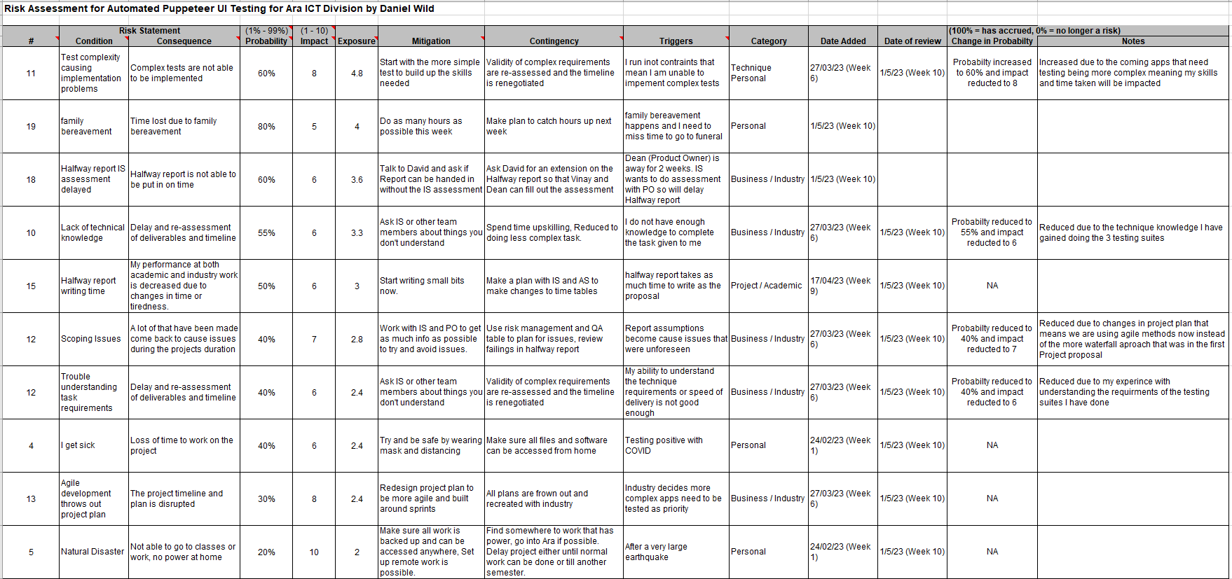

Table 29   
*Inactive Risk Table* *at Week 10 (Ending 30/04/2023)*

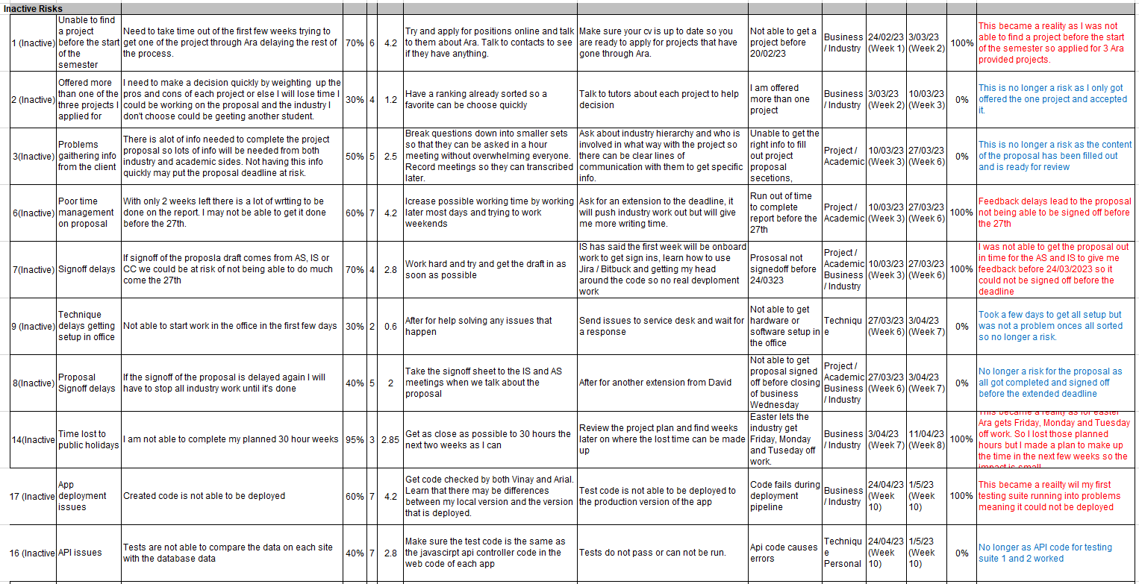

Table 30  
*Risk Brainstorming Board at Week 10 (Ending 30/04/2023)*

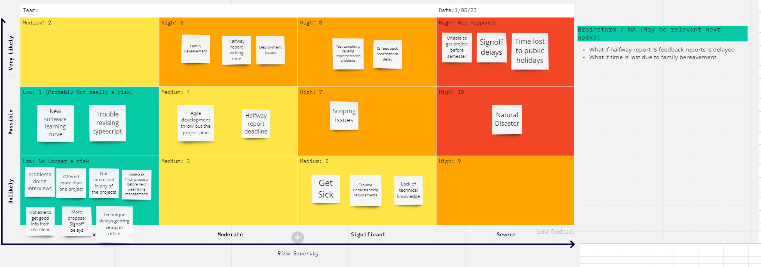

## Reflection

### What Went Well

I think the collaboration of the process has made the risk assessment very successful. On top of the brainstorming process, I go through as detailed above to discover risks, the supervisors have encouraged me to use the Weekly Reports to help with risk discovery. What this means is anything listed under “Barriers to progress” becomes an issue that can be listed as it could become a risk later, anything listed under “Possible solutions to barriers” will serve as that issues mitigation, and anything listed under “Areas of concern” is already a risk. This helps to link the work I am doing each week to the risk table when I update it helping to make sure each risk identified is relevant and we can establish realistic mitigations and contingencies.

### What Didn’t Go Well

It took me a few weeks to get my head around the risk process until I started industry work, I found it hard to brainstorm relevant risks to the industry work and after I did start, I was advised that if I was using the methodology in the proposal as discussed in the Project Plan Updates section above I would need a huge number of risk listed because of the pitfalls of the methodology I had selected. Thankfully with that methodology changed I have been able to maintain a more reasonable number of risks being monitored at a time and will continue this process into the rest of the project duration.

## Final Report

## Final Summary

I continued to use the Microsoft (2022) suggested risk template tool using the scale of probability times impact to get an exposure value to rank the list of risks highest to lowest through the duration of the project. I also continued to use the Clarkson (2012) suggested What-if structure to identifying potential risks by writing out phases phase that begins with “what if…” or “how could…”. This process was completed every Monday afternoon as planned before being shared with both supervisors during their respective meeting later in the week. The process was improved around the halfway stage as explained above in the Halfway Report Reflection What Went Well Section, with the weekly reports “Barriers to progress”, “Possible solutions to barriers”, and “Areas of concern” being used to help discover potential risks and mitigations each week.

As shown below in Table 31 *Final* *Project Risk Assessment* and Table 32 *Final* *Risk Brainstorming Board* both the Brainstorm and Risk Table have been updated to their final week versions. This means there are a very small number of risks that are being tracked with the biggest being the risk of not meeting the current academic deliverable deadline for the panel. I have rated it at an exposure of 3.5 as the timeframe is quite short and the impact on the overall project would be not insignificant at a 7, but it is well mitigated as I have carefully planned out my hours for the week and I have discussed contingency plans with my AS, so the risk is well managed.

As shown in the below Table 33 *Final Inactive Risk Table* there have been a significant number of risks that have been tracked throughout the project duration which have either not happened or have happened and had to be dealt with. The biggest academic category risk that occurred was feedback delays on both the Proposal and Halfway reports. This risk could not be effectively mitigated so I needed to use my contingency plan of asking for a week extension which proved be enough time to get both completed and handed in. The biggest industry category that occurred was debugging issues as discussed in the above Final Report Skills Section. This was a risk I did not see coming but cost me a few days’ time working on fixing it instead of working on new tests. In the end I was able to mitigate it without needing to use my contingency plan, but it is a risk I will plan better or in future projects.

Table 31   
*Final* *Project Risk Assessment*

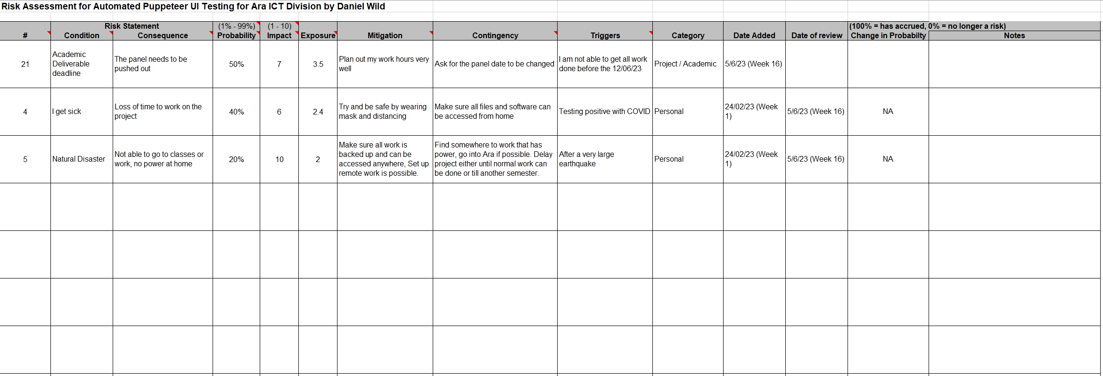

Table 32   
*Final* *Risk Brainstorming Board*

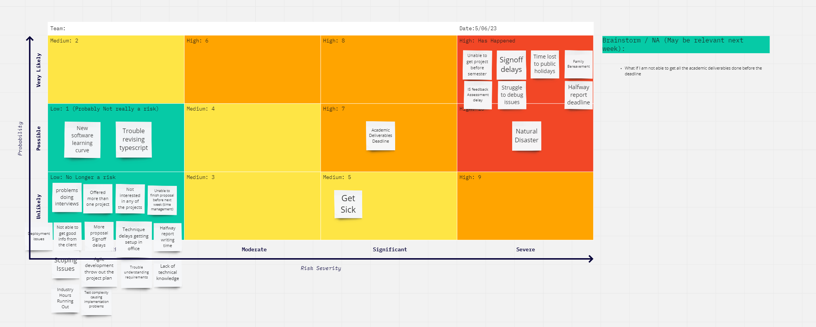

Table 33 *Final Inactive Risk Table*

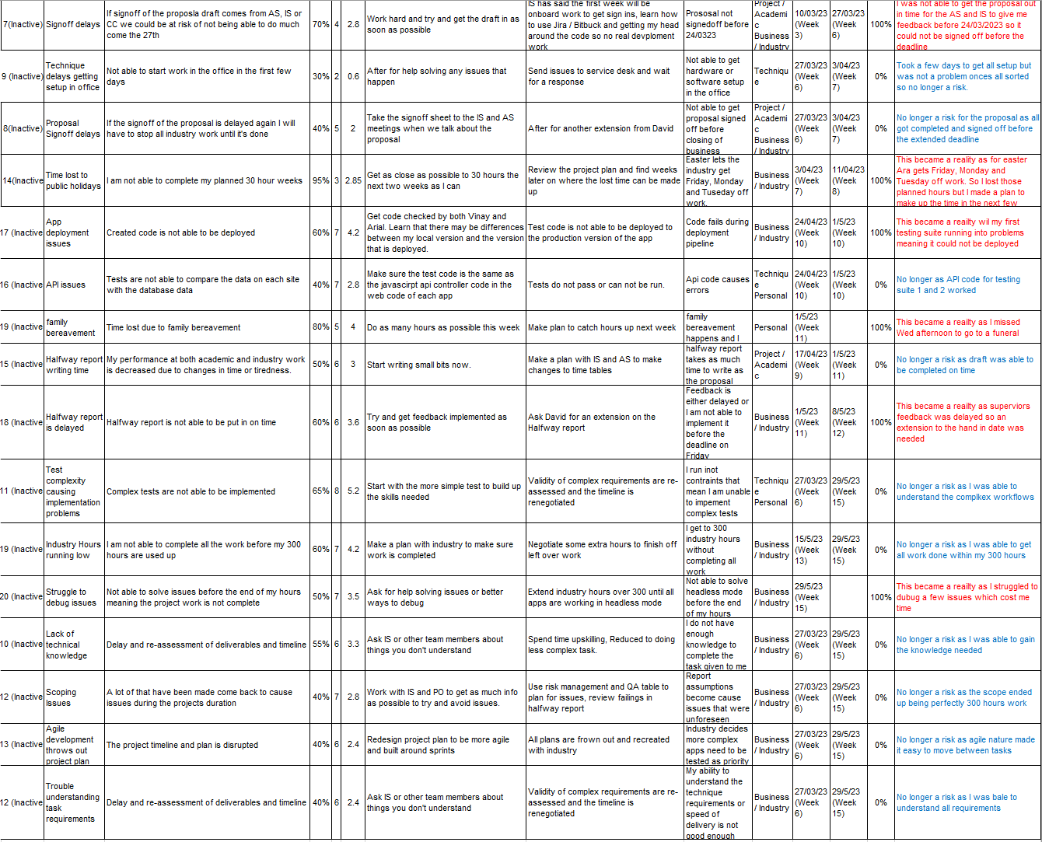

## Reflection

### What Went Well

I think I was very well organised and effective with my risk assessment. By making sure to update everything weekly I was able to see risks coming using the weekly reports and with the help of my supervisors create mitigation and contingency plans that helped make sure the risks that did occur only had small impacts on the timeframe of the project. For example, my family bereavement and illness discussed in the above project plan section only lost me three days between them thanks to good planning and risk management.

### What Didn’t Go Well

Many people who have looked at the brainstorming as shown above have found it confusing and questioned how the probability and risk severity words correspond to the numbers both on the board and in the risk assessment. I have even confused myself with the system as I noticed at one point some of the impact numbers in the Risk Assessment were different to the ones for the same risk on the Brainstorm Board by 1. In hindsight what I should have done was change to the Virginia Tech (2006) suggested template which uses words to convey levels of Probability and Severity. For example, Severity ranges from Catastrophic to Negligible, while Probability ranges from Frequent to Unlikely. These words give the risk and overall risk level of high, medium, or low. This approach would have fit in nicely with my brainstorming board and could have made risk identification easier. If I had the chance to do the project over I would make sure to change to the Virginia Tech assessment model. A lesson for the future to not always go with what is familiar as somethings the new approach fits better.

# Quality Assurance

In this section, I will go in-depth into how quality assurance will be maintained during the duration of the project. The project has several deliverables that need to be done for the different clients during the process as listed in previous sections of this report.

## Approach

Using a derivative of the Virginia Tech QA Table for management of Quality Assurance (Virginia Tech, 2022) as shown below in Table 34 and Table 35. Each deliverable is listed and then planned out what standard the deliverable will need to be in when finished for the customer to be satisfied, what I will do with each deliverable to make sure it reaches the needed quality, how frequently each will be reviewed and iterated, who is responsible for each deliverable getting done and when they need to be done by.

The report will be reviewed weekly by me with both my academic and industry supervisors. It will then be updated when each deliverable is at a stage that could be considered complete, where it will be judged by the appropriate stakeholder to see if it meets their success criteria and the criteria established in the report. If not, it will go back to development until it does meet the criteria.

The method was selected because of my familiarity with it after using it in BCDE311 where it worked well for me overall at the end of the project to judge quality, but I did fall behind in updating it till the end of the course, so my goal is to do better updating the report weekly this time.

As per Table 34 and Table 35, the QA table is broken up into six columns as per the ITPM Quality Management Plan (ITPM Quality Management Plan, 2010):

1. Project Deliverable – The name of the deliverable subject to quality assurance.
2. Deliverable Quality Standards/ Customer Satisfaction – The standards and expectations each deliverable should meet.
3. Quality Assurance Activity – The activities that will be completed on each deliverable to maintain standards.
4. Frequency/Interval – How often the Quality Assurance Activity will be completed.
5. Who is responsible – The person or people responsible for reporting on the deliverable.
6. Date of Acceptance – The date planned for acceptance and the actual date the deliverable was accepted.

## Quality Assurance Table

### Academic Deliverables

Table 34  
*QA Table for Academic Deliverables at Week 5 (Ending 24/03/2023)*

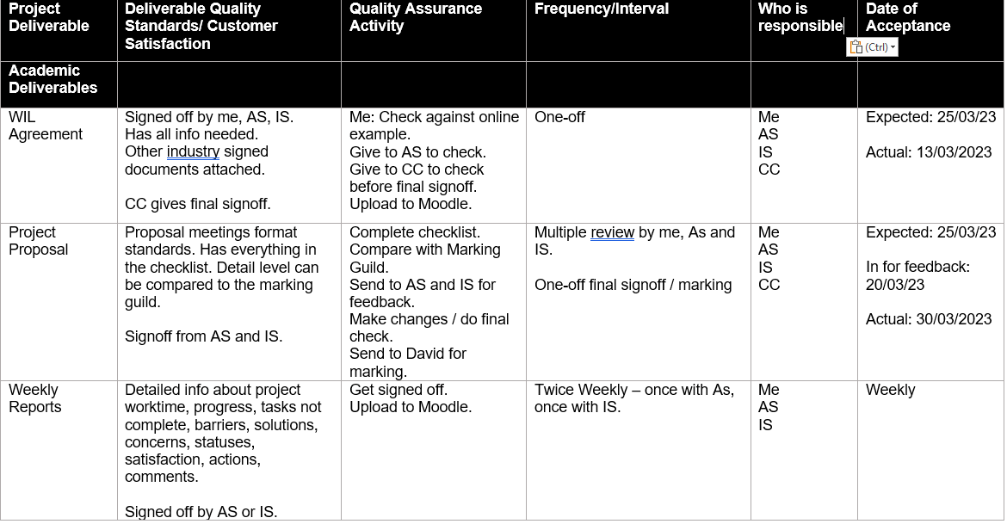

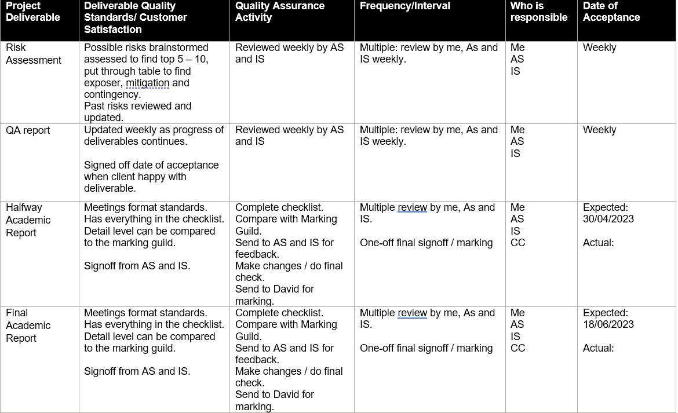

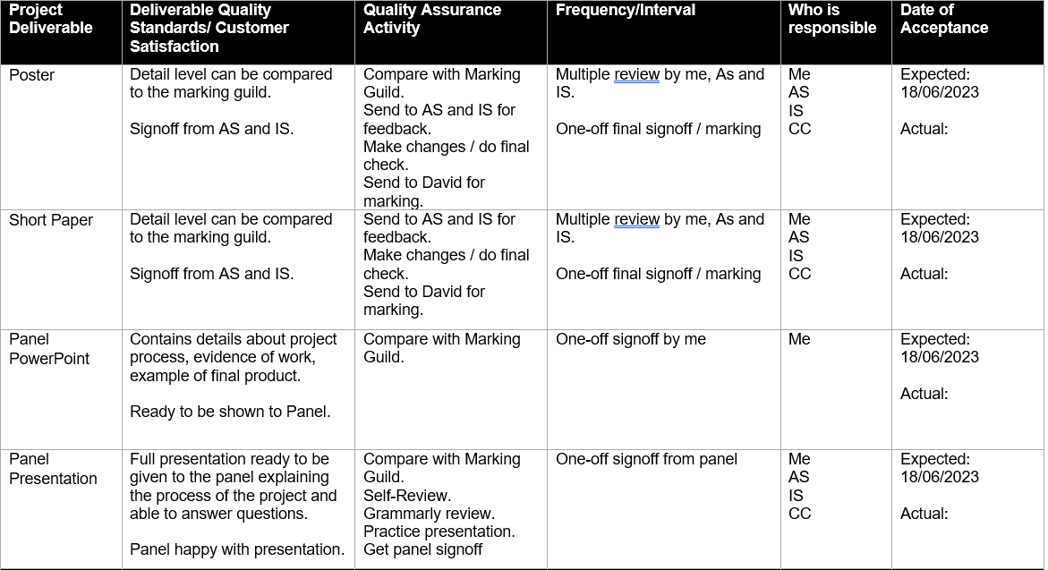

### Industry Deliverables

Table 35  
*QA Table for Industry Deliverables at Week 5 (Ending 24/03/2023)*

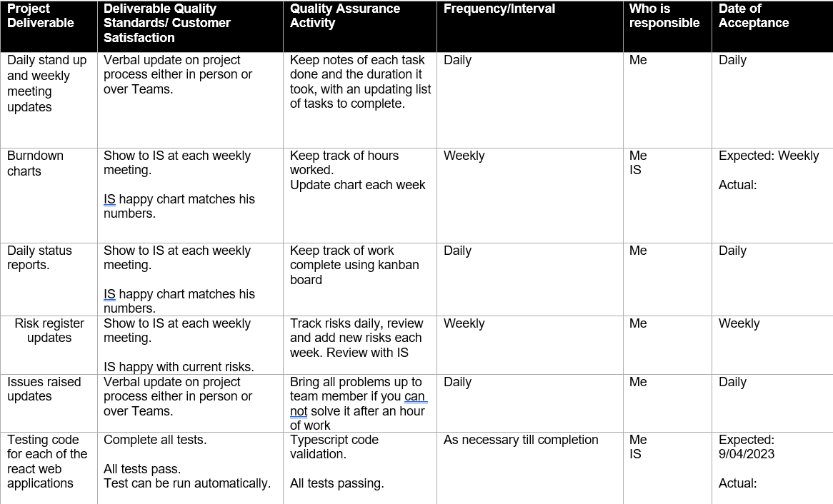

## Test Plan/Scenarios/Cases

With the project being based around creating testing suites for five web-based apps and one desktop-based app end-to-end testing is part of the development of each of the deliverables. A testing plan will be created to make sure the tests being created automate real-world input so that each tests a real-world scenario. A test plan will be used where each test is given an ID, described, and given an expected result then these will be compared to the actual result, a tick off if the tests passed or not, and a section for comments about issues or follow-up. Chowdhury (2018) found this was the best practice when doing end-to-end testing.

Bose (2023) believed when doing end-to-end testing, the software is tested from the end users’ perspective to validate the application’s overall behaviour, including its functionality, reliability, performance, and security. Aiming to identify any defects or issues that may arise when different parts of the application interact with each other.

Bose (2023) suggested the Best Practices steps for End-to-End Testing are:

* Test like the user. Get into the mindset of someone using the app for the first time.
* Use acceptance testing documents and user stories that help clarify the user’s point of view. Design test cases accordingly.
* Focus tests on app features whose failure will cause maximum issues. Start with these features, and design more elaborate test cases to verify them.

## Halfway Report

## Updates

As seen in the above Table 35 the name of each app that needed to be tested is listed with an expected acceptance date. This has been changed as seen in the below Table 37 to reflect the shift we made during the process of creating the proposal as discussed above in the Project Plan Halfway Reflection section from a Waterfall like Project Management Life Cycle to Agile Project Management Phases. Meaning the focus of the industry deliverable shifted more to completing sprints by a day of acceptance but the deliverables are about using the listed documentation to report progress daily or weekly. This ensures working software can be delivered to be tested against the stakeholder’s standards, but we can be more agile with the competition dates as some subtasks have had to be moved into the next sprint if they were not complete by the date of the sprint retrospective which would have thrown all the date of acceptance actual dates above out of relevance if we had continued with the above approach.

The belowTable 36 and Table 37 has also been updated weekly with both academic and industry supervisors. The date each testing suite has been code reviewed and accepted for deployment is listed in the “Testing code for each of the react web applications” row as have the dates the project proposal and signoff were given the Course Convenor’s final approval and marks. Two new academic deliverables of Proposal approval document and Halfway Assessments (from IS, AS and self) have also been added to the table after the feedback I received about the Project Proposal from the Course Convenor as discussed in the Project Scope Updates and Reflection section above.

### Test Plan/Scenarios/Cases

As stated above I use Bose (2023) suggested Best Practices steps when creating the tests for each app. When I am at the start of a sprint with a new app, I first go through a discovery process with myself or one of the team. During this process we lay out all the things that a user would need to be able to do to use the app in the way they want to. From this I write down a list of actions and then group them into logical steps for example click on the student Id textbox, enter a valid Id, and click the search button are grouped and become a user story of “verify a user should be able to search with a valid student Id”. These then become a list of scenarios which are the functionality of each test. See the below Figure 21 *Testing Suite 3 Test Script List* for a full example from app 3.

From there the tests are created in code as shown in Figure 22 *Testing Suite 1 End 2 End Test Code* below and tested to make sure they add text in the textbox I want them to or click the button needed. After that they can be logically grouped some more. For some apps the user would fill out a whole page of textboxes before clicking a submit button so all those actions are grouped together but kept as separate tests so each can be done individually. While in other applications one form is used to search for the same person depending on the info the user has like in app 2 Password Change Tool see Figure 20 *App 2 (Password Change Tool)*, which lets a Library staff reset a student password by search for them with their student ID, Email or name and date of birth. In this case this was separated into three separate tests with actions of enter text in right textbox, click search, confirm info, and click reset button. This allows me and the team to make sure each test is doing the correct functionality when it is run and covering a significant part of each application’s UI which needs to be tested.

Table 36   
*QA Table for Academic Deliverables at Week 10 (Ending 30/04/2023)*

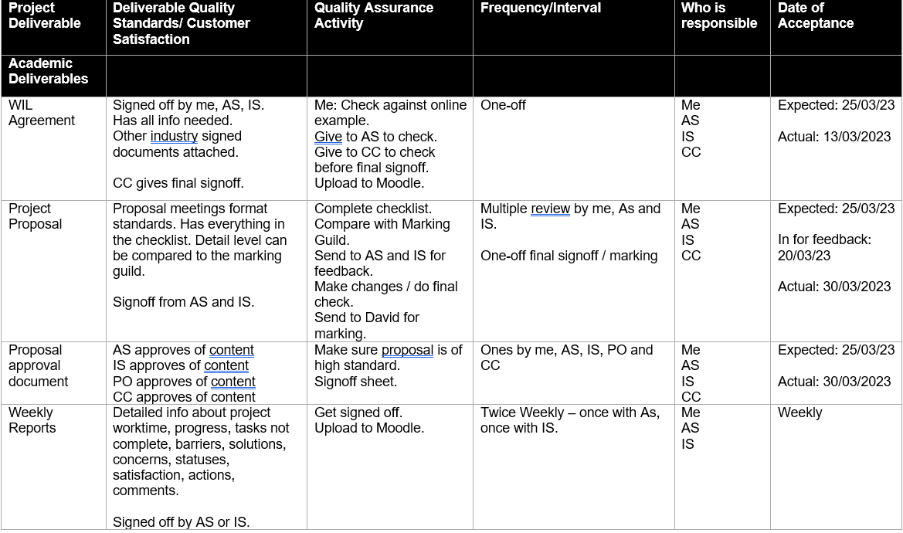

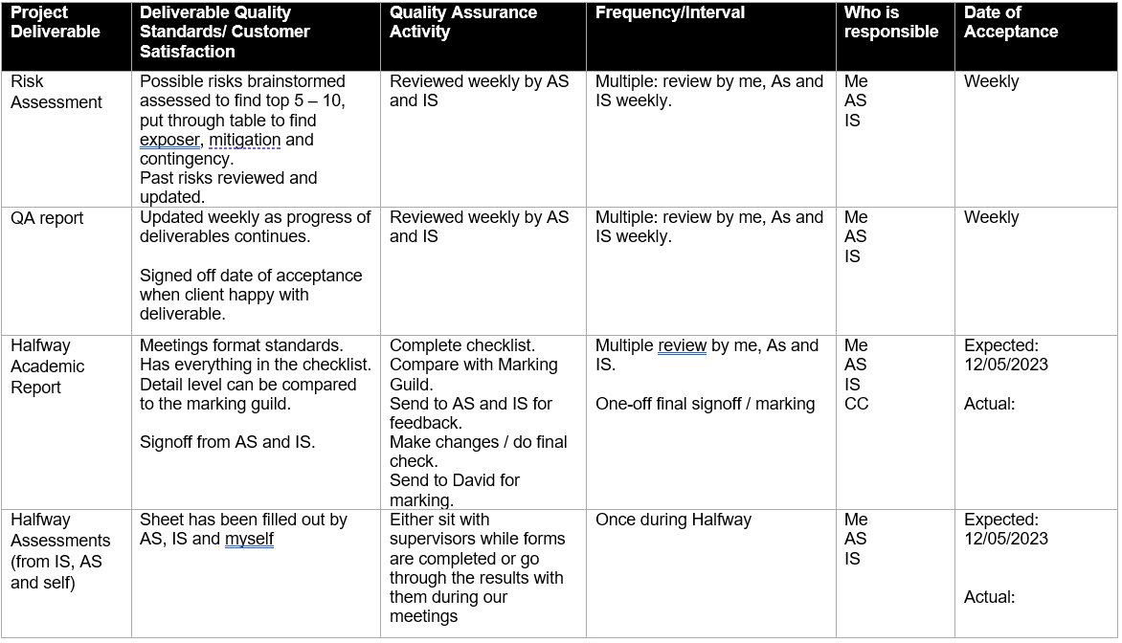

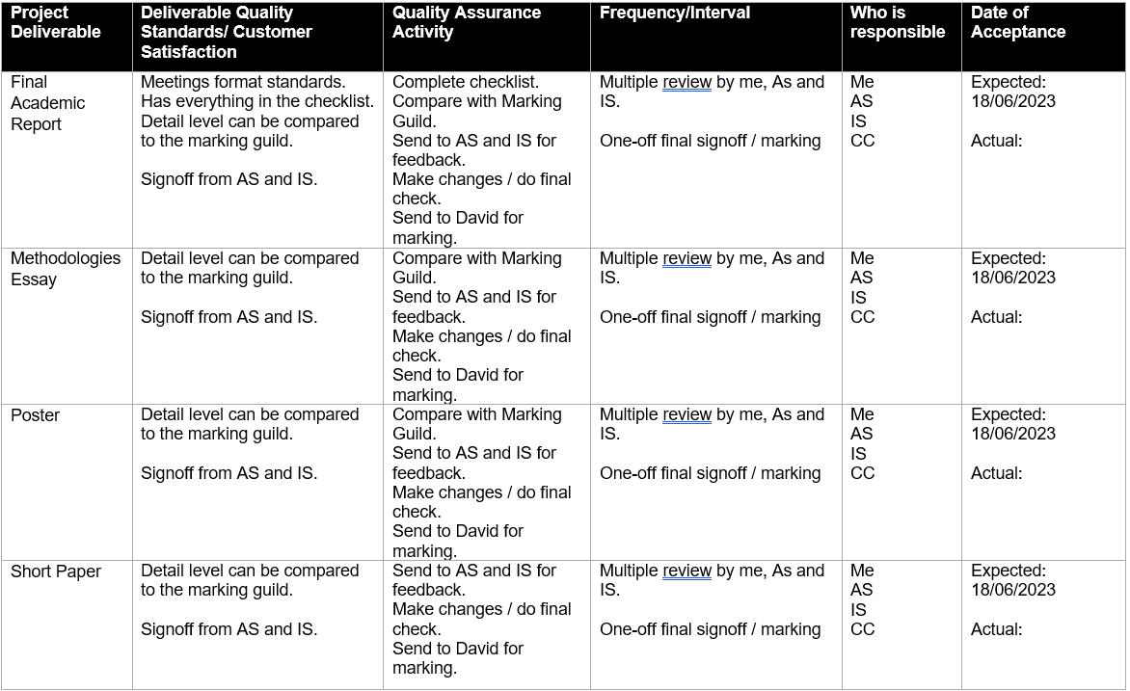

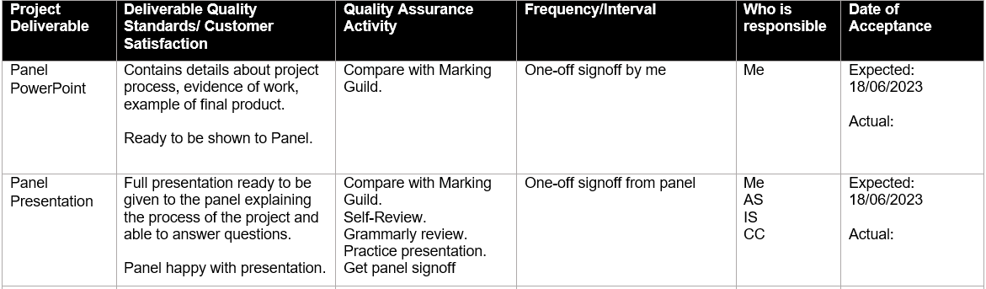

Table 37   
*QA Table for Industry Deliverables at Week 10 (Ending 30/04/2023)*

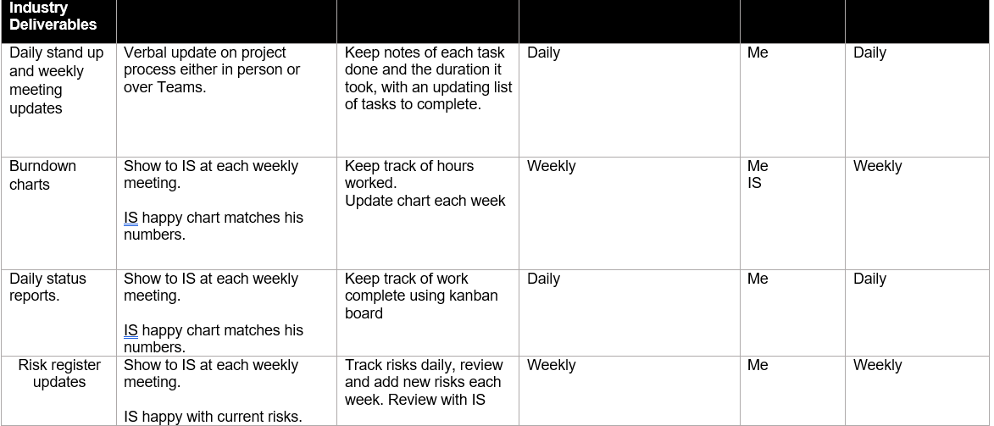

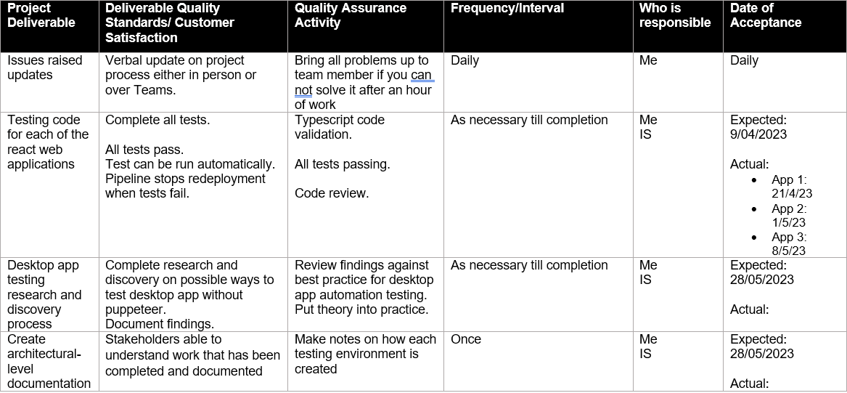

Figure 20   
*App 2 (Password Change Tool)*

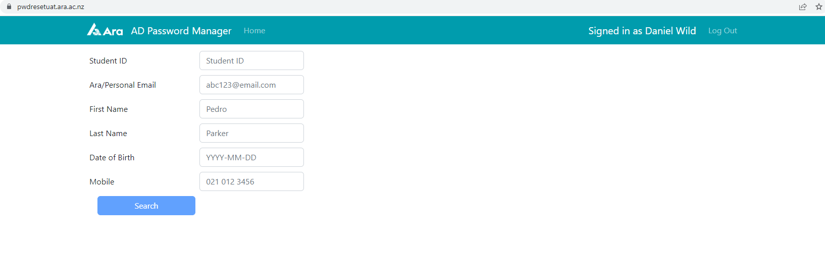

Figure 21   
*Testing Suite 3 Test Script List*

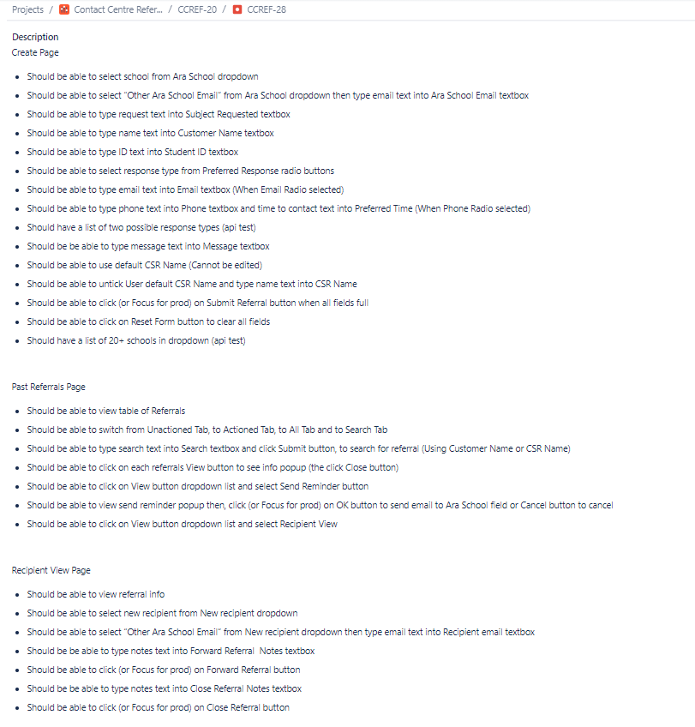

## Reflection

### What Went Well

The high-quality standards I maintained with the feedback across both academic and industry for the Project Proposal meant there was a lot of back and forth followed by a few long nights writing for me but ultimately produced a Project Proposal that I think was the best I could get it in the given timeframe. Meaning a high mark, I was very happy with and a very strong base to build on in the following versions of the report.

The QA of the code for each testing suite has been maintained using Bitbucket. When each app has been completed, I send a pull request to the developer branch in Bitbucket and add one of the team as a reviewer. The team then review the code and leave notes for me to make either changes to refactor before they can approve the merge or suggestions for things they would like to discuss or for me to think about when I work on the next testing suite. Only when this is done does the merge happen and the code is sent for deployment at which point, I add the name of the app and the date to the QA table as shown above. Which makes sure the quality of my code is kept at a high standard or allows for me to improve my knowledge. I have been very happy with the results of my first three code reviews as no major problems have been raised at for any of them, it has helped to highlight my biggest weakness so far has been code formatting which I am working on improving.

After the first few weeks of both onboard learning and programming of the first testing suite, I was able to send the code for review. Once it had been put through a linting process to enforce style, formatting, and coding standards it was given the go-ahead by the team to be merged into the development branch and sent for deployment to the main branch. Meaning my coding had functionally and stylistically met the acceptance standards of the team. Showing that I can complete the task given to me during the project so far to industry standards. As shown by the below Figure 22 *Testing Suite 1 End 2 End Test Code* and Figure 23 *Testing Suite 1 Test Output* which show part of the main end-to-end testing code which has been linted and approved for deployment, with the output in the terminal when the tests have finished running.

Figure 22   
*Testing Suite 1 End 2 End Test Code*

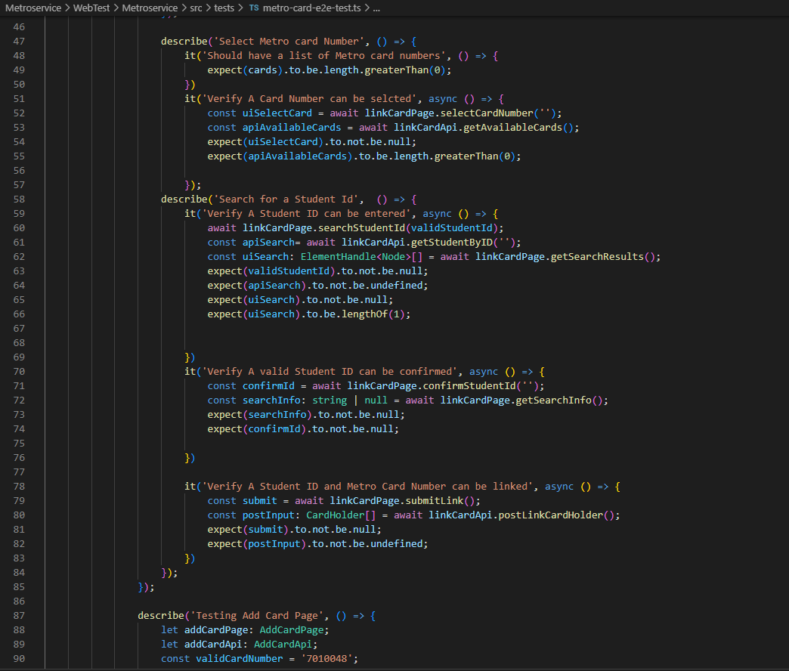

Figure 23   
*Testing Suite 1 Test Output*

**

### What Didn’t Go Well

I have struggled so far to keep to the expected date of acceptance list in the above Table 36 and Table 37 as the project proposal and approval document needed to be pushed out after I got an extension on the due date because I was not able to get the Proposal feedback through and implemented before the original deadline. It is also looking at this moment in time like the Halfway Report might end up in a similar situation, so I very much need to improve my process of meeting deadlines going into the final report and other deliverables by starting them earlier than I think I need to so that I finished this project on time.

## Final Report

## Final Summary

The biggest part of my approach to quality assurance during the project was constant feedback, using the continuous improvement model detailed in Figure 12 *Continuous Improvement Diagram* above in the Project Plan Section. Each time a deliverable was shown and given feedback the process would be completed. For example, each week I would create the weekly report and update the risk assessment. These would then be shown to the supervisors. This acted as the Plan and Do phases as I thought about what I had achieved in the past week or what risk could happen in that phase of the project, then created the necessary documentation around each. During the meetings we would do the Check phase where the weekly reports were checked, and feedback was given. Often only small wording was changed, other times we changed a section like the General Reflections to have more focus on what I wish I would have been taught in class. This was done to reflect the skills course evaluation done in the above section of this report. Once this feedback had been given, I would act on it either after the meeting, if it was an update that was needed on that report or use the information when planning and doing the process the next week. This process helped to keep the standards of all the deliverables high.

This also helped all the variations of the academic reports. Each report would be checked by each of the stakeholders meaning the process was being done by four people at the same time, resulting in a lot of feedback to action that greatly improved the quality of the report as each round of feedback was completed. The number of rounds of feedback was different depending on the report. The proposal went through three rounds of feedback while the halfway and final only went through one or two rounds of feedback.

The process was carried out more regularly and vastly on the testing suites. Team members would make suggestions either in meetings when I asked a specific question or when they were showing me past examples of tests. These would help me to either solve problems or improve the overall effectiveness of the tests. Often the improvements would be so impactful that they would change the way I created the next testing suite or could retrospectively improve testing suites that had already been accepted. For example, the update from each app having its own individual Microsoft Login interface to it becoming a global file that each app downloads as a dependency library cut down on a lot of duplicate code and problems in the future when a change to that specific code was needed. Once the apps tests were ready, they were given a final check by one of the team members familiar with the respective app in a Bitbucket pull request. This was a code review before the code was pulled into the development branch and merged. The final checks were done here to make sure the code was up to industry standards. My first code review gave me changes to my linting and spacing standards which needed to be updated before approval. These changes were then carried through into all the other testing suites.

Only when this process was completed would I be happy that the quality of the respective deliverable was high enough to be sent for marking and the date of acceptance be updated in the Quality Assurance Table as shown below in Table 38 and Table 39.

Table 38 *Final QA Table for Academic Deliverables*

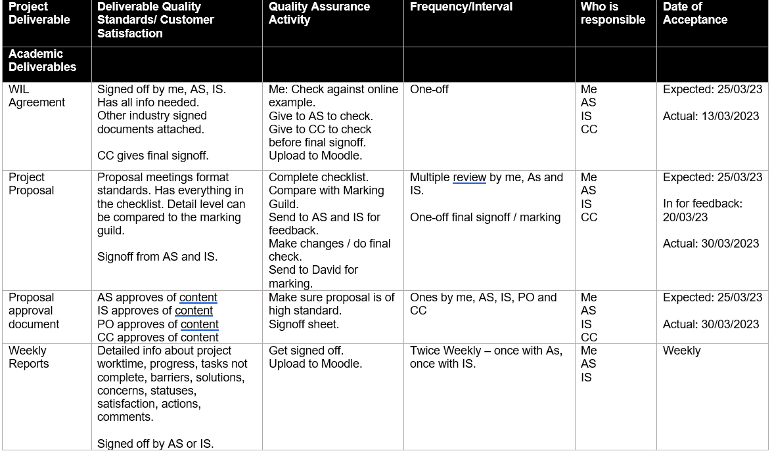

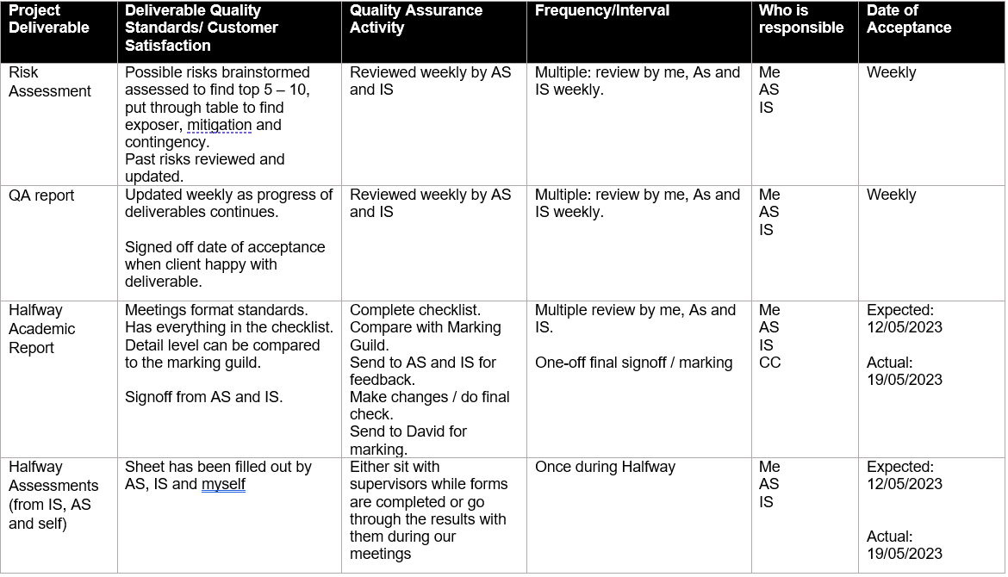

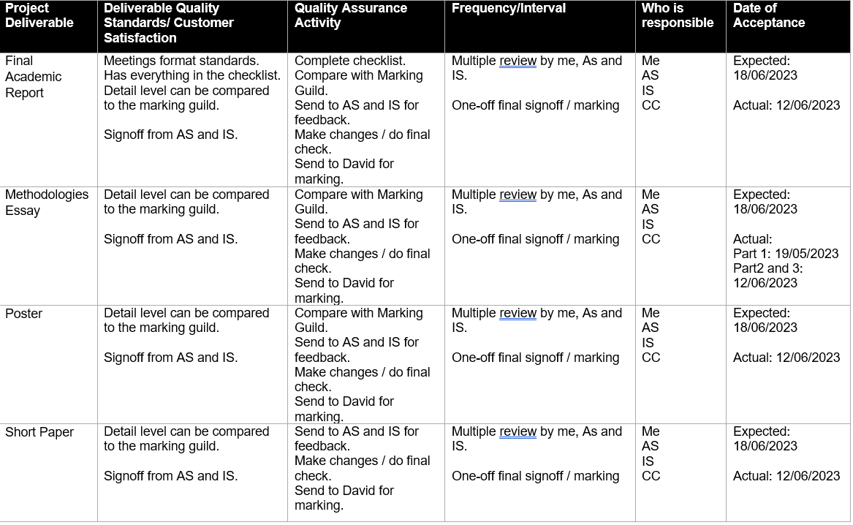

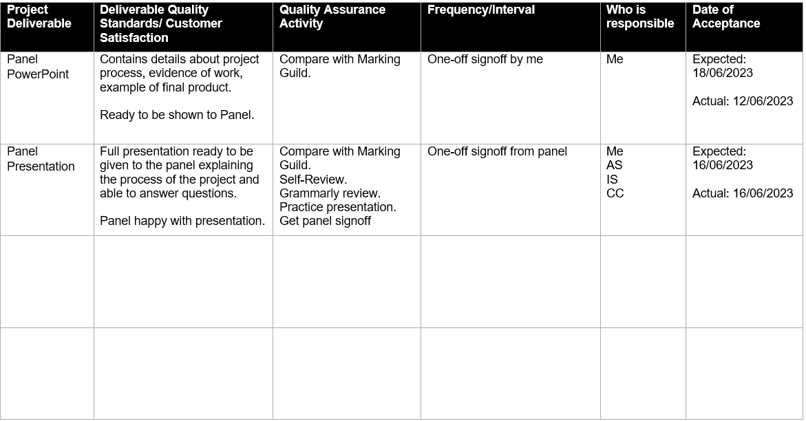

Table 39 *Final QA Table for Industry Deliverables*

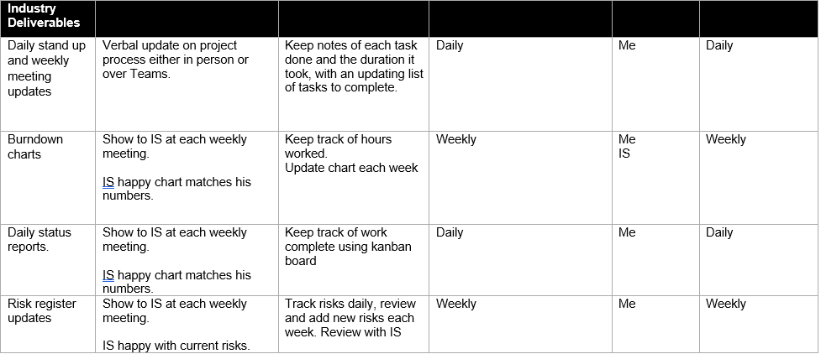

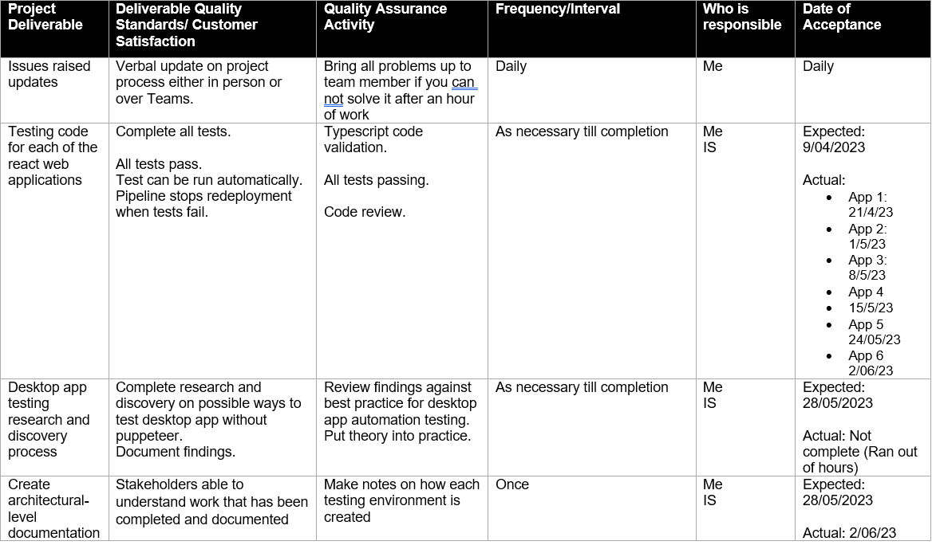

## Reflection

### What Went Well

The process detailed above proved to be very effective in maintaining the high standards of the deliverables. As we progressed through the tests suites the number of changes needed after code review was very few with some apps like testing suite 5 being accepted first time with no changes needed. The reason for this even though the apps were increasing in complexity was that they were all created using the same template meaning that any suggested improvements made during the earlier suites’ creations, could be used to solve problems in the later suites. Showing that the continuous improvement model not only can be used to increase the standards of the product created but also of the skills of the people implementing the process.

### What Didn’t Go Well

What I have learnt during this project is that QA is about balance. With all deliverables either no matter if they are short weekly reports, huge reports or testing code there will always be ways they could be improved. The trick is to manage a willingness to make everything perfect with dates that need to be met. At times during this project’s process, I have got frustrated that the deliverables are not perfect, and I have lost time or missed original hand in dates due to doing more rounds of feedback. The lesson I have learnt that I will take into future projects is that when dealing with real-world stakeholders and time pressures as long as everyone is kept informed about progress high standard deliverables accepted a week later than planned are better than low standard deliverables accepted a week early.

# Methodology

In this section, I will go in-depth about the development methodology that will be used throughout the project duration. The software development methodology is a process or series of processes used in software development to give projects structure and defined phases. While giving teams a framework for work management and collaboration.

## Overview

Alaidaros (2018) explained Agile methods refer to the family of lightweight software development methods that define a process of iteration, where the design, construction, and deployment of different pieces can occur simultaneously. It can also provide a shorter development cycle, higher customer satisfaction, and rapid changes to the business requirements. Scrum and Kanban are considered the two powerful Agile methods. This is because both can optimise the development process by identifying the tasks and managing time more effectively.

Agile Kanban method has five defined principles, which are to limit work in progress, visualise workflow, measure and manage flow, make process policies explicit, and use models to recognise improvement opportunities. Alaidaros (2018) suggests Kanban is a vital method for managing workflow and controlling waste. It does not push the work tasks to members, but it utilises the pulling system. All team members must have only one task to work on at a specific time. After finishing that task, a team member can pull another task.

Radigan (2021) explained that a Kanban board is used to visualise the workflow and monitor the project progress by showing the activities of the development process and keeping WIP in control. A basic board has a three-step workflow: To Do, In Progress, and Done. Though some teams also add an on-hold or review column for tasks that cannot move forward at that time. Each task is represented by cards on the board to allow the team to track the progress of work through its workflow in a highly visual manner. The cards only feature critical information about that work item like a brief description of the job and how long that piece of work is estimated to take. Allowing all stakeholders to see the state of every work item at any given point in time insuring increased focus, full traceability, and fast identification of blockers and dependencies.

I will implement Agile Kanban during the development of my project by using Jira. Atlassian (n.d.) advised Jira is an agile project management product developed to provide agile methodology methods to businesses online.

I will plan each deliverable with my industry supervisors to break them down into smaller goals and tasks which can then be added as cards to my board. I will then move each one as they progress through my workflow and will be able to immediately show my stakeholders tasks that either have been done, are in progress, or need their review.

The reason Kanban has been selected is that the Ara ICT Division team already uses it so they want to continue the teams focus on Continuous delivery (CD) and Continuous integration (CI) as stated in the project scope, while also being able to provide me with a framework that will help guild me through my project using their Kanban experience. The CI/CD pipeline is essential for development teams to ship software fast while ensuring high quality. Kanban and CD complement each other because both techniques focus on the delivery of value.

## Literature Review

Agile methods are widely accepted in today’s era as approaches with multiple benefits over traditional methods. VersionOne (2022) suggested in their 16th annual State of Agile survey that four out of five organisations (80%) are using agile or a combination of agile and another method with the majority of those responders in the tech industry. With just under nine in ten responders saying they are leveraging scrum methodologies and half leveraging Kanban making them by far the most popular method frameworks. In conclusion, the survey stated that if agile is done successfully its respondents found that benefits accrue for both individuals and organisations showing the main reason organisations continue to invest in agile more each year.

Kumar (2012) advised that the International Journal of Computer Technology and Electronics Engineering (IJCTEE) did a study on the impact agile has had on the software development process. They found that the main benefits were firstly the improvements to the handling of requirement changes thanks to a planning phase that directly involves the customer and implements a customer control process throughout the project’s development. Secondly improved fault detection and testing feedback because of testing being performed each iteration meaning faults are detected earlier and can be fixed before they increase in severity. Finally increased overall performance thanks to daily stand-up meetings providing opportunities to exchange info and fine-tune improvement continuously. This encourages more teamwork and better communication which leads to knowledge sharing, self-organizing teams, and increased team morale. In conclusion, the IJCTEE study found agile in software development increased team productivity and performance as well as individual output in organisations that invested in implementing agile into their business culture.

Alaidaros (2021) advised that the Independent Journal of Management & Production (IJM&P) reported on the challenges and opportunities presented by the Kanban method. The concept of Kanban has been introduced at Toyota in 1947. The term originated from the Japanese word for ‘signboard’. It’s a visual process management system that can manage knowledge and work by considering the Just in Time delivery approach. The major benefits IJM&P found were visibility and understanding of the development process, flexibility, and responsiveness to project change, improved communication and transparency between teams and stakeholders. While the challenges IJM&P found were that Kanban is only suitable for teams with overlapping skills where everyone can pitch in to help move the backlog or that problems with WIP limits or small breakdowns in communication can cause scheduling lag or whole process shutdowns. These challenges have given rise to the opportunity to improve the method by combining Kanban with other methods like Scrum, IJM&P found that Scrum ban and other integration of different methods have started to be adopted by many teams to try and mitigate the flaws in the separate methods.

## Critique (Pros and Cons)

### Pros

Cohen (2022) suggested that the Agile Kanban methodology is extremely beneficial to most projects but has problems that mean it can fall short when trying to apply it to more complex projects with very large teams. A big benefit of Kanban is task clarity. With the tasks laid out on the Kanban board it is made clear what is needed, in progress, on hold, or complete. Allowing the team to flow easily from one task to the next. This also has benefits to project status. It allows the stakeholders to see the current status of the project and each individual without having to look over their shoulders. It also lets the team members align with each other so that they know at a glance what progress has been made, what my teammates are doing, what am I supposed to be doing and what am not supposed to be doing. This should overall improve team efficiency. This gives the team a better focus that reduces individual stress as high task visibility makes your team members worry less about forgetting important things and focus on the small task they are currently working on.

### Cons

Petit (2022) explained the cons of Agile Kanban methodology are mostly based around problems that occur with its simplicity if your Kanban board is the only tool you are using to track your project the lack of time frames and schedules makes it difficult to predict when tasks are expected to be completed or when the whole project could be finished. The simplicity of your Kanban board can also give way to complexity when managing large projects, as lack of proper maintenance can lead to the boards becoming less easy to read and reduce the team's efficiency. Teams need to get used to being very disciplined in making updates for the methodology to work optimally meaning a team that does not buy into the Kanban can quickly find itself with boards that are out of date and not able to tell stakeholders anything of use. This can also be exaggerated by a lack of documentation, Kanban method does not emphasise the creation of documentation meaning problems can happen when complex projects are handed over to new personnel or other teams who only have in-progress boards to work off.

## Halfway Report

## Methodology Essay Summary

Sacolick (2022) tells us that in 2001, a group of software developers began to question the efficiency of the traditional waterfall methodology in the technology industry, where small startup teams were asked to produce websites, applications, and new capabilities more than ever before. In this rapidly changing environment, they needed to be able to respond to change quickly by working in an iterative and collaborative process that was not slowed down by up from documentation. The groups’ beliefs about how the modern software development process should operate became the Agile Manifesto, which outlined the principles that would be used to deliver better software.

In my essay, I will compare the similarities and contrast differences between Scrum and Kanban in theory and why using a mix of both is a benefit. I will also go into detail about my time putting both into practice during my project work to illustrate why the mixing of the two helped hide the negatives of each. Finally, I will compare the theory with my practical experience to evaluate if it was the right choice of methodology.

Scrumban as a hybrid of Kanban and Scrum provides many benefits to teams if they have experience with either methodology separately or if they have no experience with either. It also makes up for the weakness of the individual methodologies by allowing each team to be adaptive in how much of each methodology they integrate into their version of Scrumban until it is fit for their own purposes.

For more please see separate Methodology Essay.

## Updates

Thanks to my time in the industry so far, I have gained a much clearer idea of how Kanban works in an industry environment, as shown below in Figure 1 above and Figure 24 *My Kanban Board at End of Sprint 2* below the boards is broken up into lanes for each team member. Things that have been assigned to me are shown in the to-do lane. Things that have been stopped from progressing for any reason are moved into the blocked lane. The tasks I am actively working on each day are in the in-progress lane. When in-progress tasks are at a working state, they are moved into the testing lane where they can either be reviewed by other team members or iterated by me as needed. Overall tasks are moved to the deployment lane when they are ready to be merged with the main branch and employed to either the UAT or PROD versions of the site. This is a bit more complex than the three-step workflow: To Do, In Progress, and Done explained by Radigan (2021) which I discussed above in the methodology overview section.

I originally planned after the change to the methodology as discussed in the Project Plan Update section, to have my own sprint board in Jira linked to the team’s Kanban boards so that I could keep track of the sprints planned out with my IS. However, this proved hard to do due to Jira wanting to put every task created into the main Kanban Board meaning any task I created for my sprints was also added to the team’s board causing double-ups and confusion. Jira would also only let a task for a job be added to a sprint if I had permission over all tasks that had ever been created for that job. Which would have caused a lot of problems with permissions as many of the apps go back many years and have many tasks linked to them. In the end, I quickly gave up on that idea and decided to track my sprints using the various spreadsheets shown in this report.

Figure 24   
*My Kanban Board at End of Sprint 2*

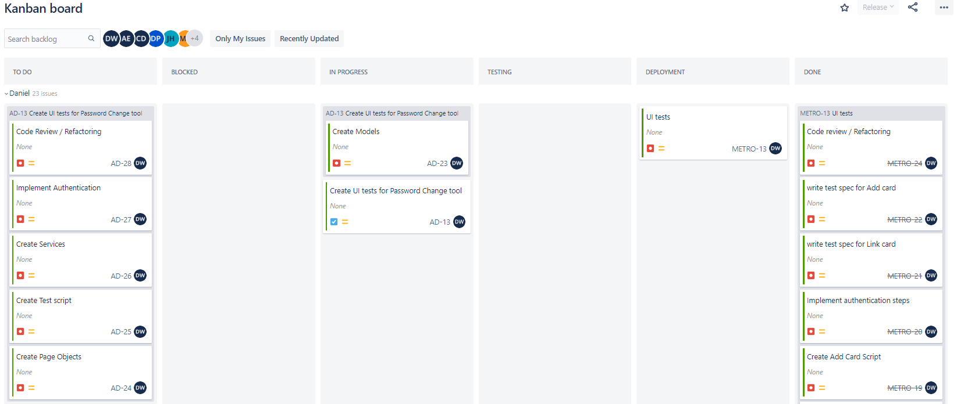

## Reflection

### What Went Well

I think I have adapted to and implemented the Kanban methodology well. It very much helps going into a team that have been doing it for a long time and so are very experienced with it. So, from day one I got to see Kanban in action in a real work environment. The team showed me how they talk about what they did the day before and are planning to do today during the daily stand-up meeting. This helped to illustrate how the workflow and pull system of the Kanban board worked with each team members card getting moved across the board each day till they are complete, and they assign themselves new tasks from the backlog. This helped me as I broke down my tasks into small sub tasks as seen in Figure 24 above which allowed me to focus on progressing and time tracking so that I could make small incremental steps each day towards delivery the working UI tests for each app during my sprints. Overall, I think seeing the teamwork has given me an appreciation for how a well implemented Kanban methodology can affect productivity during IT projects. Which shows in practice what we learnt about Agile methodology in the level 6 and 7 classes as discussed in the Student Skills Update section above.

### What Didn’t Go Well

Tracking of process has been very spread out into different places for me. A discussed above in the Update section the sprint board did not work out, so I am tracking my progress across many different tools. At work it is reasonably straight forward as I use Jira to update the cards on the Kanban Board into the correct lane as shown above in Figure 24. I then update each subtask with the hours I have spent working on it from my tracking in my notebook. This then gives the job a total time spent which is compared to time estimates I did on each sub task before starting the job, as seen in the below Figure 25 *Jira Sprint 2 Task Breakdown and Time Tracking*. However, these then need to be transferred into my timetable and burndown to track the hours, my task breakdown, and weekly reports to track the tasks and my project plan to track the sprints. Meaning there is a lot of separate updating and duplicate data that could cause issues in the future if it does not match across all tracking methods. All this highlights to me the biggest con discussed above which is the simplicity of Kanban causing tracking and scheduling problems if the Kanban Board is the only tool being used to track the project. It has not caused any major problems yet, but I am considering finding ways to streamline and consolidate my Kanban tracking methodology as the project progresses in scale and complexity.

Figure 25   
*Jira Sprint 2 Task Breakdown and Time Tracking*

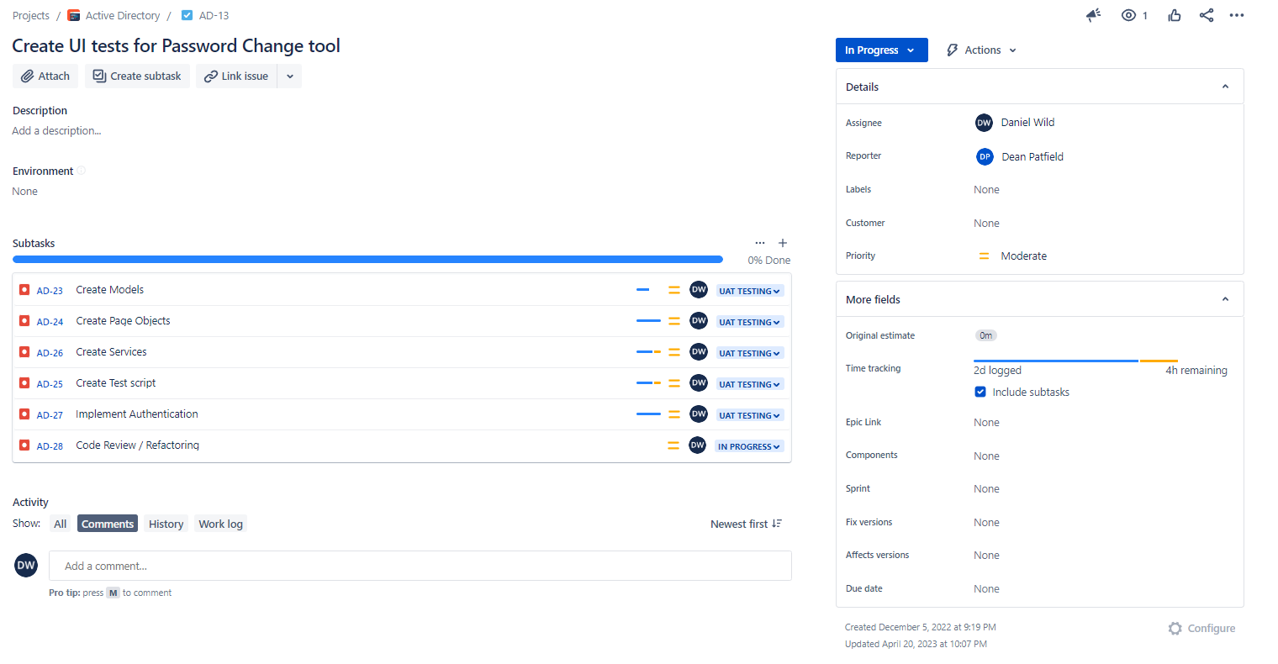

## Final Report

## Final Summary

In my methodology essay I compared the similarities and contrasting differences between Scrum and Kanban in theory to explain why using a mix of both is a benefit. I also detailed my experience putting both of them into practice during my project to illustrate why the mixing of the two helped hide the negatives of each. Then finally I compared the theory with my practical experience to evaluate if my approach to methodology was the right choice.

In my first section I found that Scrumban as a hybrid of Kanban and Scrum provided many benefits to teams if they have experience with either methodology separately. As it makes up for the weakness of the individual methodologies such as the complexity of Scrum for inexperienced teams or Kanban’s lack of structure, by allowing each team to be adaptive in how much of each methodology, they integrate into their version of Scrumban until it is fit for their own purposes.

In section two I detailed my experience that in practice Kanban provided the team with a structure that helped them continuously deliver a range of tasks from bug fixes to the creation of new applications while working within a less restrained structure that would allow any of them to jump to an urgent task at a moment's notice. This flexibility helped their productivity but could have hindered me as I worked through a set number of tasks in a set number of hours. For this reason, I required the structure of Scrum’s sprints to make sure each of my broken-down sub task on the Kanban Boards could be organised into a 60-hour sprint that would deliver a functioning product.

In section three I concluded that my slightly mixed Scrumban of Kanban’s task management and Scrum’s time structure proved to be very effective as it provided the stakeholders with information they needed on the Kanban Board while allowing me to keep close track of my process per hours during each sprint. It was a bit of a slow start as we got rid of the old methodology and got to know Scrumban but once I got the hang of it, it proved to be the best possible solution. I learnt a lot about implementing Scrumban I will take those lessons into the future as I do not want to go back to working without some form of Agile.

# Professionalism

In this section, I will go in-depth about how I will meet professional standards during my industry and academic throughout the project duration. Professionalism is important as it reflects how I and Ara are seen within the wider industry. The following standards are things I will be mindful of when completing my work.

## Professional Standards

Professionalism involves consistently achieving high standards, both visibly and behind the scenes whatever your role or profession. Professionalism is a powerful quality. It allows you to fulfil your role to the best of your ability. It helps you to impress and inspire others. And it gives you a deep sense of satisfaction and self-worth. I will meet these standards by drawing on my experience from both working in an office environment and what I have learned from my time studying at Ara. Also as being mindful of both the explicit rules of my new work environment such as the dress code but also other rules and expectations that may not be written down such as professional behaviour at meetings.

### Reliability and Accountability

I will make sure I am as organised as possible during my industry and class hours; I will turn up on time prepared to start work. I will use my experience from three years of meeting assessment deadlines during class work to make sure I can meet the industry deliverables and be relied upon to complete the academic work.

I will come in with the right attitude ready to listen to instructions and follow directions. I am ready to accept and act on constructive criticism as I am keen to learn about the industry work and challenge myself to improve my current skills throughout the process of the project’s duration.

### Communication

Professional communication has many different aspects it can mean respecting other people’s time by knowing when to start a conversation with them or making the most of your time with another person by staying on topic, asking clear questions, and completely answering any questions you’ve been asked. In a group setting allowing others to talk without interruption is a critical skill.

I understand communication is key to the success of projects so I will work hard on improving my communication skills around being clear thoughtful and decisive when giving updates and being able to ask for help when problems occur as I know this is currently a weakness of mine.

### Attitude

Professionalism means being a role model for politeness and good manners to everyone, not just those you need to impress. I will make sure I have a friendly and positive attitude when approaching my work. I will show respect when dealing with stakeholders. To be a true professional you need to stay professional even under pressure. I will make sure personal issues do not encroach negatively into the workplace.

### Teamwork

Being professional means feeling confident to show what you know not for self-promotion, but to help yourself and others to succeed. I will make sure I openly share ideas, skills, and knowledge and I will try to not be afraid to ask for help or admit mistakes.

### Motivation

Professionalism means being motivated to you get the job done and do it well. I will make sure I am motivated to do the work and show my passion for what I am doing and the chance to learn new things.

### Open to Learning

Well-founded confidence reassures and motivates other people, boosting your ability to influence and lead. It also pushes you to take on new challenges, because you don't fear damaging your professional reputation if things go wrong. I enjoy learning new things and challenging myself. I try to be confident about what I am doing but am always eager to do it better and achieve more.

## Relevance of ITP Code of Ethics

IT Professionals New Zealand (2017) believe that respect in society for tech professions is earned and maintained by members upholding a commitment to ethical values, so in this section, the tenets of the code of ethics will be explored and I will explain how they will be upheld during this project’s development. The Code of Ethics’ goal is to provide greater assurance and trust to clients and the public when working with tech professionals to help build and maintain respect in society.

### Good Faith

### Good faith is about treating people equally and with dignity making sure not to discriminate and being sensitive to the values and culture of all people who view our work.

### This is important because I will be dealing with a lot of other people’s work be it code, project management tools, data, and maybe some personal information so I will need to make sure I work with them in good faith.

### Integrity

Integrity is about working with honour, honesty, and professionalism to gain the trust of the community.

This is important for us as the class is working with real clients during our capstone projects. I will need to be able to work with integrity when dealing with the client as my skills, honesty, and judgment will reflect on both my and Ara’s reputations within the wider industry.

### Community Focus

Community focus is about putting the welfare and rights of the community before our interests.

This is important for me as I am dealing with testing internal Ara apps meaning I may be exposed to sensitive data stored within these apps. For this reason, I have signed a Confidentiality Agreement and as per Community focus ethics agree that the rights and welfare of the people come before the interests of me and my project.

### Skills

Skills are about applying our knowledge in the interests of clients so they will not compromise the other Tenets.

This is important for me as I need to make sure that I use my skills and knowledge to complete the project for the Ara ICT division in a way that does not compromise the other tenets.

### Continuous Development

Continuous development is about us committing to the long-term development of our skills and knowledge so that we can contribute to the collective wisdom of the profession in the future.

This is important to all the capstone project students because it is the basis of our projects, we are taking the knowledge we have learned over the past three years and learning how to apply it in real-world scenarios. If we do a good job like the students before us future students will get the same opportunity through Ara and our documentation will be able to pass our knowledge down to them to help them with their capstone projects.

### Informed Consent

Informed consent is about making sure everyone involved in a project is informed about the economic, social, environmental, or legal consequences which may arise from the project.

This is important for me as I am dealing with web apps that are used by Ara staff every day meaning mistakes may have economic consequences for Ara if the overall quality of the tested apps is reduced over time and social consequences as this could reflect badly both on myself and the ICT division.

### Conflicts of Interest

Conflicts of interest are about making sure clients or employers are made aware of any conflict the IT professional may have with the interests of the employers that could affect the quality of the service or the IT professional’s judgment.

This is important for me as I am dealing with branches of the same organisation between myself as both Ara student and intern meaning there could be a scenario where I could be exposed to personal data of myself or other people, I know though studying at Ara which could cause a conflict of interests with my project work.

### Competence

Competence is about following professional practice by not providing advice outside our area of expertise.

Important for me to remember to only interact with the apps I am tasked with testing in ways that correspond to UI testing and automation. All other things should be left to other people in that area of expertise.

## Relevant Legislation

In this section, I will go in-depth about the legislation that is relevant to the different aspects of the project I am working on and how I intend to meet their requirements of them.

### Privacy/Confidentiality

Under the Privacy Act 2020 (Privacy Commissioner, n.d.) for organisations and businesses to collect, store and share information they must ensure that:

* you know when your information is being collected.
* your information is used and shared appropriately.
* your information is kept safe and secure.
* you can get access to your information.

While working on my project working in the backend of many of Ara’s web apps, I may be able to see people’s data that is being stored or deal with sensitive data. For example, one of the apps to be tested is InformUS which is used by people to report incidents that occur at Ara. Ara Institute of Canterbury (n.d.-a) states in the Inform Us FAQ all reports are anonymous, and strict access controls mean the raw data can only be accessible by four individuals within the Institution. However, if the backend does hold some data which I access while testing it will be up to me to respect the privacy of anyone who has filled out a report and make sure I keep that data safe and secure while making sure not to share it with anyone.

To this end, I have signed a Confidentiality Agreement with Ara. LawHawk (n.d.) advised that a confidentiality agreement or also referred to as a non-disclosure agreement or NDA is a contract where parties agree not to disclose information covered by the agreement, typically used to protect non-public business information such as trade secrets.

The New Zealand Government Procurement (n.d.) explained that this means by New Zealand laws I have agreed to treat all information provided or made available to me by Ara as confidential and that I will take all reasonable steps to ensure that Confidential Information is protected from unauthorised disclosure.

### Copyright

The New Zealand intellectual Property Office (n.d.) advised that by New Zealand laws copyright applies automatically from when your work is created and lasts for your lifetime plus 50 years. Meaning Ara Institute of Canterbury Ltd owns the copyright of any code or other intellectual property covered by original works, created during the duration of my employment both during and outside of work hours with Ara Institute of Canterbury.

## Halfway Report

## Reflection

### What Went Well

During one of our weekly meetings my industry supervisor and I talked about team integration around the time of the end of sprint 2 where I had showed off what I had been working on up to that point to the team. We talked about perception if the team seemed impressed with the work done because this is the first indicator of progress within a team structure. The aspects above are not just things for me to try and implement but the whole team also need to do the same. In a team that does not integrate people well the new person might not feel they can ask questions of team members. This will slowly start to affect their professional standards, with no communication or openness to learning the attitude and motivation of the collective will be reduced which will kill the teamwork and reliability of the team. This will result in the projects failure as the team’s perception of a person will invariably filter up to the management who will need to act on what the team’s perception.

With this in mind we reflected on what we have experienced the last few months. I feel very much part of the team, they welcomed me into a very friendly atmosphere with very upbeat and motivated attitudes even despite everything going on with the Te Pūkenga merger that has been happening since I started. They have all been happy to communicate and help me where they can to pass on the skills, they have learnt both as students that did the capstone project and professionals working for Te Pūkenga.

For my part I hope I have conveyed a good attitude and motivation towards the work. I think I have shown my willingness to learn and work with the team so that I can use my skills to reliability deliver working software or accountability to take the initiative to fix any mistakes I make so that I can be continuously improving as I work through the project. Overall, I think both myself and the team have done well to meet and hold each other to the professional standards discussed above.

### What Didn’t Go Well

As stated above in the Professionalism Communication section I realise communication is my weakest aspect of the Professional Standards and I have had moments where I didn’t really know what to say about what I had done or was doing during the stand-up meeting or have been stubborn and tried to solve a problem by myself instead of asking for help. I am however very much aware of those issues and think I am getting more confident in my communication which I hope to continue to do as the project progresses.

## Final Report

## Final Summary

I continued my approach to professionalism as described in the above Halfway Refection. I continued to approach each day with a good attitude and motivation to learn while completing my work. I made sure to be accountable for any mistakes I made and worked hard to show initiative in solving any problems I came across. As discussed above the team continued to make me feel like an integrated, welcome part of the team. The team were all very keen to both view and discuss my work or help me with any questions I had, which I very much appreciated. Overall, I think both myself and the team continued to meet and hold each other to the professional standards discussed above and I would like to thank all of them for their help.

Overall, I am proud about my approach to my ethics, I made sure to keep the topics discussed above in mind as I worked through the project. For example, as discussed above in the Proposal Privacy/Confidentiality section I did deal with apps that contained people’s personal data or sensitive information. To make sure I upheld the values of the ITP Code of Ethics I made sure to limit my use of the production versions of both InformUS (App 3) and ccReferrals (App 4) to only the most necessary moments so that I only exposed myself to as little of the information as possible. This meant making sure that all the development was done on the UAT version of the apps which contains mock information and only testing on the PROD version to make sure all the same tests pass. I also made sure to only live demonstrate and take reporting screenshots or other evidence from the UAT versions of the sites, to make sure only mock data is shown and everyone’s information is in the PROD version had their privacy maintained. In this example I believe I worked in good faith and with integrity to put the welfare and rights of the community above all else.

## Reflection

### What Went Well

Overall, I my approach to professionalism was very affective. I was able to keep my professional standards like attitude and my openness to learn high which I think fit in well with the environment the team already had established. The team maintained a positive atmosphere with lots of good banter and willingness to help each other which helped bring out the professional standards in everyone. It is a big credit to the product owner and his team that they can keep it up through the uncertainty of the Te Pūkenga merger and is the kind of professional work environment I would like to be a part of in the future.

### What Didn’t Go Well

I think my approach to ethics was effective but did have some holes that could have caused issues that I did not think about. It was not until I was live demoing Inform US to the team that the product owner asked which version of the app, I had done the demo on UAT or PROD that I considered the issue of live demoing something with sensitive info in it. However, I was able to manage these concerns as it was something I had considered both before I started the apps as evidenced by my discussion about it above in the Proposal but also when I was developing the tests and taking screenshots. This meant I was very unlikely to think about using the PROD version as a live demo, but I could have done it by accident if the PROD URL was the one set as the environment variable, which would have been a big mistake. Luckily my industry supervisor and I had talked about setting up live demos in one of our meetings, an hour before they need to be done making sure everything is working as it should be then leaving it and doing other things which I had done. Meaning I was able to avoid making that mistake and I learnt to always be careful with what data you view, store as evidence or demo. It is a lesson I will take into future projects and would warn future students to be wary of in similar situations.

# Sustainability, Inclusive Practice, and Te Tiriti o Waitangi

In this section, I will go in-depth about the principles of Sustainability, Inclusive Practice, and Te Tiriti o Waitangi will be integrated into the project.

## Relevance of Principles to Student and Industry

The Ministry of Education (2020) stated the New Zealand Curriculum has eight principles that embody beliefs about what is important in the school curriculum - nationally and locally. These principles provide a foundation for schools' decision-making.

The Ministry of Education (n.d.-a). explained that the Future Focus principle is about encouraging students to look to the future by exploring future-focused issues like sustainability, citizenship, enterprise, and globalisation. This encourages students to recognise that they have a stake in the future and a role and responsibility to help shape it This will be addressed during the project with the knowledge that sustainability is not just about the environment but about people, culture, and relationships. I realise I have a unique opportunity to do the work I will be doing thanks to the sustainable relationships Ara has built with the IT industry over many years and that if the standards of projects drop those industry relationships could be harmed by bad reputations which could make continuing the capstone project for future learning groups unsustainable. Therefore, I need to ensure my work and professionalism are kept up to standards for future students.

The Ministry of Education (n.d.-b) explained that the Inclusion principle is about encouraging students to celebrate the diverse abilities, languages, identities, and talents of every individual. By providing equitable learning opportunities to all students, recognising, and meeting all their learning needs. This will be addressed during the project by us recognising the range of abilities and talents each member of the team working with me on this project has.

### Kaitiakitanga

Te Tāruke-ā-Tāwhiri (n.d.) advised that Kaitiakitanga is the ethics and practice of protection and conservation of the natural environment and the resources within it, on which people depend. Kaitiakitanga is concerned with maintaining a natural and appropriate balance.

The Ara Institute of Canterbury Sustainability Charter (2020) explained that all colleagues will be accountable for their sustainable practice, within the institute’s capability framework and ensure they are accountable for sustainable practices in their work. To this end, I will do my best to take opportunities to be sustainable where I can make sure I look after our resources, and the environment during the project duration while encouraging team members to do the same.

### Rangatiratanga

Moorfield (2003) explained Rangatiratanga means chieftainship. The right to exercise authority, ownership, or leadership of a social group.

I will respect and acknowledge the fact that everyone who works on this project or with me on the project has the right to make their own decisions or exercise their rights of independence and freedom of choice over the decision-making throughout the project duration.

### Whanaungatanga

AraTaiohi (n.d.) explained that Whanaungatanga is about relationships, kinships, and a sense of family connection. It is created through shared experiences and working together to provide people with a sense of belonging.

Throughout the process of working together for the next three months on this project, I will try to form relationships and kinships from our team’s shared experiences that will help us form connections that help the team through the project’s duration and may continue after its conclusion.

### Mana Reo

Barlow (1991) explained Mana reo is the mana of language. Meaning the ability to express oneself in the Māori language. It is important to use mana reo to gain an understanding and gain greater depth of the culture.

Ara Institute of Canterbury | Te Pūkenga (n.d.-b) is very committed to the national effort to strengthen Te Reo Māori through its teaching and learning, events and services doing things like challenging learners and colleagues to help revitalise and strengthen Te Reo Māori by using it more in everyday conversations or within written communication like emails or direct messages. To this end, I will attempt to incorporate Te Reo Māori into my communication during the life cycle of the project.

## Halfway Report

## Reflection

### What Went Well

I think as a group we have implemented the principle of Whanaungatanga well so far during the project. Not just with myself and the dev team as discussed above in my Professionalism Reflection but also my industry supervisor, the product owner, my academic supervisor and the Course Convenor as the group of people helping me through the experience of this project. They have all helped me a lot with my sense of belonging that I am ready to do this project. They have also added a lot of help and improvements to both my academic and industry work through their various forms of feedback they have given and hopefully will continue to give me as we progress through towards the end of the project.

### What Didn’t Go Well

My attempts at Mana Reo have not gone how I would have wanted. I have struggled with even the pronunciation of Te Pūkenga even though I have heard it said many times. I have also struggled to remember to incorporate Te Reo Māori into my communication where I could like emails, in MS Teams messages or during meetings. I have also not remembered to try and use Te Reo Māori in my academic work like during emails to the Course Convenor or my academic supervisor, as well as during our class stand-ups or academic meetings. Mana Reo is something I intend to focus on going forward so that I can improve my memory and be able to say I used Te Reo Māori in action during my project by the end of the process.

## Final Report

## Final Summary

Overall, I think my approach to Sustainability, Inclusive Practice and Te Tiriti o Waitangi was a weakness of mine during the project. I found it hard to fit any principles of sustainability into the project and often forgot to try and include Te Tiriti o Waitangi where I could. I was able to make a good effort to be as inclusive as possible as I welcomed a diverse range of people with different abilities, talents and backgrounds that helped me in both academic and industry aspects of my work. However, in hindsight I think sustainability and Te Tiriti o Waitangi needed more of a deliberate weekly planned approach like the accompanying documents and aspects of this report to make it more of a relevant focus and concern for me as I progressed.

## Reflection

### What Went Well

Through this project I have had help from a range of diverse people as I tried to include as many people in my project as possible. From all the members of the dev team who used their different abilities and experience with both the industry work I was doing and the academic work, as past students, to help and guild me with whatever aspect of the project I needed help with. To my family who helped by spell checking long reports they could barely understand, listening to me explain complicated technical problems or helping me practice my presentation. To my supervisors giving feedback on all my work. People with different abilities, talents and backgrounds have been included in this journey and all contributed greatly to the success of this project.

### What Didn’t Go Well

I failed to incorporate both sustainability and Te Reo Māori into my project as planned, which means my approach was not very effective. My approach was to try and incorporate both sustainability and Te Reo Māori into my project from the start so that it became habit. For example, using Te Reo Māori greetings, but I constantly forgot to use Te Reo Māori in even simple ways outside of my report during my project. I also struggled to find any ways I could be sustainable during my project. In retrospect I should have created a spreadsheet to track these aspects so that I would be more focused on finding ways to incorporate them into my project. This would have also allowed me to bring these principles up with my supervisors or team members during our meeting. This could have given me a chance to take ideas and suggestions from them about ways I could incorporate sustainability and Te Reo Māori. In the future I will make these principles and practice more of a focus within my projects as they are very important. If I had the chance to do the project over again these are aspects, I would make sure to focus on from the start.

# Self-Assessments

In this section I will go in-depth about the self-assessment process I will do at both the halfway and Final stages of the project.

## Halfway Self-Assessment

These will be broken up into industry self-assessment and academic self-assessment and include input and assessment from both supervisors around topics of academic report writing, course management, project management, and industry professional standards. All will be rated from excellent to poor or not done and totalled up to give a final score before being signed off by both student and supervisor as per below Table 40 *My* *Self-Assessment of Industry Progress at the Halfway Point*.

In the below Table 40 and Table 41 I have assessed my industry and academic work. I have given myself two overall grades of 8. To break down why I gave each rating here is a list of my thought process.

### Industry

* I rated my commitment to the project very good as I think I have shown good work ethic by going into the office everyday for as long as I could to try and learn and get my work done.
* I have myself good in oral communication as I think as explained in the above sections. I struggled a bit with how to explain things both in daily stand-ups and sprint review presentations.
* I have myself very good for written communication as I think my ideas in my reports have been in good depth but are let down by my spelling and grammar.
* I gave myself excellent for scheduled meetings as I have attended all the industry meetings and followed up on any feedback given to me.
* I gave myself a very good in understanding of business needs as it took me seeing a couple of the past testing suites in action to understand why the team wanted them on all the apps.
* I gave myself very good for professional conduct as I think I am meeting but not exceeding the profession standards as discussed above.
* I gave myself a very good in interpreting project objectives as I have tried to work through with the stakeholders a balance of app complexity vs priority when selecting the app for the next sprint.
* I gave myself very good for agreed progress as the first sprint took over two weeks which pushed out the schedule at first, but we were able to get back on track in sprint 3, by doing a smaller app which meant app 4 started during sprint 3.
* I gave myself very good for progress communicated as I communicated most of my problems quickly to get help with a solution.
* I gave myself very good for adjusted outcome as I have talked to stakeholders in small parts about not getting the final desktop testing done but we are still working out the details and timeframes.

### Academic

* I rated my report very good as the progression is good but let down by spelling, grammar and how easy it is to read.
* I rated myself very good for QA as I think my updates to the table were not at excellent standard.
* I rated myself very good for risk as I think the updates could have been explained better.
* I rated myself very good for effective communication as I mostly kept my AS informed of any events.
* I rated myself very good for written communication as the spelling and grammar in the report were not at an excellent standard.
* I rated myself excellent for meetings as I have attended all the weekly meetings.
* I rated myself very good for issues communicated, as I mostly kept my AS informed of any issues.
* I rated myself very good for proposal progress as we were able to get back on track after the week extension for the hand-in.
* I rated myself very good for the project final objects, as we are still working out the final deliverable and the timeline.

## Self-Assessment

### Industry

Table 40   
*My* *Self-Assessment of Industry Progress at the Halfway Point*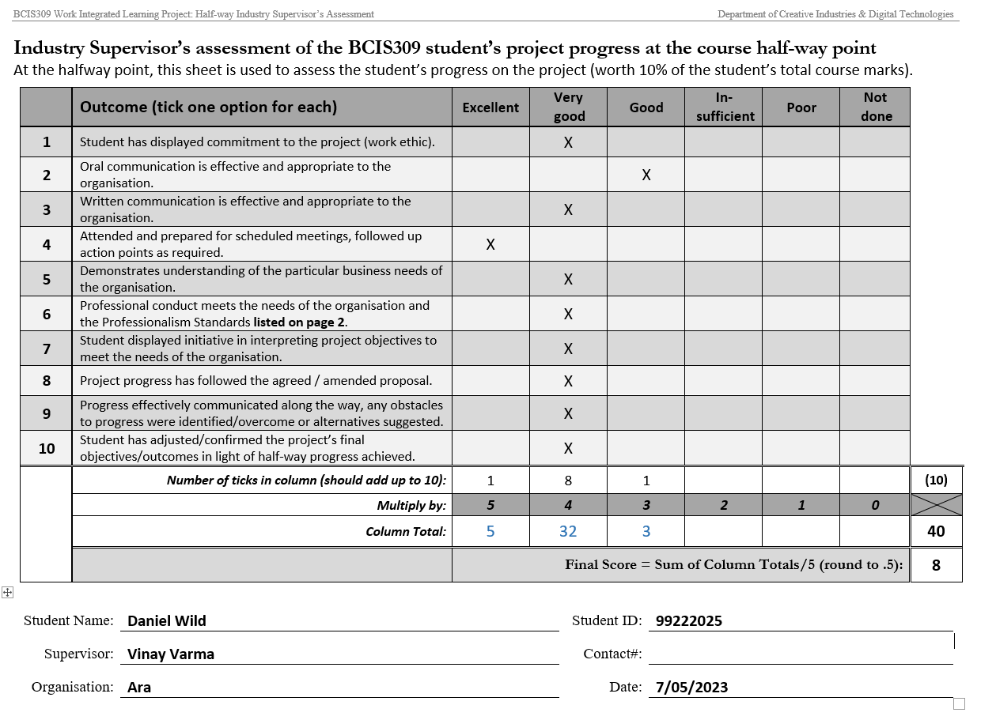

### Academic

Table 41   
*My* *Self-Assessment of Academic Progress at the Halfway Point*

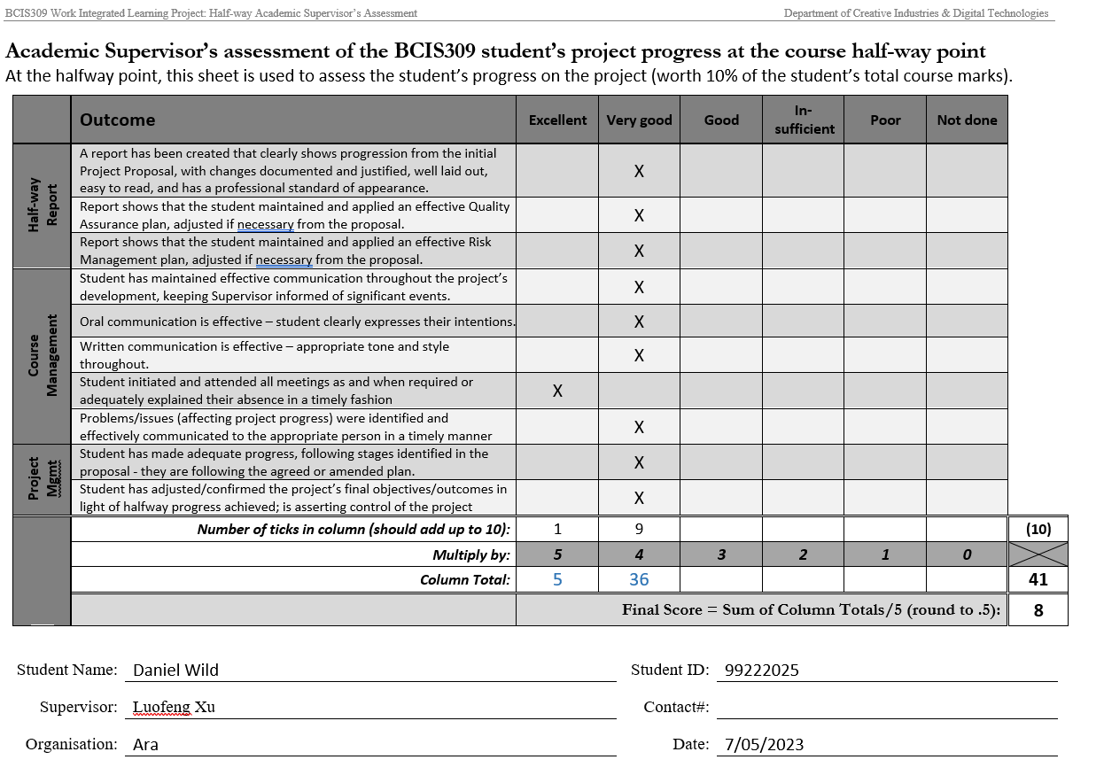

## Final Self-Assessment

Table 42

*My* *Self-Assessment of the Panel Assessment*

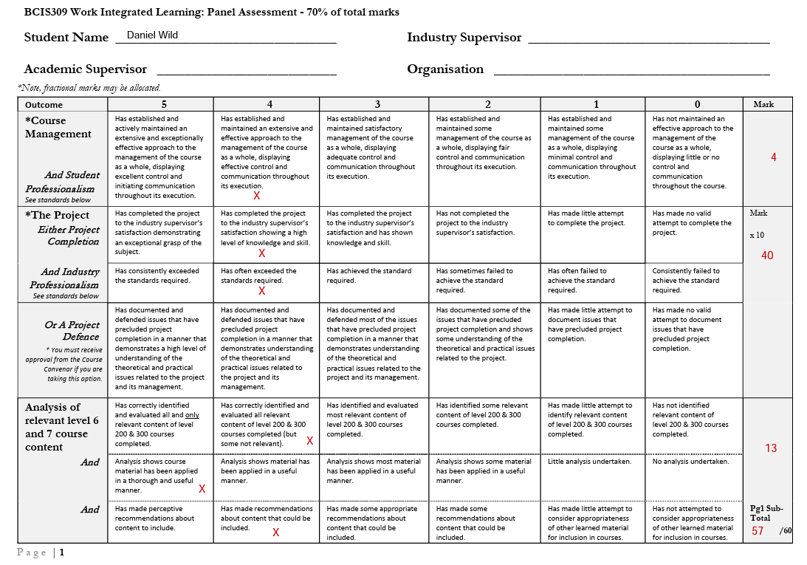

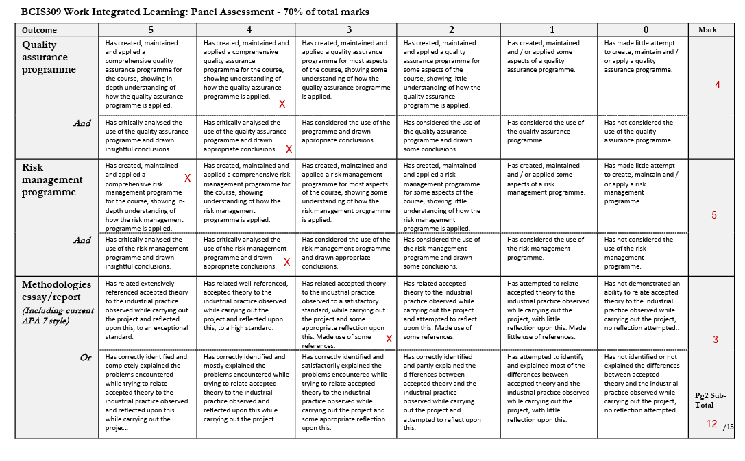

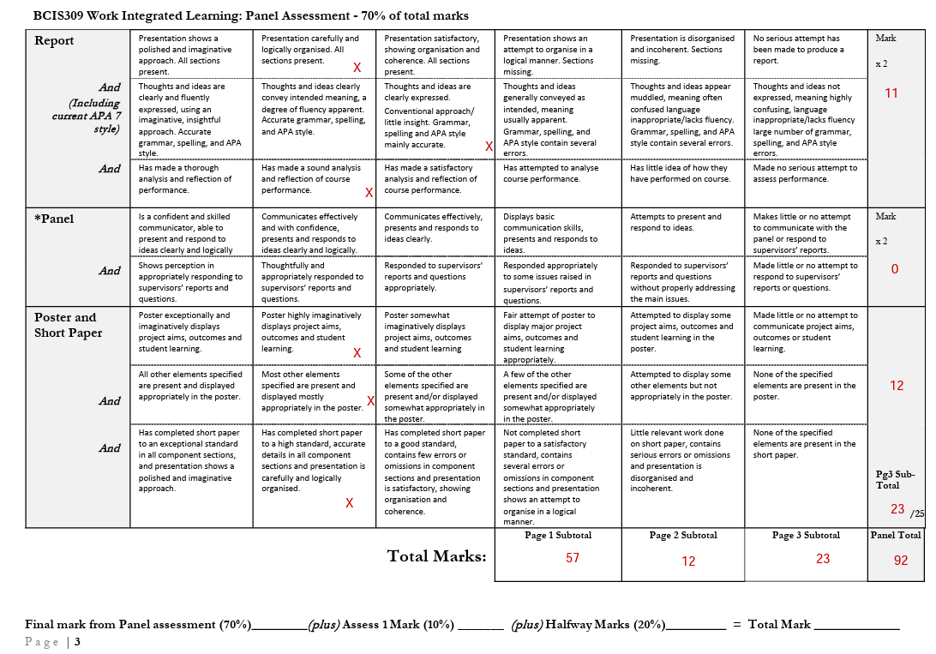

### Final Self-Assessment

As per above, I have completed the panel assessment to evaluate how I think I have done during the project. In this section, I will break down why I gave myself each mark.

* For Couse Management, I gave myself a 4 as I think I have done very well with verbal communication but lost the 1 mark for my spelling and grammar in my written communication.
* For Project Completion and Industry Professionalism, I gave myself 4’s as I think I completed the project high level of skill and professionalism but took away 1 mark for the debugging described above.
* For Analysis of Course Content, I gave myself a 4, 5 and 4 as I think I identified mostly relevant skills from the courses and have analysed where they were useful during the project thoroughly. While making recommendations that could be included in future courses.
* For Quality Assurance, I gave myself 4’s as I think I maintained the QA well and showed a good understanding of how it is applied while critically analysing the results. Took 1 mark away as I think the analysis could be more insightful.
* For Risk Assessment, I gave myself 45 and 4 as I think I maintained the table very well and showed a good understanding of how it is applied while critically analysing the results. Took 1 mark away as I think the analysis could be more insightful.
* For Methodologies, I gave myself a 3 as I think I did some appropriate reflection, but it could have been better given more time, so I took 2 marks away.
* For the Report, I gave myself 4 and 3 as I think all my sections are included and organised with good ideas but am let down by the spelling and grammar, so I took away 2 marks.
* For the Post and Short Paper, I gave myself 4’s as I think they are completed to a high standard but could be better polished.

# Reflections

In this section, I will go in-depth about the reflection process I will do at both the halfway and Final stages of the project, explaining what my approach will be to taking note of each event and how they form my lessons learned.

## Approach

At the end of each week, I will complete a weekly reflection by myself where I think about what went well, what could have gone better, what I learned, what questions I have, and whom I should ask, as per Table 43 *Weekly Reflection of Week 5 Ending 26/03/2023*.

This will help me get my thoughts, problems, and questions in order before my weekly meetings, where I will expand upon those ideas and get answers to questions from my supervisors. This will help us fill out our weekly reports, as seen below in Table 44 *Weekly Progress Report Template*.

These will then all be grouped at the end of the project to give me proof of my reflections and an overall retrospective of what I learned during the project for my presentation.

Table 43  
*Weekly Reflection of Week 5 Ending 26/03/2023*

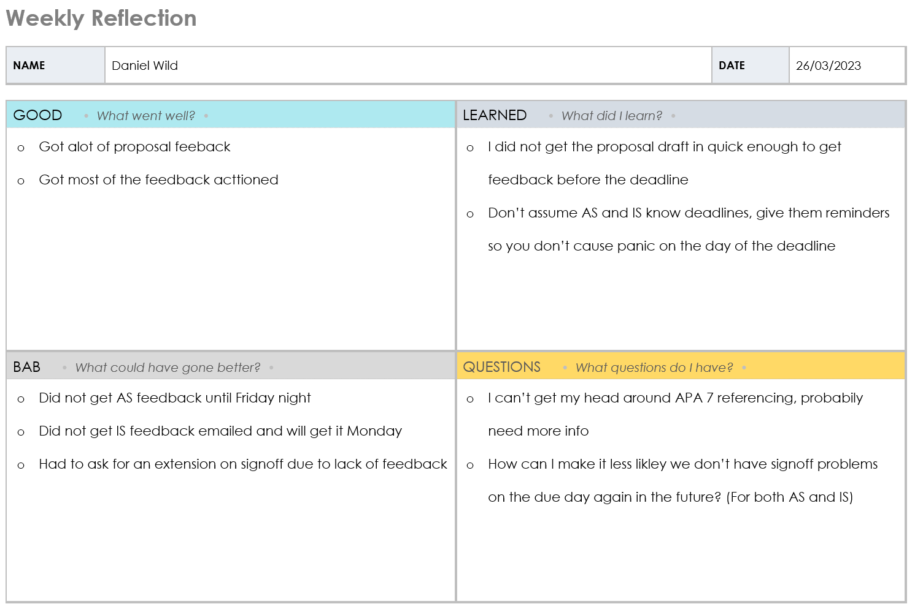

Table 44  
*Weekly Progress Report Template*

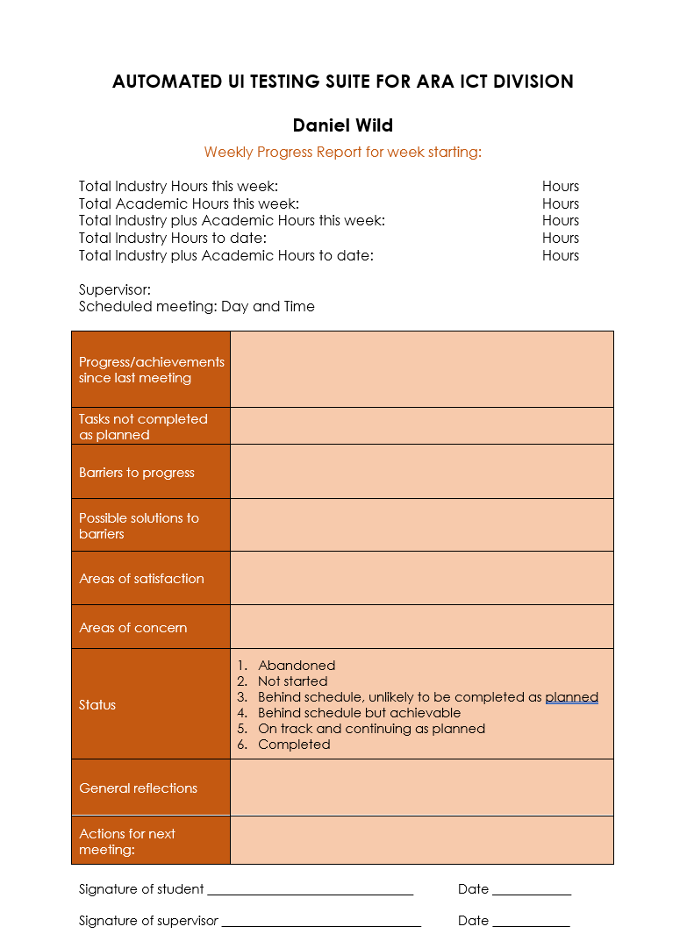

## Halfway Report

## Update

As discussed in the sections above, the process of the weekly report turned out to be different than originally planned. Instead of two separate weekly reports being completed with the academic and industry supervisors during the weekly meeting, which build on my weekly reflection, I complete one weekly report on a Monday afternoon about the previous week, which is shown and discussed with the supervisors during their respective meetings so that updates and changes can be made. This has led to small updates to the wording of some sections, as shown in the report below in Table 45 *Weekly Progress Report at Week 11 (1/05/2023)* and Appendix H for more. This has also meant the Weekly Reflection has become somewhat irrelevant to the point where I have forgotten to do it a few times, but I will try to continue using it as it is a good way of sorting out my thoughts before I do the Weekly Report.

Table 45   
*Weekly Progress Report at Week 11 (1/05/2023)*

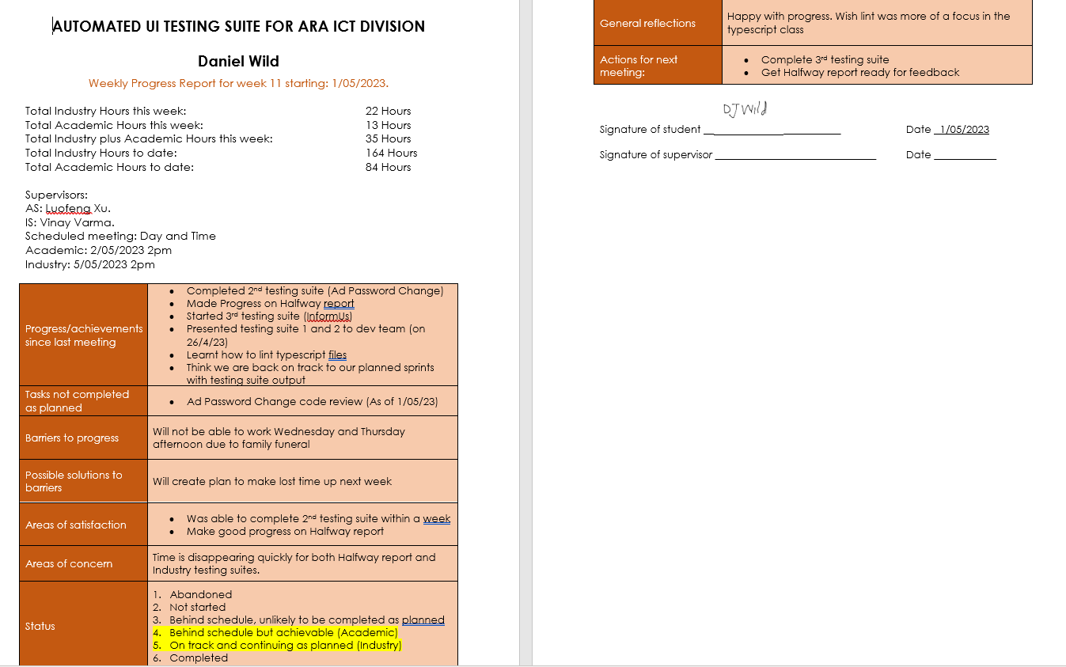

## Reflection

### What Went Well

The reflection process has been very beneficial to the over aspects of the project. It has helped me think about all the things I have learnt and achieved each week. It has helped me get a sense of how I am progressing from my supervisor and started in-depth conversations that have helped explain to me ways to do aspects of the project better or give me talking points for this report. Finally, it has helped me keep the documents that make up this report to date and relevant so that I am in the best possible place as I work through my project each week.

### What Didn’t Go Well

As mentioned above in the updates section, with the change to the way the Weekly Reports were done, my approach planned out and discussed above during the Project Proposal was quickly made irrelevant, meaning the reflection document was often forgotten about. Though I think it was useful for focusing my thoughts on at least half of it, mostly the “What I learnt” and “Questions” sections were not often transferable to the Weekly Report and were double-ups of the notes, I made in my notebook each day. I think going forward, I will review my approach to doing the reflections each week and come up with a new overall approach so that I can do a comparison and conclusion of the approach that worked best for me in my final report.

## Final Report

## Final Summary

In summary, I learnt many things during my experience of working on this project.

In the Project Scope Section, I reflected that I learnt about finding ways to not put myself under time pressure while working through the deliverables and prioritising when in the workplace. Both lessons based on organisation that I will take into future workplaces.

In the Stakeholder Management Section, I reflected that the experience I gained during my project around communication skills has helped to make me more confident in my communication skills. I also reflected that I learnt I should be careful with the time-tracking systems I implement during a project and make sure to have one constant method. Two personal lessons that I will take into everyday life following the conclusion of the project.

In the Student Skills Section, I reflected that I have greatly increased my ICT-specific testing and deployment skills as well as my academic report writing skills. I also reflected that I learnt I still need to improve on important skills like version control and debugging, which are currently weaknesses I have. These are technical lessons I will take into future projects.

In the Project Plan Section, I reflected that I learnt how to start working on something before I think I need to if I have the chance. A lesson that will be useful going forward, both in my personal life and business.

In the Risk Assessment Section, I reflected that I learnt how to effectively use the risk assessment process to help mitigate risk impact using contingency plans while also learning that the familiar approach to risk assessment is not always the best approach for every project. These lessons will be very beneficial during my next big project.

In the Quality Assurance Section, I reflected that effective QA can increase both the standards of the product created and the skills of the people working on the project. While also noting that QA is about balancing project quality with time pressures. Technical lessons I will take into future projects.

In the Methodology Section, I reflected that, in practice, Agile is a far nicer framework to work under than traditional framework in traditional office jobs. I also reflected that Scrumban was a benefit to this project as it helped make up for the negatives of using only Scrum or Kanban. Ideas that I will consider when looking into future workplaces.

In the Professionalism and ITP Code of Ethics Section, I reflected that an established Dev team environment was key to keeping both my and their professional standards high. I also learnt that when dealing with sensitive data, it is important to be careful about the ways you interact with it and how you demonstrate your work around it. A crucial lesson I will take into future projects or business.

In the Sustainability, Inclusive Practice, and Te Tiriti o Waitangi Section, I reflected on the ways I was not able to incorporate both sustainability and Te Reo Māori into my project. I also discussed how I could have done things differently and the lessons I will take from that into my next project.

Overall, I have learnt many things during this experience that I will take both into my career but also my personal life. I learnt what I am capable of when given a real test after these last few years of studying. I gained confidence in my soft skills like communication and time management. After this experience, I feel justified in my decision four years ago to quit my office job and come study at Ara. Most of all, I learnt that this is just the beginning of this journey, and I expect to have more experiences like this so that I can continue to improve my challenging myself.

References

Alaidaros, H. (2018, June 3). *Towards an Improved Software Project.* Retrieved from researchgate: https://www.researchgate.net/profile/Hamzah-Alaidaros/publication/326156795_Towards_an_Improved_Software_Project_Monitoring_Task_Model_of_Agile_Kanban_Method/links/5b3b8f8eaca27207850a43a1/Towards-an-Improved-Software-Project-Monitoring-Task-Model-of-Agil

Alaidaros, H. (2021, November). *THE STATE OF THE ART OF AGILE KANBAN METHOD CHALLENGES AND OPPORTUNITIES*. Retrieved from paulorodrigues: http://paulorodrigues.pro.br/ojs/ijmp/index.php/ijmp/article/view/1482/1945

Ara Institute of Canterbury | Te Pūkenga. (2020, August). *Sustainability - our charter*. Retrieved from ara.ac.nz/about-us: https://www.ara.ac.nz/siteassets/documents---home/about-us/sustainability---our-charter/sustainabilitycharter_2020_webres.pdf

Ara Institute of Canterbury | Te Pūkenga. (n.d.-a). *Anonymous Online Reporting FAQ: Inform Us*. Retrieved March 20, 2023, from ara.ac.nz: https://www.ara.ac.nz/about-us/need-help/inform-us/inform-us-faq/

Ara Institute of Canterbury | Te Pūkenga. (n.d.-b). *Mahuru Māori*. Retrieved March 20, 2023, from .ara.ac.nz: https://www.ara.ac.nz/news-and-events/mahuru-maori/

Ara Institute of Canterbury | Te Pūkenga. (n.d.-c). *Our Story*. Retrieved March 7, 2023, from Ara Institute of Canterbury About Us: https://www.ara.ac.nz/about-us/our-story/

AraTaiohi. (n.d.). *Whanaungatanga*. Retrieved from arataiohi: https://arataiohi.org.nz/research/aotearoa-youth-research/whanaungatanga/

Atlassian. (n.d.). *Continuous delivery starts on the Jira kanban board*. Retrieved March 17, 2023, from atlassian: https://www.atlassian.com/software/jira/features/kanban-boards

Averbuch, Z. (2022, Feb 10). *A customizable weekly schedule template*. Retrieved from MondayBlog: https://monday.com/blog/project-management/weekly-schedule-template/

Barlow, C. (1991). *Key Concepts in Māori Culture*. Retrieved from takai.nz: https://www.takai.nz/find-resources/articles/mana-reo/

Bose, S. (2023, February 20). *What is End To End Testing?* Retrieved from Browser Stack: https://www.browserstack.com/guide/end-to-end-testing

Chandana. (2023, March 20). *Agile Project Management APM Framework*. Retrieved from simplilearn: https://www.simplilearn.com/apm-framework-article#:~:text=The%20five%20different%20phases%20of,phase%2C%20and%20the%20close%20phase.

Chowdhury, A. R. (2018, December 11). *E2E Testing tutorial: Complete Guide to End to End Testing With Examples.* Retrieved from Lambdatest: https://www.lambdatest.com/blog/guide-to-end-to-end-testing-with-examples/

Clarkson, J. (2012). *Beyond FMEA: the structured what-if technique (SWIFT)*. Retrieved from pubmed: https://www.researchgate.net/publication/224821158_Beyond_FMEA_the_structured_what-if_technique_SWIFT

Cohen, E. (2022, November 2). *Pros & Cons Of The Kanban Method In Project Management*. Retrieved from workamajig: https://www.workamajig.com/blog/kanban-methodology-guide/pros-cons-kanban-method

Dobra, A. (2021, May 27). *Explaining CI, CD, CT in DevOps & How to Make Them Work Together*. Retrieved from Bunny Shell: https://www.bunnyshell.com/blog/what-is-ci-cd-ct-devops/#:~:text=Continuous%20integration%20(CI)%2C%20continuous,value%20delivery%20for%20the%20customer

Hoffman, D. G. (2002). *best practice risk management*. Retrieved from Google Scholar / books: https://books.google.co.nz/books?hl=en&lr=&id=qBCegetwV0cC&oi=fnd&pg=PR21&dq=best+practice+risk+management&ots=2BaIMx3pNE&sig=y2fX4m6BsbMeH8jYa3cI2g_8-NE&redir_esc=y#v=onepage&q=best%20practice%20risk%20management&f=false

ITPM Quality Management Plan. (2010, December 15). *ITPM Quality Management Plan.* Retrieved from Moodle.

IT-Professionals New Zealand. (2017, May). *It Professionals New Zealand code of ethics*. Retrieved from https://itp.nz/Members/Code-of-Ethics: https://itp.nz/upload/files/ITP%20Code%20of%20Ethics.pdf

Kanbanize. (2023). *Agile Project Management: A Comprehensive Guide*. Retrieved March 2023, from kanbanize: https://kanbanize.com/agile/project-management

Kumar, G. (2012, August). *Impact of Agile Methodology on Software Development Process*. Retrieved from researchgate: https://www.researchgate.net/profile/Gaurav-Kumar-175/publication/255707851_Impact_of_Agile_Methodology_on_Software_Development_Process/links/00b49520489442e12d000000/Impact-of-Agile-Methodology-on-Software-Development-Process.pdf

LawHawk. (n.d.). *LawHawk Guide to Confidentiality Agreements*. Retrieved March 20, 2023, from LawHawk.nz: https://www.lawhawk.nz/resources/document-guides/confidentiality-agreement-guide

Martin, M. (2023, March 11). *Project Management Life Cycle Phases: What are the stages?* Retrieved from guru99: https://www.guru99.com/initiation-phase-project-management-life-cycle.html

Matsuo, K. (2022, August 5). *Testing with Puppeteer - A Complete Guide*. Retrieved from headspin: https://www.headspin.io/blog/testing-with-puppeteer-a-complete-guide#:~:text=test%20automation%20frameworks-,Puppeteer%20is%20a%20Node.,control%20Chrome%20or%20Chromium%20programmatically.

Microsoft. (2022, June 7). *Learn about insider risk management*. Retrieved from Microsoft.com: https://docs.microsoft.com/en-us/microsoft-365/compliance/insider-risk-management?view=o365-worldwide

Ministry of Education. (2020, May 21). *Principles*. Retrieved from nzcurriculum.tki.org.nz: https://nzcurriculum.tki.org.nz/Principles

Ministry of Education. (n.d.-a). *Future focus principle*. Retrieved March 20, 2023, from nzcurriculum.tki.org.nz: https://nzcurriculum.tki.org.nz/Principles/Future-focus-principle

Ministry of Education. (n.d.-b). *Inclusion principle*. Retrieved March 20, 2023, from nzcurriculum.tki.org.nz: https://nzcurriculum.tki.org.nz/Principles/Inclusion-principle

Moodle. (n.d.). *BCIS309 Work Integrated Learning Project Week 4 / 5*. Retrieved April 25, 2023, from Ara Moodle: https://moodle.ara.ac.nz/course/view.php?id=15875&section=6#tabs-tree-start

Moorfield, J. C. (2003). *rangatiratanga* . Retrieved from maoridictionary: https://maoridictionary.co.nz/search?&keywords=rangatiratanga

New Zealand Government Procurement. (n.d.). *Non-disclosure agreement form*. Retrieved March 20, 2023, from procurement.govt.nz: https://www.procurement.govt.nz/non-disclosure-agreement-form/

New Zealand intellectual Property Office. (n.d.). *Copyright*. Retrieved March 20, 2023, from iponz.govt.nz: https://www.iponz.govt.nz/about-ip/copyright/

Petit, M. (2022, June 16). *The Pros and Cons of Kanban, Scrum, and Agile: How to Choose the Right Methodology for Your Team*. Retrieved from monitask: https://www.monitask.com/en/blog/the-pros-and-cons-of-kanban-scrum-and-agile-how-to-choose-the-right-methodology-for-your-team

Privacy Commissioner. (n.d.). *Privay Act 2020*. Retrieved from Privacy Commission: https://elearning.privacy.org.nz/

Radigan, D. (2021). *What is kanban?* Retrieved March 17, 2023, from atlassian: https://www.atlassian.com/agile/kanban

Sacolick, I. (2022, April 8). *A brief history of the agile methodology*. Retrieved from Infoworld: https://www.infoworld.com/article/3655646/a-brief-history-of-the-agile-methodology.html

Stanford University. (n.d.). *User Acceptance Testing*. Retrieved May 2, 2023, from Stanford University IT: https://uit.stanford.edu/pmo/UAT#:~:text=Details-,Overview,intended%20audience%20or%20business%20representative.

Study with New Zealand. (2017). *Ara Institute of Canterbury*. Retrieved March 7, 2023, from study with new zealand: https://www.studywithnewzealand.govt.nz/en/study-options/education-provider/14ed73cd-bcc8-11ea-9d98-0a38361e411e

Talin, S. (2023, March 27). *Regression Testing vs Unit Testing*. Retrieved from practitest: https://www.practitest.com/qa-learningcenter/resources/regression-testing-vs-unit-testing/#:~:text=Regression%20testing's%20purpose%20is%20to,keep%20it%20clean%20from%20defects.

Te Pūkenga. (2022, February 23). *A new kind of organisation*. Retrieved from tepūkenga: https://www.xn--tepkenga-szb.ac.nz/our-work/

Te Tāruke-ā-Tāwhiri. (n.d.). *Values and principles of the wellbeing framework*. Retrieved March 20, 2023, from aucklandcouncil.govt.nz: https://www.aucklandcouncil.govt.nz/plans-projects-policies-reports-bylaws/our-plans-strategies/topic-based-plans-strategies/environmental-plans-strategies/aucklands-climate-plan/response/Pages/values-principles-wellbeing-framework.aspx#:~:text=Kaitiakita

VersionOne. (2022). *State of Agile report*. Retrieved from info.digita: https://info.digital.ai/rs/981-LQX-968/images/AR-SA-2022-16th-Annual-State-Of-Agile-Report.pdf

Virginia Tech. (2006, December 11). *Information Technology Risk Management Guideline*. Retrieved from virginia.gov: https://www.vita2.virginia.gov/uploadedFiles/Library/PSGs/Word_versions/Risk_Assessment_Instructions.doc

Virginia Tech. (2022). *Project Quality Assurance*. Retrieved from Virginia tech: https://it.vt.edu/projects/project_management/qualityassurance.html

# Appendices

As the development process continues, the figures in this report will be updated and changed as they change each week they are reviewed. As part of this being a live document in this section, each version of those figures will be shown showing the progress each goes through during the project duration.

## 

## Appendix A: Timetables

Table A1   
*Final Industry Project Timetable (With Tabs of all Past Weeks)*

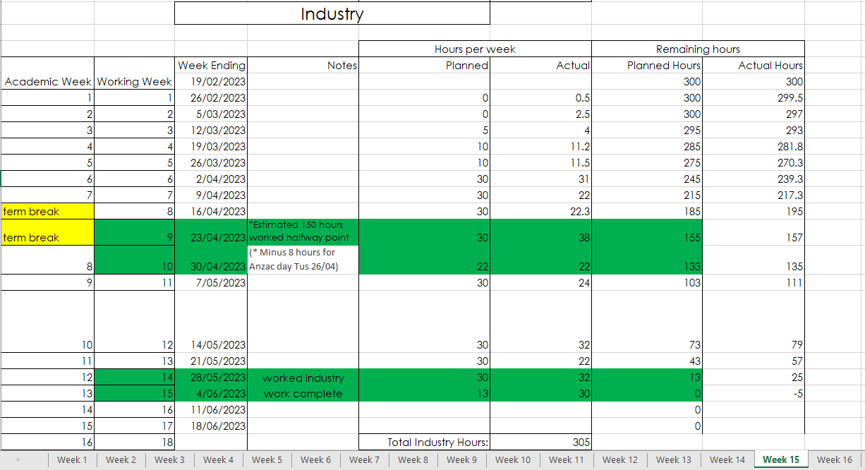

Table A2  
*Final Academic Project Timetable (With Tabs of all Past Weeks)*

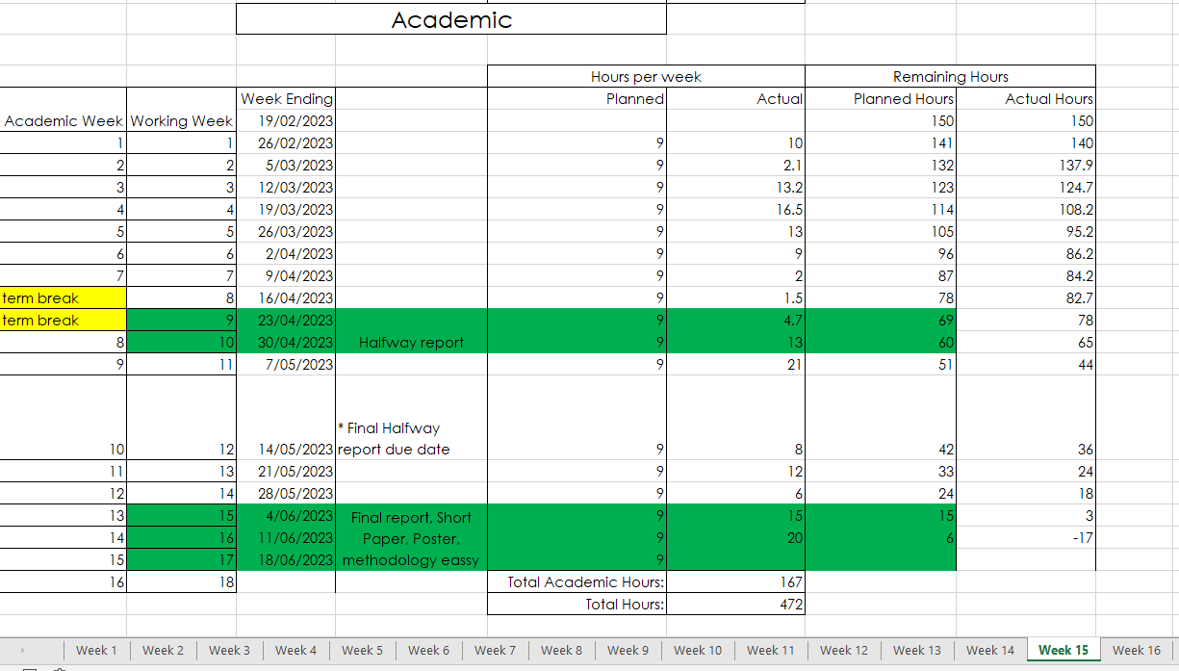

Embed File: 

## Appendix B: Industry Burndown Charts

Figure B1   
*Industry Burndown Chart at Week 10 (With Tabs of all Past Weeks)*

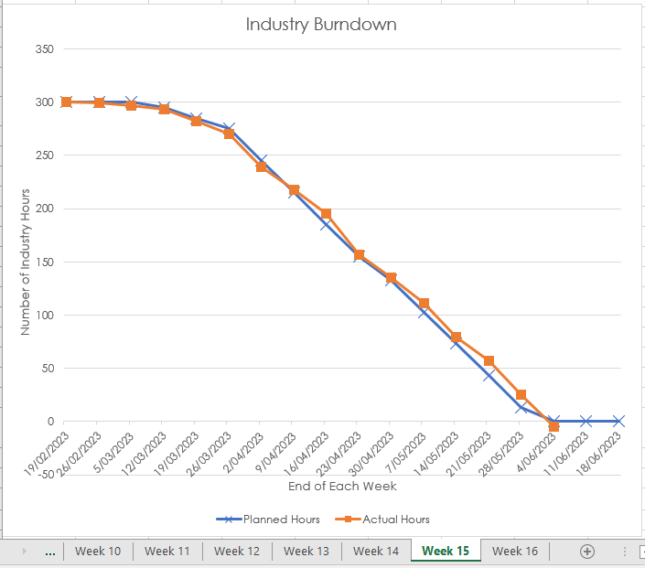 Embed File: 

## Appendix C: Academic Burndown Charts

Figure C1   
*Final Academic Burndown Chart (With Tabs of all Past Weeks)*

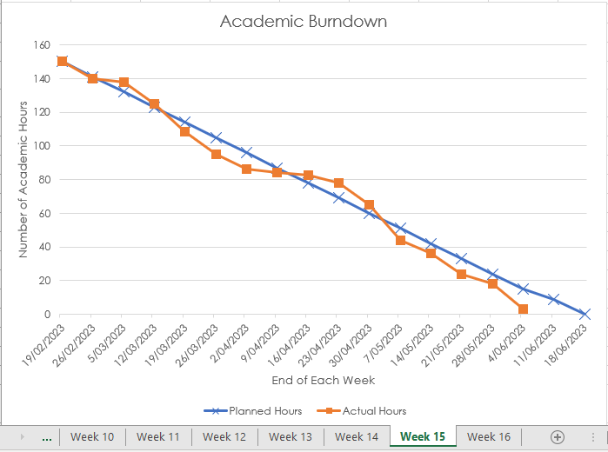 Embed File: 

## Appendix D: Academic Task breakdown

Table D1   
*Final Academic Task Breakdown (With Tabs of all Past Weeks)*

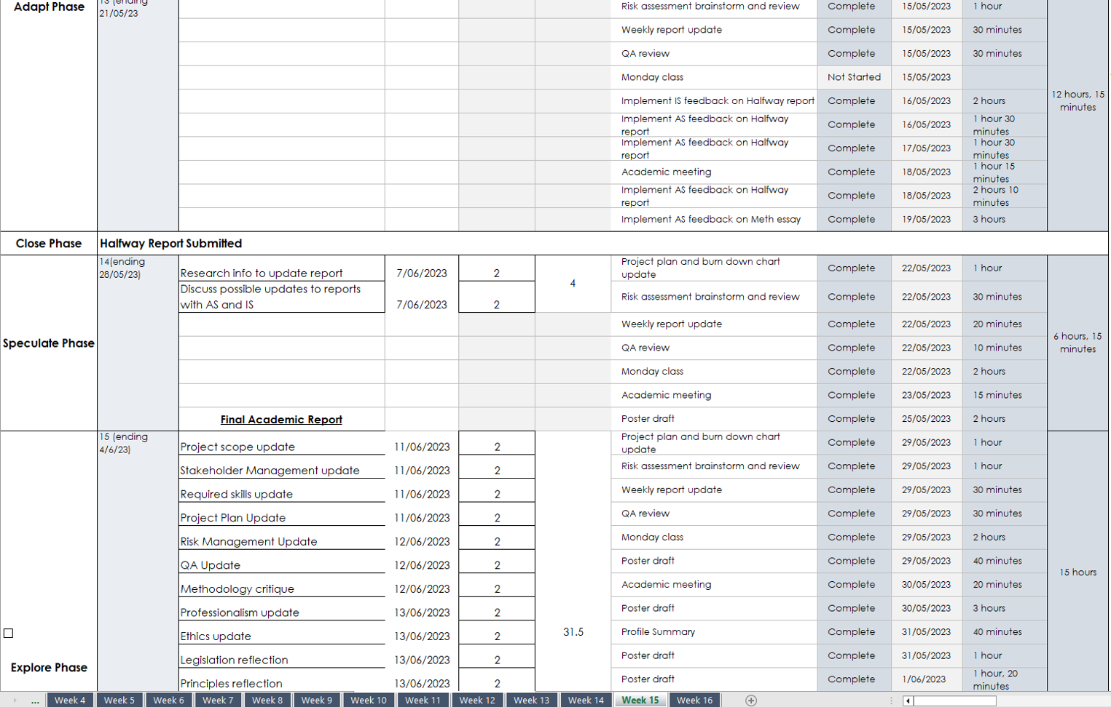 Embed File: 

## Appendix E: Industry Task breakdown

Table E1   
*Final Industry Task Breakdown (With Tabs of all Past Weeks)*

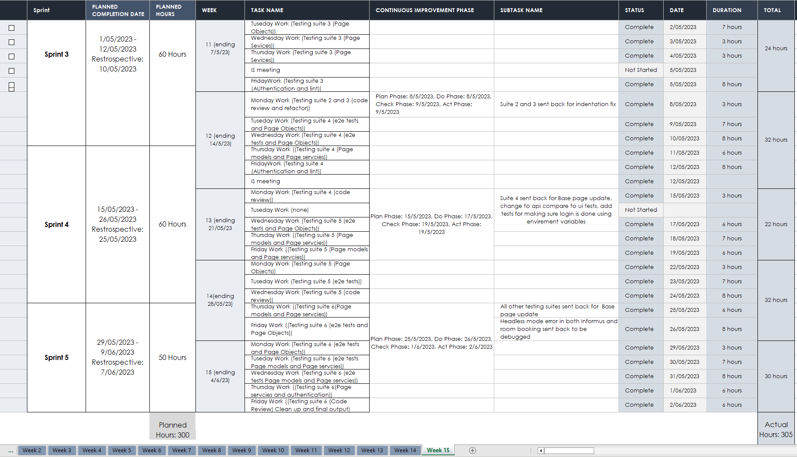

Embed File: 

## Appendix F: Risk Management

Table F1   
*Final Risk Management (With Tabs of all Past Weeks)*

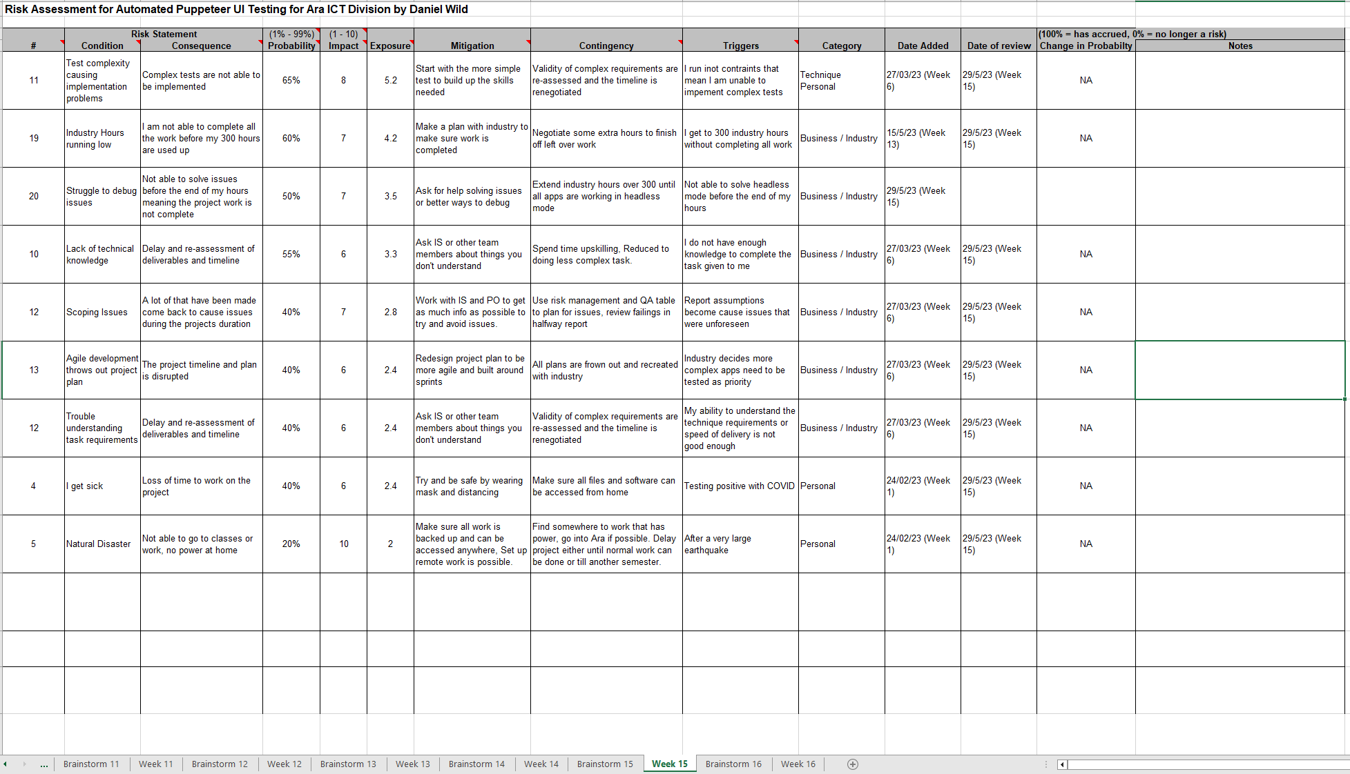

Table F2  
*Final Risk Brainstorm (With Tabs of all Past Weeks)*

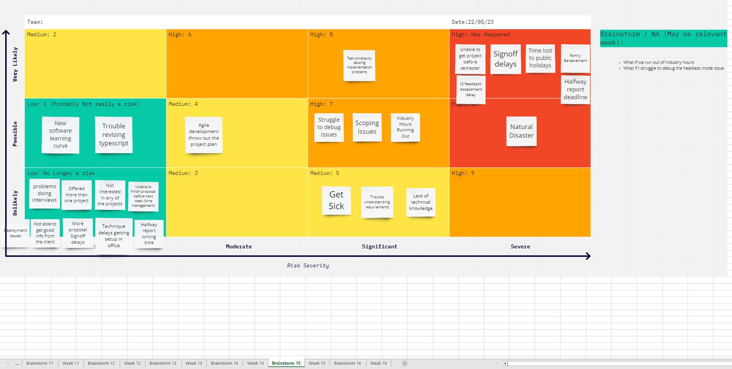

Embed File: 

## Appendix G: Past Weekly Reports

**Figure G1**   
*Past Weekly Report Thumbnails*

